# Female BMD Results for Table: Aspartate Aminotransferase

BMDS version: BMDS v2.7.0

## Input dataset

|  |  |  |  |  |  |  |  |  |
| --- | --- | --- | --- | --- | --- | --- | --- | --- |
| Dose | 0 | 0.15 | 0.5 | 1.4 | 4 | 12a | 37a | 111a |
| N | 10 | 5 | 5 | 5 | 5 | 5 | 5 | 5 |
| Mean ± SD | 82.2 ± 5.94 | 80.6 ± 2.702 | 72.4 ± 5.857 | 74.4 ± 6.877 | 77.6 ± 10.065 | 82 ± 6.442 | 77.8 ± 9.884 | 69.6 ± 3.507 |

a Dose group removed in BMD modeling session

## Summary table

|  |  |  |  |  |  |
| --- | --- | --- | --- | --- | --- |
| Modela | Goodness of fit | | BMD | BMDL | Comments |
| *p*-value | AIC |
| Linear | 0.027 | 152.637 | 8.102 | 2.974 | Exponential-M5 recommended as best-fitting model on the basis of the lowest AIC. |
| Polynomial 2° | 0.027 | 152.637 | 8.102 | 2.974 |
| Polynomial 3° (equivalent models include Polynomial 4°) | 0.027 | 152.637 | 8.102 | 2.974 |
| Polynomial 5° | 0.027 | 152.637 | 8.102 | 2.974 |
| Power (equivalent models include Polynomial 6°, 7°) | 0.027 | 152.637 | 8.102 | 2.974 |
| Hill | 0.173 | 149.316 | 0.181 | -999 |
| Exponential M2 | 0.027 | 152.614 | 8.085 | 2.873 |
| Exponential M3 | 0.027 | 152.614 | 8.085 | 2.873 |
| Exponential M4 | 0.235 | 148.358 | 0.371 | 0.002 |
| Exponential M5b | 0.173 | 149.316 | 0.256 | 0.11 |

a Constant variance case presented (BMDS Test 2 p-value = 0.118, BMDS Test 3 p-value = 0.118).

b Recommended model

## Model recommendation details

|  |  |  |
| --- | --- | --- |
| Model | Bin | Notes |
| Linear | Warning | **Warnings**  • Goodness of fit p-value is less than threshold (0.027 < 0.1)  • BMD/high dose ratio is greater than threshold (2.03 > 1.0) |
| Polynomial 2° | Warning | **Warnings**  • Goodness of fit p-value is less than threshold (0.027 < 0.1)  • BMD/high dose ratio is greater than threshold (2.03 > 1.0) |
| Polynomial 3° (equivalent models include Polynomial 4°) | Warning | **Warnings**  • Goodness of fit p-value is less than threshold (0.027 < 0.1)  • BMD/high dose ratio is greater than threshold (2.03 > 1.0) |
| Polynomial 5° | Warning | **Warnings**  • Goodness of fit p-value is less than threshold (0.027 < 0.1)  • BMD/high dose ratio is greater than threshold (2.03 > 1.0) |
| Power (equivalent models include Polynomial 6°, 7°) | Warning | **Warnings**  • Goodness of fit p-value is less than threshold (0.027 < 0.1)  • BMD/high dose ratio is greater than threshold (2.03 > 1.0) |
| Hill | Failure | **Failures**  • BMDL does not exist  **Cautions**  • Warning(s): BMDL computation failed. |
| Exponential M2 | Warning | **Warnings**  • Goodness of fit p-value is less than threshold (0.0273 < 0.1)  • BMD/high dose ratio is greater than threshold (2.02 > 1.0) |
| Exponential M3 | Warning | **Warnings**  • Goodness of fit p-value is less than threshold (0.0273 < 0.1)  • BMD/high dose ratio is greater than threshold (2.02 > 1.0) |
| Exponential M4 | Warning | **Warnings**  • BMD/BMDL ratio is greater than threshold (1.74e+02 > 20.0)  **Cautions**  • BMD/BMDL ratio is greater than threshold (1.74e+02 > 5.0) |
| Exponential M5a | Valid | - |

a Recommended model

## Recommended model

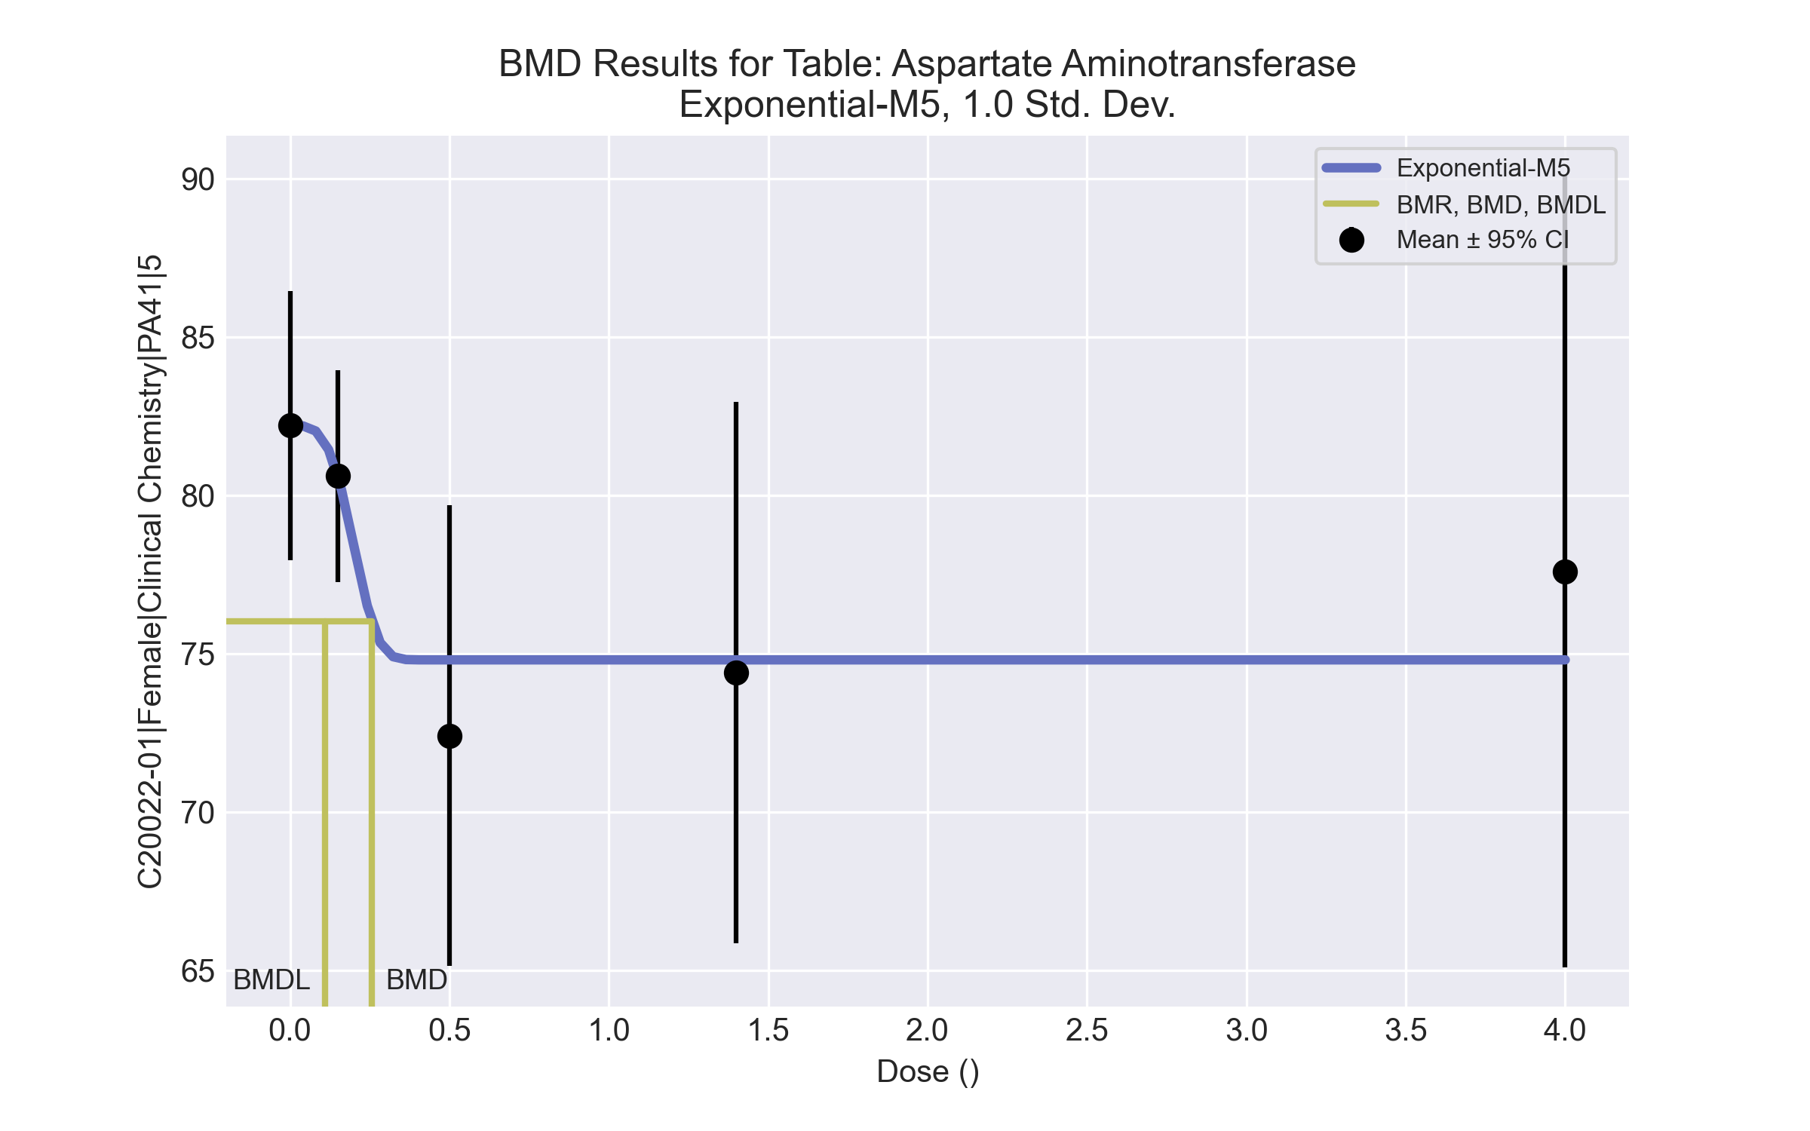

====================================================================   
 Exponential Model. (Version: 1.11; Date: 03/14/2017)   
 Input Data File: C:\Windows\TEMP\bmds-py2t94q4.(d)   
 Gnuplot Plotting File:   
 Tue Apr 13 16:24:05 2021  
 ====================================================================   
  
 BMDS_Model_Run   
~~~~~~~~~~~~~~~~~~~~~~~~~~~~~~~~~~~~~~~~~~~~~~~~~~~~~~~~~~~~~~~~~~~~~  
   
 The form of the response function by Model:   
 Model 2: Y[dose] = a * exp{sign * b * dose}  
 Model 3: Y[dose] = a * exp{sign * (b * dose)^d}  
 Model 4: Y[dose] = a * [c-(c-1) * exp{-b * dose}]  
 Model 5: Y[dose] = a * [c-(c-1) * exp{-(b * dose)^d}]  
  
 Note: Y[dose] is the median response for exposure = dose;  
 sign = +1 for increasing trend in data;  
 sign = -1 for decreasing trend.  
  
 Model 2 is nested within Models 3 and 4.  
 Model 3 is nested within Model 5.  
 Model 4 is nested within Model 5.  
  
  
 Dependent variable = Response  
 Independent variable = Dose  
 Data are assumed to be distributed: normally  
 Variance Model: exp(lnalpha +rho *ln(Y[dose]))  
 rho is set to 0.  
 A constant variance model is fit.  
  
 Total number of dose groups = 5  
 Total number of records with missing values = 0  
 Maximum number of iterations = 500  
 Relative Function Convergence has been set to: 1e-008  
 Parameter Convergence has been set to: 1e-008  
  
 MLE solution provided: Exact  
  
  
 Initial Parameter Values  
  
 Variable Model 5  
 -------- --------  
 lnalpha 3.58204   
 rho 0 Specified  
 a 86.31   
 b 0.28945   
 c 0.798892   
 d 1   
  
  
  
 Parameter Estimates  
  
 Variable Model 5 Std. Err.  
 -------- ------- ---------  
 lnalpha 3.64388 9.87353  
 a 82.2 1.95551  
 b 4.57051 786.846  
 c 0.909976 0.0290849  
 d 3.74081 1705.99  
  
 NC = No Convergence  
  
  
 Table of Stats From Input Data  
  
 Dose N Obs Mean Obs Std Dev  
 ----- --- ---------- -------------  
 0 10 82.2 5.94  
 0.15 5 80.6 2.702  
 0.5 5 72.4 5.857  
 1.4 5 74.4 6.878  
 4 5 77.6 10.06  
  
  
 Estimated Values of Interest  
  
 Dose Est Mean Est Std Scaled Residual  
 ------ ---------- --------- ----------------  
 0 82.2 6.184 -1.19e-007  
 0.15 80.6 6.184 -9.842e-007  
 0.5 74.8 6.184 -0.8678  
 1.4 74.8 6.184 -0.1446  
 4 74.8 6.184 1.012  
  
  
  
 Other models for which likelihoods are calculated:  
  
 Model A1: Yij = Mu(i) + e(ij)  
 Var{e(ij)} = Sigma^2  
  
 Model A2: Yij = Mu(i) + e(ij)  
 Var{e(ij)} = Sigma(i)^2  
  
 Model A3: Yij = Mu(i) + e(ij)  
 Var{e(ij)} = exp(lalpha + log(mean(i)) * rho)  
  
 Model R: Yij = Mu + e(i)  
 Var{e(ij)} = Sigma^2  
  
  
 Likelihoods of Interest  
  
 Model Log(likelihood) DF AIC  
 ------- ----------------- ---- ------------  
 A1 -68.73055 6 149.4611  
 A2 -65.05364 10 150.1073  
 A3 -68.73055 6 149.4611  
 R -73.77372 2 151.5474  
 5 -69.65823 5 149.3165  
  
  
 Additive constant for all log-likelihoods = -27.57. This constant added to the  
 above values gives the log-likelihood including the term that does not  
 depend on the model parameters.  
  
  
 Explanation of Tests  
  
 Test 1: Does response and/or variances differ among Dose levels? (A2 vs. R)  
 Test 2: Are Variances Homogeneous? (A2 vs. A1)  
 Test 3: Are variances adequately modeled? (A2 vs. A3)  
  
 Test 7a: Does Model 5 fit the data? (A3 vs 5)  
  
  
 Tests of Interest  
  
 Test -2*log(Likelihood Ratio) D. F. p-value  
 -------- ------------------------ ------ --------------  
 Test 1 17.44 8 0.02584  
 Test 2 7.354 4 0.1183  
 Test 3 7.354 4 0.1183  
 Test 7a 1.855 1 0.1732  
  
  
 The p-value for Test 1 is less than .05. There appears to be a  
 difference between response and/or variances among the dose  
 levels, it seems appropriate to model the data.  
  
 The p-value for Test 2 is greater than .1. A homogeneous  
 variance model appears to be appropriate here.  
  
 The p-value for Test 3 is greater than .1. The modeled  
 variance appears to be appropriate here.  
  
 The p-value for Test 7a is greater than .1. Model 5 seems  
 to adequately describe the data.  
  
  
 Benchmark Dose Computations:  
  
 Specified Effect = 1.000000  
  
 Risk Type = Estimated standard deviations from control  
  
 Confidence Level = 0.950000  
  
 BMD = 0.256241  
  
 BMDL = 0.11022  
  
 BMDU = 40000

# Female BMD Results for Table: Sorbitol dehydrogenase

BMDS version: BMDS v2.7.0

## Input dataset

|  |  |  |  |  |  |  |  |  |
| --- | --- | --- | --- | --- | --- | --- | --- | --- |
| Dose | 0 | 0.15 | 0.5 | 1.4a | 4a | 12a | 37a | 111a |
| N | 10 | 5 | 5 | 5 | 5 | 5 | 5 | 5 |
| Mean ± SD | 11.88 ± 2.929 | 11.84 ± 1.455 | 9.34 ± 1.119 | 10.1 ± 1.173 | 11.8 ± 2.342 | 11.84 ± 3.41 | 8.6 ± 0.809 | 9.08 ± 0.896 |

a Dose group removed in BMD modeling session

## Summary table

|  |  |  |  |  |  |
| --- | --- | --- | --- | --- | --- |
| Modela | Goodness of fit | | BMD | BMDL | Comments |
| *p*-value | AIC |
| Linear (equivalent models include Power, Polynomial 2°, 3°, 4°) | 0.9 | 53.01 | 0.461 | 0.286 | Exponential-M2 recommended as best-fitting model on the basis of the lowest AIC. |
| Polynomial 5° | 0.9 | 53.01 | 0.461 | 0.286 |
| Polynomial 6° | <0.0001 | 87.363 | 0.33 | 0.074 |
| Polynomial 7° | 0.9 | 53.01 | 0.461 | 0.286 |
| Hill | 0.297 | 61.698 | -999 | -999 |
| Exponential M2b | 0.987 | 52.994 | 0.455 | 0.264 |
| Exponential M3 | 0.987 | 52.994 | 0.455 | 0.264 |
| Exponential M4 | -999 | 54.994 | 0.455 | 0.187 |
| Exponential M5 | -999 | 63.698 | -999 | 0 |

a Modeled variance case presented (BMDS Test 2 p-value = 0.028, BMDS Test 3 p-value = 0.168).

b Recommended model

## Model recommendation details

|  |  |  |
| --- | --- | --- |
| Model | Bin | Notes |
| Linear (equivalent models include Power, Polynomial 2°, 3°, 4°) | Valid | - |
| Polynomial 5° | Valid | - |
| Polynomial 6° | Warning | **Warnings**  • Residual of interest is greater than threshold (2.4 > 2.0)  **Cautions**  • Warning(s): THE MODEL HAS PROBABLY NOT CONVERGED!!!; THIS USUALLY MEANS THE MODEL HAS NOT CONVERGED! |
| Polynomial 7° | Valid | - |
| Hill | Failure | **Failures**  • BMD does not exist  • BMDL does not exist  **Warnings**  • Residual of Interest does not exist  **Cautions**  • Warning(s): BMR value is not in the range of the mean function |
| Exponential M2a | Valid | - |
| Exponential M3 | Valid | - |
| Exponential M4 | Warning | **Warnings**  • Zero degrees of freedom; saturated model |
| Exponential M5 | Failure | **Failures**  • BMD does not exist  **Warnings**  • Residual of Interest does not exist  • Zero degrees of freedom; saturated model |

a Recommended model

## Recommended model

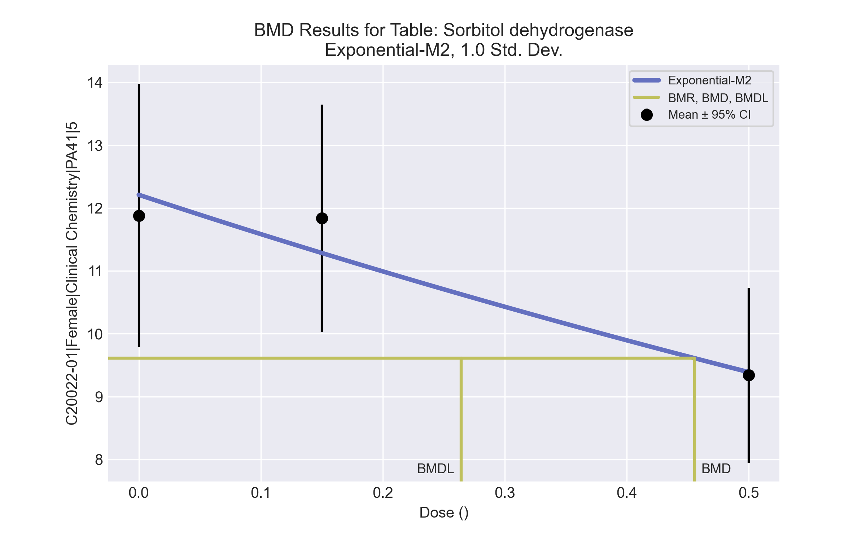

====================================================================   
 Exponential Model. (Version: 1.11; Date: 03/14/2017)   
 Input Data File: C:\Windows\TEMP\bmds-7_phhfnv.(d)   
 Gnuplot Plotting File:   
 Tue Apr 13 16:24:33 2021  
 ====================================================================   
  
 BMDS_Model_Run   
~~~~~~~~~~~~~~~~~~~~~~~~~~~~~~~~~~~~~~~~~~~~~~~~~~~~~~~~~~~~~~~~~~~~~  
   
 The form of the response function by Model:   
 Model 2: Y[dose] = a * exp{sign * b * dose}  
 Model 3: Y[dose] = a * exp{sign * (b * dose)^d}  
 Model 4: Y[dose] = a * [c-(c-1) * exp{-b * dose}]  
 Model 5: Y[dose] = a * [c-(c-1) * exp{-(b * dose)^d}]  
  
 Note: Y[dose] is the median response for exposure = dose;  
 sign = +1 for increasing trend in data;  
 sign = -1 for decreasing trend.  
  
 Model 2 is nested within Models 3 and 4.  
 Model 3 is nested within Model 5.  
 Model 4 is nested within Model 5.  
  
  
 Dependent variable = Response  
 Independent variable = Dose  
 Data are assumed to be distributed: normally  
 Variance Model: exp(lnalpha +rho *ln(Y[dose]))  
 The variance is to be modeled as Var(i) = exp(lalpha + log(mean(i)) * rho)  
  
 Total number of dose groups = 3  
 Total number of records with missing values = 0  
 Maximum number of iterations = 500  
 Relative Function Convergence has been set to: 1e-008  
 Parameter Convergence has been set to: 1e-008  
  
 MLE solution provided: Exact  
  
  
 Initial Parameter Values  
  
 Variable Model 2  
 -------- --------  
 lnalpha -11.3751   
 rho 5.18767   
 a 10.328   
 b 0.486253   
 c 0 Specified  
 d 1 Specified  
  
  
  
 Parameter Estimates  
  
 Variable Model 2 Std. Err.  
 -------- ------- ---------  
 lnalpha -17.4511 8.07876  
 rho 7.73759 3.37878  
 a 12.2106 0.701159  
 b 0.525698 0.151294  
  
 NC = No Convergence  
  
  
 Table of Stats From Input Data  
  
 Dose N Obs Mean Obs Std Dev  
 ----- --- ---------- -------------  
 0 10 11.88 2.929  
 0.15 5 11.84 1.455  
 0.5 5 9.34 1.119  
  
  
 Estimated Values of Interest  
  
 Dose Est Mean Est Std Scaled Residual  
 ------ ---------- --------- ----------------  
 0 12.21 2.6 -0.4022  
 0.15 11.28 1.916 0.648  
 0.5 9.388 0.9403 -0.1147  
  
  
  
 Other models for which likelihoods are calculated:  
  
 Model A1: Yij = Mu(i) + e(ij)  
 Var{e(ij)} = Sigma^2  
  
 Model A2: Yij = Mu(i) + e(ij)  
 Var{e(ij)} = Sigma(i)^2  
  
 Model A3: Yij = Mu(i) + e(ij)  
 Var{e(ij)} = exp(lalpha + log(mean(i)) * rho)  
  
 Model R: Yij = Mu + e(i)  
 Var{e(ij)} = Sigma^2  
  
  
 Likelihoods of Interest  
  
 Model Log(likelihood) DF AIC  
 ------- ----------------- ---- ------------  
 A1 -25.12045 4 58.24091  
 A2 -21.54572 6 55.09144  
 A3 -22.49707 5 54.99413  
 R -27.46287 2 58.92574  
 2 -22.4972 4 52.99439  
  
  
 Additive constant for all log-likelihoods = -18.38. This constant added to the  
 above values gives the log-likelihood including the term that does not  
 depend on the model parameters.  
  
  
 Explanation of Tests  
  
 Test 1: Does response and/or variances differ among Dose levels? (A2 vs. R)  
 Test 2: Are Variances Homogeneous? (A2 vs. A1)  
 Test 3: Are variances adequately modeled? (A2 vs. A3)  
 Test 4: Does Model 2 fit the data? (A3 vs. 2)  
  
  
 Tests of Interest  
  
 Test -2*log(Likelihood Ratio) D. F. p-value  
 -------- ------------------------ ------ --------------  
 Test 1 11.83 4 0.01863  
 Test 2 7.149 2 0.02802  
 Test 3 1.903 1 0.1678  
 Test 4 0.0002565 1 0.9872  
  
  
 The p-value for Test 1 is less than .05. There appears to be a  
 difference between response and/or variances among the dose  
 levels, it seems appropriate to model the data.  
  
 The p-value for Test 2 is less than .1. A non-homogeneous  
 variance model appears to be appropriate.  
  
 The p-value for Test 3 is greater than .1. The modeled  
 variance appears to be appropriate here.  
  
 The p-value for Test 4 is greater than .1. Model 2 seems  
 to adequately describe the data.  
  
  
 Benchmark Dose Computations:  
  
 Specified Effect = 1.000000  
  
 Risk Type = Estimated standard deviations from control  
  
 Confidence Level = 0.950000  
  
 BMD = 0.455386  
  
 BMDL = 0.264272  
  
 BMDU = 1.12106

# Female BMD Results for Table: Eosinophil count

BMDS version: BMDS v2.7.0

## Input dataset

|  |  |  |  |  |  |  |  |  |
| --- | --- | --- | --- | --- | --- | --- | --- | --- |
| Dose | 0 | 0.15 | 0.5 | 1.4 | 4 | 12 | 37 | 111 |
| N | 8 | 5 | 5 | 3 | 3 | 4 | 4 | 5 |
| Mean ± SD | 0.096 ± 0.033 | 0.072 ± 0.027 | 0.092 ± 0.011 | 0.083 ± 0.006 | 0.097 ± 0.031 | 0.098 ± 0.075 | 0.065 ± 0.026 | 0.062 ± 0.026 |

## Summary table

|  |  |  |  |  |  |
| --- | --- | --- | --- | --- | --- |
| Modela | Goodness of fit | | BMD | BMDL | Comments |
| *p*-value | AIC |
| Linear (equivalent models include Polynomial 2°, 3°, 4°, 5°, 6°) | 0.062 | -209.773 | 128.814 | 66.234 | No model was recommended as a best-fitting model. Doses were dropped until there were only 3 remaining dose-groups. |
| Polynomial 7° | <0.0001 | -142.571 | 39.996 | -999 |
| Power | 0.036 | -207.839 | 128.596 | 66.741 |
| Hill | 0.129 | -211.21 | -999 | -999 |
| Exponential M2 (equivalent models include Exponential M4) | 0.062 | -209.778 | 131.173 | 53.621 |
| Exponential M3 | 0.037 | -207.897 | 130.537 | 54.706 |
| Exponential M5 | 0.048 | -208.183 | -999 | 0 |

a Modeled variance case presented (BMDS Test 2 p-value = 6.7E-04, BMDS Test 3 p-value = 0.011).

## Model recommendation details

|  |  |  |
| --- | --- | --- |
| Model | Bin | Notes |
| Linear (equivalent models include Polynomial 2°, 3°, 4°, 5°, 6°) | Warning | **Warnings**  • Variance model poorly fits dataset (p-value 3 = 0.01147)  • Goodness of fit p-value is less than threshold (0.0624 < 0.1)  • BMD/high dose ratio is greater than threshold (1.16 > 1.0) |
| Polynomial 7° | Failure | **Failures**  • BMDL does not exist  **Warnings**  • Variance model poorly fits dataset (p-value 3 = 0.01147)  **Cautions**  • Warning(s): THIS USUALLY MEANS THE MODEL HAS NOT CONVERGED!; BMDL computation failed. |
| Power | Warning | **Warnings**  • Variance model poorly fits dataset (p-value 3 = 0.01147)  • Goodness of fit p-value is less than threshold (0.0359 < 0.1)  • BMD/high dose ratio is greater than threshold (1.16 > 1.0) |
| Hill | Failure | **Failures**  • BMD does not exist  • BMDL does not exist  **Warnings**  • Residual of Interest does not exist  • Variance model poorly fits dataset (p-value 3 = 0.01147)  **Cautions**  • Warning(s): BMR value is not in the range of the mean function |
| Exponential M2 (equivalent models include Exponential M4) | Warning | **Warnings**  • Variance model poorly fits dataset (p-value 3 = 0.01147)  • Goodness of fit p-value is less than threshold (0.0625 < 0.1)  • BMD/high dose ratio is greater than threshold (1.18 > 1.0) |
| Exponential M3 | Warning | **Warnings**  • Variance model poorly fits dataset (p-value 3 = 0.01147)  • Goodness of fit p-value is less than threshold (0.0368 < 0.1)  • BMD/high dose ratio is greater than threshold (1.18 > 1.0) |
| Exponential M5 | Failure | **Failures**  • BMD does not exist  **Warnings**  • Residual of Interest does not exist  • Variance model poorly fits dataset (p-value 3 = 0.01147)  • Goodness of fit p-value is less than threshold (0.0483 < 0.1) |

## Recommended model

*No model was recommended as a best-fitting model.*

# Female BMD Results for Table: Erythrocyte Count

BMDS version: BMDS v2.7.0

## Input dataset

|  |  |  |  |  |  |  |  |  |
| --- | --- | --- | --- | --- | --- | --- | --- | --- |
| Dose | 0 | 0.15 | 0.5 | 1.4 | 4 | 12 | 37 | 111 |
| N | 8 | 5 | 5 | 3 | 3 | 4 | 4 | 5 |
| Mean ± SD | 7.675 ± 0.246 | 8.27 ± 1.075 | 7.854 ± 0.415 | 7.797 ± 0.117 | 7.463 ± 0.325 | 7.615 ± 0.441 | 7.625 ± 0.289 | 7.382 ± 0.285 |

## Summary table

|  |  |  |  |  |  |
| --- | --- | --- | --- | --- | --- |
| Modela | Goodness of fit | | BMD | BMDL | Comments |
| *p*-value | AIC |
| Linear | <0.0001 | -6.864 | -9999 | 353.678 | No model was recommended as a best-fitting model. Doses were dropped until there were only 3 remaining dose-groups. |
| Polynomial 2° | <0.0001 | -6.864 | -9999 | 198.111 |
| Polynomial 3° | <0.0001 | -6.864 | -9999 | 160.943 |
| Polynomial 4° | <0.0001 | -6.864 | -9999 | 145.829 |
| Polynomial 5° | <0.0001 | -6.864 | -9999 | -999 |
| Polynomial 6° | <0.0001 | -6.864 | -9999 | -999 |
| Polynomial 7° | <0.0001 | -6.864 | -9999 | 160.023 |
| Power | 0.001 | -14.337 | 116.555 | 79.37 |
| Hill | 0.003 | -15.65 | -999 | -999 |
| Exponential M2 | <0.0001 | -4.864 | 1 | -999 |
| Exponential M3 | <0.0001 | -3.469 | -88.802 | -999 |
| Exponential M4 | <0.0001 | -3.935 | 4758.98 | 477.429 |
| Exponential M5 | <0.0001 | -0.864 | -999 | 0 |

a Modeled variance case presented (BMDS Test 2 p-value = 2.8E-04, BMDS Test 3 p-value = 0.267).

## Model recommendation details

|  |  |  |
| --- | --- | --- |
| Model | Bin | Notes |
| Linear | Warning | **Warnings**  • Residual of Interest does not exist  • Ratio of modeled to actual stdev. at control is greater than threshold (2.07 > 1.5)  **Cautions**  • Warning(s): BMD = 100*(maximum dose)  • BMDL/high dose ratio is greater than threshold (3.19 > 1.0) |
| Polynomial 2° | Warning | **Warnings**  • Residual of Interest does not exist  • Ratio of modeled to actual stdev. at control is greater than threshold (2.07 > 1.5)  **Cautions**  • Warning(s): THIS USUALLY MEANS THE MODEL HAS NOT CONVERGED!; BMD = 100*(maximum dose)  • BMDL/high dose ratio is greater than threshold (1.78 > 1.0) |
| Polynomial 3° | Warning | **Warnings**  • Residual of Interest does not exist  • Ratio of modeled to actual stdev. at control is greater than threshold (2.07 > 1.5)  **Cautions**  • Warning(s): THIS USUALLY MEANS THE MODEL HAS NOT CONVERGED!; BMD = 100*(maximum dose)  • BMDL/high dose ratio is greater than threshold (1.45 > 1.0) |
| Polynomial 4° | Warning | **Warnings**  • Residual of Interest does not exist  • Ratio of modeled to actual stdev. at control is greater than threshold (2.07 > 1.5)  **Cautions**  • Warning(s): THIS USUALLY MEANS THE MODEL HAS NOT CONVERGED!; BMD = 100*(maximum dose)  • BMDL/high dose ratio is greater than threshold (1.31 > 1.0) |
| Polynomial 5° | Failure | **Failures**  • BMDL does not exist  **Warnings**  • Residual of Interest does not exist  • Ratio of modeled to actual stdev. at control is greater than threshold (2.07 > 1.5)  **Cautions**  • Warning(s): THIS USUALLY MEANS THE MODEL HAS NOT CONVERGED!; BMD = 100*(maximum dose); BMDL computation failed. |
| Polynomial 6° | Failure | **Failures**  • BMDL does not exist  **Warnings**  • Residual of Interest does not exist  • Ratio of modeled to actual stdev. at control is greater than threshold (2.07 > 1.5)  **Cautions**  • Warning(s): THIS USUALLY MEANS THE MODEL HAS NOT CONVERGED!; BMD = 100*(maximum dose); BMDL computation failed. |
| Polynomial 7° | Warning | **Warnings**  • Residual of Interest does not exist  • Ratio of modeled to actual stdev. at control is greater than threshold (2.07 > 1.5)  **Cautions**  • Warning(s): THIS USUALLY MEANS THE MODEL HAS NOT CONVERGED!; BMD = 100*(maximum dose)  • BMDL/high dose ratio is greater than threshold (1.44 > 1.0) |
| Power | Warning | **Warnings**  • Goodness of fit p-value is less than threshold (0.00146 < 0.1)  • BMD/high dose ratio is greater than threshold (1.05 > 1.0)  • Ratio of modeled to actual stdev. at control is greater than threshold (2.09 > 1.5) |
| Hill | Failure | **Failures**  • BMD does not exist  • BMDL does not exist  **Warnings**  • Residual of Interest does not exist  • Goodness of fit p-value is less than threshold (0.00287 < 0.1)  • Ratio of modeled to actual stdev. at control is greater than threshold (2.46 > 1.5)  **Cautions**  • Warning(s): THE MODEL HAS PROBABLY NOT CONVERGED!!!; THIS USUALLY MEANS THE MODEL HAS NOT CONVERGED!; BMR value is not in the range of the mean function |
| Exponential M2 | Failure | **Failures**  • BMDL does not exist |
| Exponential M3 | Failure | **Failures**  • BMDL does not exist  **Warnings**  • Residual of Interest does not exist  • Residual at lowest dose is greater than threshold (3.8e+59 > 2.0) |
| Exponential M4 | Warning | **Warnings**  • BMD/high dose ratio is greater than threshold (42.9 > 1.0)  **Cautions**  • BMD/BMDL ratio is greater than threshold (9.97 > 5.0)  • BMDL/high dose ratio is greater than threshold (4.3 > 1.0) |
| Exponential M5 | Failure | **Failures**  • BMD does not exist  **Warnings**  • Residual of Interest does not exist |

## Recommended model

*No model was recommended as a best-fitting model.*

# Female BMD Results for Table: Manual hematocrit

BMDS version: BMDS v2.7.0

## Input dataset

|  |  |  |  |  |  |  |  |  |
| --- | --- | --- | --- | --- | --- | --- | --- | --- |
| Dose | 0 | 0.15 | 0.5 | 1.4 | 4 | 12 | 37 | 111 |
| N | 8 | 5 | 5 | 3 | 4 | 4 | 4 | 5 |
| Mean ± SD | 44.625 ± 1.408 | 47.4 ± 5.983 | 45 ± 1.581 | 44.333 ± 1.528 | 44.25 ± 0.957 | 43.5 ± 1.291 | 43 ± 0 | 42.6 ± 1.673 |

## Summary table

|  |  |  |  |  |  |
| --- | --- | --- | --- | --- | --- |
| Modela | Goodness of fit | | BMD | BMDL | Comments |
| *p*-value | AIC |
| Linear (equivalent models include Power, Polynomial 2°, 3°, 5°, 6°) | <0.0001 | 109.7 | 110.806 | 73.071 | No model was recommended as a best-fitting model. Doses were dropped until there were only 3 remaining dose-groups. |
| Polynomial 4° | <0.0001 | 117.839 | -9999 | -999 |
| Polynomial 7° | <0.0001 | 500.778 | 3.726 | -999 |
| Hill | <0.0001 | 100.885 | 0.584 | -999 |
| Exponential M2 | -999 | 334.367 | -999 | 0 |
| Exponential M3 | -999 | 153.002 | 16539.8 | -999 |
| Exponential M4 | -999 | 102.236 | 4.604 | 0.928 |
| Exponential M5 | -999 | 104.235 | 4.516 | 0.192 |

a Modeled variance case presented (BMDS Test 2 p-value = <0.0001, BMDS Test 3 p-value = <0.0001).

## Model recommendation details

|  |  |  |
| --- | --- | --- |
| Model | Bin | Notes |
| Linear (equivalent models include Power, Polynomial 2°, 3°, 5°, 6°) | Warning | **Warnings**  • Variance model poorly fits dataset (p-value 3 = 0.0001)  • Ratio of modeled to actual stdev. at control is greater than threshold (1.86 > 1.5)  **Cautions**  • Warning(s): Warning: Likelihood for fitted model larger than the Likelihood for model A3. |
| Polynomial 4° | Failure | **Failures**  • BMDL does not exist  **Warnings**  • Residual of Interest does not exist  • Variance model poorly fits dataset (p-value 3 = 0.0001)  • Ratio of modeled to actual stdev. at control is greater than threshold (1.87 > 1.5)  **Cautions**  • Warning(s): THIS USUALLY MEANS THE MODEL HAS NOT CONVERGED!; BMD = 100*(maximum dose); BMDL computation failed.; Warning: Likelihood for fitted model larger than the Likelihood for model A3. |
| Polynomial 7° | Failure | **Failures**  • BMDL does not exist  **Warnings**  • Variance model poorly fits dataset (p-value 3 = 0.0001)  • Residual of interest is greater than threshold (2.99 > 2.0)  • Ratio of modeled to actual stdev. at control is greater than threshold (9.57 > 1.5)  **Cautions**  • Warning(s): THE MODEL HAS PROBABLY NOT CONVERGED!!!; THIS USUALLY MEANS THE MODEL HAS NOT CONVERGED!; BMDL computation failed.; Warning: Likelihood for fitted model larger than the Likelihood for model A3. |
| Hill | Failure | **Failures**  • BMDL does not exist  **Warnings**  • Variance model poorly fits dataset (p-value 3 = 0.0001)  • Residual at lowest dose is greater than threshold (2.01 > 2.0)  • Ratio of modeled to actual stdev. at control is greater than threshold (2.17 > 1.5)  **Cautions**  • Warning(s): BMDL computation failed. |
| Exponential M2 | Failure | **Failures**  • BMD does not exist  **Warnings**  • Residual of Interest does not exist  • Variance model poorly fits dataset (p-value 3 = 0.0001)  • Residual at lowest dose is greater than threshold (2.81 > 2.0) |
| Exponential M3 | Failure | **Failures**  • BMDL does not exist  **Warnings**  • Variance model poorly fits dataset (p-value 3 = 0.0001)  • BMD/high dose ratio is greater than threshold (1.49e+02 > 1.0) |
| Exponential M4 | Warning | **Warnings**  • Variance model poorly fits dataset (p-value 3 = 0.0001) |
| Exponential M5 | Warning | **Warnings**  • Variance model poorly fits dataset (p-value 3 = 0.0001)  • BMD/BMDL ratio is greater than threshold (23.5 > 20.0)  **Cautions**  • BMD/BMDL ratio is greater than threshold (23.5 > 5.0) |

## Recommended model

*No model was recommended as a best-fitting model.*

# Female BMD Results for Table: Mean Cell HGB Concentration

BMDS version: BMDS v2.7.0

## Input dataset

|  |  |  |  |  |  |  |  |  |
| --- | --- | --- | --- | --- | --- | --- | --- | --- |
| Dose | 0 | 0.15 | 0.5 | 1.4 | 4a | 12a | 37a | 111a |
| N | 8 | 5 | 5 | 3 | 3 | 4 | 4 | 5 |
| Mean ± SD | 32.212 ± 0.831 | 30.12 ± 0.638 | 30.4 ± 0.49 | 30.267 ± 1.415 | 32.467 ± 0.115 | 30.3 ± 0.424 | 30.525 ± 1.466 | 32.3 ± 0.57 |

a Dose group removed in BMD modeling session

## Summary table

|  |  |  |  |  |  |
| --- | --- | --- | --- | --- | --- |
| Modela | Goodness of fit | | BMD | BMDL | Comments |
| *p*-value | AIC |
| Linear (equivalent models include Polynomial 6°) | 3.4E-04 | 30.167 | 0.94 | 0.532 | Hill recommended as best-fitting model on the basis of the lowest AIC. |
| Polynomial 2° (equivalent models include Power, Polynomial 3°, 5°, 7°) | 3.4E-04 | 30.167 | 0.94 | 0.532 |
| Polynomial 4° | 3.4E-04 | 30.167 | 0.94 | 0.532 |
| Hillb | 0.55 | 16.571 | 9.4E-16 | 9.4E-16 |
| Exponential M2 (equivalent models include Exponential M3) | 3.6E-04 | 30.091 | 0.917 | 0.512 |
| Exponential M4 | 0.55 | 16.571 | 0.006 | 1.6E-05 |
| Exponential M5 | -999 | 18.571 | 0.061 | 1.0E-04 |

a Constant variance case presented (BMDS Test 2 p-value = 0.236, BMDS Test 3 p-value = 0.236).

b Recommended model

## Model recommendation details

|  |  |  |
| --- | --- | --- |
| Model | Bin | Notes |
| Linear (equivalent models include Polynomial 6°) | Warning | **Warnings**  • Goodness of fit p-value is less than threshold (0.000343 < 0.1)  • Residual at lowest dose is greater than threshold (2.1 > 2.0) |
| Polynomial 2° (equivalent models include Power, Polynomial 3°, 5°, 7°) | Warning | **Warnings**  • Goodness of fit p-value is less than threshold (0.000343 < 0.1)  • Residual at lowest dose is greater than threshold (2.1 > 2.0) |
| Polynomial 4° | Warning | **Warnings**  • Goodness of fit p-value is less than threshold (0.000343 < 0.1)  • Residual at lowest dose is greater than threshold (2.1 > 2.0) |
| Hilla | Valid | **Cautions**  • Minimum dose/BMD ratio is greater than threshold (1.6e+14 > 3.0) |
| Exponential M2 (equivalent models include Exponential M3) | Warning | **Warnings**  • Goodness of fit p-value is less than threshold (0.000357 < 0.1)  • Residual at lowest dose is greater than threshold (2.08 > 2.0) |
| Exponential M4 | Warning | **Warnings**  • BMD/BMDL ratio is greater than threshold (3.89e+02 > 20.0)  **Cautions**  • BMD/BMDL ratio is greater than threshold (3.89e+02 > 5.0)  • Minimum dose/BMD ratio is greater than threshold (24.7 > 3.0) |
| Exponential M5 | Warning | **Warnings**  • BMD/BMDL ratio is greater than threshold (5.99e+02 > 20.0)  • Zero degrees of freedom; saturated model  **Cautions**  • BMD/BMDL ratio is greater than threshold (5.99e+02 > 5.0) |

a Recommended model

## Recommended model

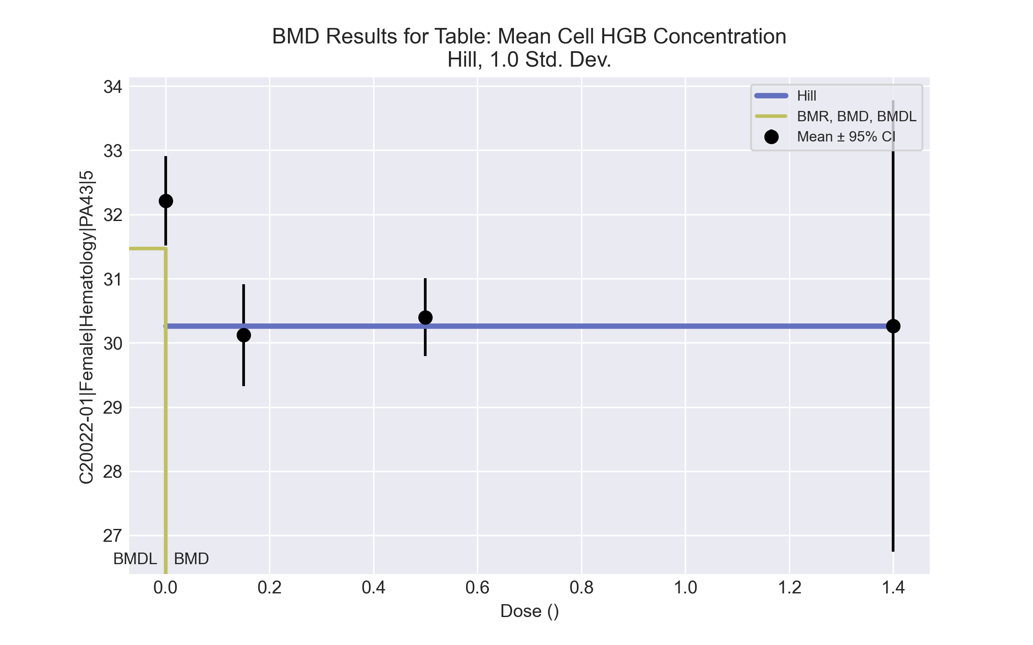

====================================================================   
 Hill Model. (Version: 2.18; Date: 03/14/2017)   
 Input Data File: C:\Windows\TEMP\bmds-0ldmehny.(d)   
 Gnuplot Plotting File: C:\Windows\TEMP\bmds-0ldmehny.plt  
 Tue Jul 27 09:32:00 2021  
 ====================================================================   
  
 BMDS_Model_Run   
~~~~~~~~~~~~~~~~~~~~~~~~~~~~~~~~~~~~~~~~~~~~~~~~~~~~~~~~~~~~~~~~~~~~~  
   
 The form of the response function is:   
  
 Y[dose] = intercept + v*dose^n/(k^n + dose^n)  
  
  
 Dependent variable = Response  
 Independent variable = Dose  
 rho is set to 0  
 Power parameter restricted to be greater than 1  
 A constant variance model is fit  
  
 Total number of dose groups = 4  
 Total number of records with missing values = 0  
 Maximum number of iterations = 500  
 Relative Function Convergence has been set to: 1e-008  
 Parameter Convergence has been set to: 1e-008  
  
  
  
 Default Initial Parameter Values   
 alpha = 0.671966  
 rho = 0 Specified  
 intercept = 32.2125  
 v = -2.0925  
 n = 0.933905  
 k = 0.075  
  
  
 Asymptotic Correlation Matrix of Parameter Estimates  
  
 ( *** The model parameter(s) -rho -k   
 have been estimated at a boundary point, or have been specified by the user,  
 and do not appear in the correlation matrix )  
  
 alpha intercept v n  
  
 alpha 1 4.5e-014 -2.1e-009 -2e-005  
  
 intercept 4.5e-014 1 -0.79 8.7e-006  
  
 v -2.1e-009 -0.79 1 8.9e-005  
  
 n -2e-005 8.7e-006 8.9e-005 1  
  
  
  
 Parameter Estimates  
  
 95.0% Wald Confidence Interval  
 Variable Estimate Std. Err. Lower Conf. Limit Upper Conf. Limit  
 alpha 0.553311 0.170755 0.218636 0.887985  
 intercept 32.2125 0.26299 31.697 32.728  
 v -1.95096 0.334255 -2.60609 -1.29583  
 n 1.20718 958.606 -1877.63 1880.04  
 k 1.4e-015 NA  
  
NA - Indicates that this parameter has hit a bound  
 implied by some inequality constraint and thus  
 has no standard error.  
  
  
  
 Table of Data and Estimated Values of Interest  
  
 Dose N Obs Mean Est Mean Obs Std Dev Est Std Dev Scaled Res.  
------ --- -------- -------- ----------- ----------- ----------  
  
 0 8 32.2 32.2 0.831 0.744 -1.38e-012  
 0.15 5 30.1 30.3 0.638 0.744 -0.425  
 0.5 5 30.4 30.3 0.49 0.744 0.416  
 1.4 3 30.3 30.3 1.42 0.744 0.0119  
  
  
  
 Model Descriptions for likelihoods calculated  
  
  
 Model A1: Yij = Mu(i) + e(ij)  
 Var{e(ij)} = Sigma^2  
  
 Model A2: Yij = Mu(i) + e(ij)  
 Var{e(ij)} = Sigma(i)^2  
  
 Model A3: Yij = Mu(i) + e(ij)  
 Var{e(ij)} = Sigma^2  
 Model A3 uses any fixed variance parameters that  
 were specified by the user  
  
 Model R: Yi = Mu + e(i)  
 Var{e(i)} = Sigma^2  
  
  
 Likelihoods of Interest  
  
 Model Log(likelihood) # Param's AIC  
 A1 -4.107006 5 18.214013  
 A2 -1.983748 8 19.967496  
 A3 -4.107006 5 18.214013  
 fitted -4.285727 4 16.571454  
 R -14.408149 2 32.816298  
  
  
 Explanation of Tests   
  
 Test 1: Do responses and/or variances differ among Dose levels?   
 (A2 vs. R)  
 Test 2: Are Variances Homogeneous? (A1 vs A2)  
 Test 3: Are variances adequately modeled? (A2 vs. A3)  
 Test 4: Does the Model for the Mean Fit? (A3 vs. fitted)  
 (Note: When rho=0 the results of Test 3 and Test 2 will be the same.)  
  
 Tests of Interest   
  
 Test -2*log(Likelihood Ratio) Test df p-value   
  
 Test 1 24.8488 6 0.0003642  
 Test 2 4.24652 3 0.236  
 Test 3 4.24652 3 0.236  
 Test 4 0.357442 1 0.5499  
  
The p-value for Test 1 is less than .05. There appears to be a  
difference between response and/or variances among the dose levels  
It seems appropriate to model the data  
  
The p-value for Test 2 is greater than .1. A homogeneous variance   
model appears to be appropriate here  
  
  
The p-value for Test 3 is greater than .1. The modeled variance appears   
 to be appropriate here  
  
The p-value for Test 4 is greater than .1. The model chosen seems   
to adequately describe the data  
   
  
 Benchmark Dose Computation  
  
Specified effect = 1  
  
Risk Type = Estimated standard deviations from the control mean   
  
Confidence level = 0.95  
  
 BMD = 9.37455e-016  
  
 BMDL = 9.37455e-016  
  
 BMDU = 9.37459e-016

# Female BMD Results for Table: Mean Cell Hemoglobin

BMDS version: BMDS v2.7.0

## Input dataset

|  |  |  |  |  |  |  |  |  |
| --- | --- | --- | --- | --- | --- | --- | --- | --- |
| Dose | 0 | 0.15 | 0.5 | 1.4 | 4a | 12a | 37a | 111a |
| N | 8 | 5 | 5 | 3 | 3 | 4 | 4 | 5 |
| Mean ± SD | 19.438 ± 0.641 | 18.18 ± 0.327 | 18.46 ± 0.483 | 18.167 ± 0.751 | 19.667 ± 0.252 | 18.525 ± 0.435 | 18.575 ± 1.135 | 19.66 ± 0.391 |

a Dose group removed in BMD modeling session

## Summary table

|  |  |  |  |  |  |
| --- | --- | --- | --- | --- | --- |
| Modela | Goodness of fit | | BMD | BMDL | Comments |
| *p*-value | AIC |
| Linear (equivalent models include Power, Polynomial 2°, 6°) | 0.002 | 10.723 | 0.916 | 0.524 | Hill recommended as best-fitting model on the basis of the lowest AIC. |
| Polynomial 3° (equivalent models include Polynomial 4°) | 0.002 | 10.723 | 0.916 | 0.524 |
| Polynomial 5° | 0.002 | 10.723 | 0.916 | 0.524 |
| Polynomial 7° | 0.002 | 10.723 | 0.916 | 0.524 |
| Hillb | 0.328 | 1.302 | 2.5E-10 | 2.5E-10 |
| Exponential M2 (equivalent models include Exponential M3) | 0.002 | 10.657 | 0.895 | 0.504 |
| Exponential M4 | 0.328 | 1.302 | 0.006 | 1.8E-05 |
| Exponential M5 | -999 | 3.302 | 0.063 | 1.7E-04 |

a Constant variance case presented (BMDS Test 2 p-value = 0.369, BMDS Test 3 p-value = 0.369).

b Recommended model

## Model recommendation details

|  |  |  |
| --- | --- | --- |
| Model | Bin | Notes |
| Linear (equivalent models include Power, Polynomial 2°, 6°) | Warning | **Warnings**  • Goodness of fit p-value is less than threshold (0.00205 < 0.1) |
| Polynomial 3° (equivalent models include Polynomial 4°) | Warning | **Warnings**  • Goodness of fit p-value is less than threshold (0.00205 < 0.1) |
| Polynomial 5° | Warning | **Warnings**  • Goodness of fit p-value is less than threshold (0.00205 < 0.1) |
| Polynomial 7° | Warning | **Warnings**  • Goodness of fit p-value is less than threshold (0.00205 < 0.1) |
| Hilla | Valid | **Cautions**  • Minimum dose/BMD ratio is greater than threshold (5.99e+08 > 3.0) |
| Exponential M2 (equivalent models include Exponential M3) | Warning | **Warnings**  • Goodness of fit p-value is less than threshold (0.00212 < 0.1) |
| Exponential M4 | Warning | **Warnings**  • BMD/BMDL ratio is greater than threshold (3.54e+02 > 20.0)  **Cautions**  • BMD/BMDL ratio is greater than threshold (3.54e+02 > 5.0)  • Minimum dose/BMD ratio is greater than threshold (23.9 > 3.0) |
| Exponential M5 | Warning | **Warnings**  • BMD/BMDL ratio is greater than threshold (3.61e+02 > 20.0)  • Zero degrees of freedom; saturated model  **Cautions**  • BMD/BMDL ratio is greater than threshold (3.61e+02 > 5.0) |

a Recommended model

## Recommended model

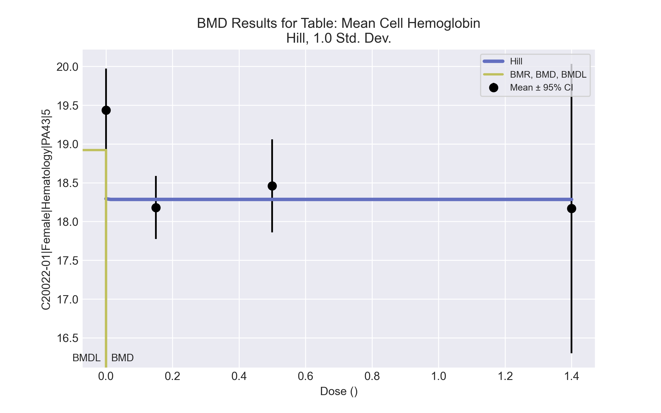

====================================================================   
 Hill Model. (Version: 2.18; Date: 03/14/2017)   
 Input Data File: C:\Windows\TEMP\bmds-el9zrmd1.(d)   
 Gnuplot Plotting File: C:\Windows\TEMP\bmds-el9zrmd1.plt  
 Tue Jul 27 09:32:33 2021  
 ====================================================================   
  
 BMDS_Model_Run   
~~~~~~~~~~~~~~~~~~~~~~~~~~~~~~~~~~~~~~~~~~~~~~~~~~~~~~~~~~~~~~~~~~~~~  
   
 The form of the response function is:   
  
 Y[dose] = intercept + v*dose^n/(k^n + dose^n)  
  
  
 Dependent variable = Response  
 Independent variable = Dose  
 rho is set to 0  
 Power parameter restricted to be greater than 1  
 A constant variance model is fit  
  
 Total number of dose groups = 4  
 Total number of records with missing values = 0  
 Maximum number of iterations = 500  
 Relative Function Convergence has been set to: 1e-008  
 Parameter Convergence has been set to: 1e-008  
  
  
  
 Default Initial Parameter Values   
 alpha = 0.315613  
 rho = 0 Specified  
 intercept = 19.4375  
 v = -1.27083  
 n = 3.6494  
 k = 0.0757952  
  
  
 Asymptotic Correlation Matrix of Parameter Estimates  
  
 ( *** The model parameter(s) -rho -k   
 have been estimated at a boundary point, or have been specified by the user,  
 and do not appear in the correlation matrix )  
  
 alpha intercept v n  
  
 alpha 1 -5.2e-008 4.1e-008 -3.3e-014  
  
 intercept -5.2e-008 1 -0.79 1.7e-014  
  
 v 4.1e-008 -0.79 1 7.3e-014  
  
 n -3.3e-014 1.7e-014 7.3e-014 1  
  
  
  
 Parameter Estimates  
  
 95.0% Wald Confidence Interval  
 Variable Estimate Std. Err. Lower Conf. Limit Upper Conf. Limit  
 alpha 0.267413 0.0825255 0.105666 0.42916  
 intercept 19.4375 0.18283 19.0792 19.7958  
 v -1.15288 0.232372 -1.60833 -0.697443  
 n 3.66183 5.61352e+011 -1.10023e+012 1.10023e+012  
 k 2.64777e-010 NA  
  
NA - Indicates that this parameter has hit a bound  
 implied by some inequality constraint and thus  
 has no standard error.  
  
  
  
 Table of Data and Estimated Values of Interest  
  
 Dose N Obs Mean Est Mean Obs Std Dev Est Std Dev Scaled Res.  
------ --- -------- -------- ----------- ----------- ----------  
  
 0 8 19.4 19.4 0.641 0.517 1.67e-007  
 0.15 5 18.2 18.3 0.327 0.517 -0.452  
 0.5 5 18.5 18.3 0.483 0.517 0.758  
 1.4 3 18.2 18.3 0.751 0.517 -0.395  
  
  
  
 Model Descriptions for likelihoods calculated  
  
  
 Model A1: Yij = Mu(i) + e(ij)  
 Var{e(ij)} = Sigma^2  
  
 Model A2: Yij = Mu(i) + e(ij)  
 Var{e(ij)} = Sigma(i)^2  
  
 Model A3: Yij = Mu(i) + e(ij)  
 Var{e(ij)} = Sigma^2  
 Model A3 uses any fixed variance parameters that  
 were specified by the user  
  
 Model R: Yi = Mu + e(i)  
 Var{e(i)} = Sigma^2  
  
  
 Likelihoods of Interest  
  
 Model Log(likelihood) # Param's AIC  
 A1 3.827752 5 2.344496  
 A2 5.402180 8 5.195641  
 A3 3.827752 5 2.344496  
 fitted 3.349085 4 1.301831  
 R -4.795954 2 13.591909  
  
  
 Explanation of Tests   
  
 Test 1: Do responses and/or variances differ among Dose levels?   
 (A2 vs. R)  
 Test 2: Are Variances Homogeneous? (A1 vs A2)  
 Test 3: Are variances adequately modeled? (A2 vs. A3)  
 Test 4: Does the Model for the Mean Fit? (A3 vs. fitted)  
 (Note: When rho=0 the results of Test 3 and Test 2 will be the same.)  
  
 Tests of Interest   
  
 Test -2*log(Likelihood Ratio) Test df p-value   
  
 Test 1 20.3963 6 0.002354  
 Test 2 3.14886 3 0.3692  
 Test 3 3.14886 3 0.3692  
 Test 4 0.957334 1 0.3279  
  
The p-value for Test 1 is less than .05. There appears to be a  
difference between response and/or variances among the dose levels  
It seems appropriate to model the data  
  
The p-value for Test 2 is greater than .1. A homogeneous variance   
model appears to be appropriate here  
  
  
The p-value for Test 3 is greater than .1. The modeled variance appears   
 to be appropriate here  
  
The p-value for Test 4 is greater than .1. The model chosen seems   
to adequately describe the data  
   
  
 Benchmark Dose Computation  
  
Specified effect = 1  
  
Risk Type = Estimated standard deviations from the control mean   
  
Confidence level = 0.95  
  
 BMD = 2.50255e-010  
  
 BMDL = 2.50255e-010  
  
 BMDU = 2.50256e-010

# Female BMD Results for Table: Platelet count

BMDS version: BMDS v2.7.0

## Input dataset

|  |  |  |  |  |  |  |  |  |
| --- | --- | --- | --- | --- | --- | --- | --- | --- |
| Dose | 0 | 0.15 | 0.5 | 1.4 | 4 | 12 | 37 | 111a |
| N | 8 | 5 | 5 | 3 | 3 | 4 | 4 | 5 |
| Mean ± SD | 802.375 ± 117.823 | 967.4 ± 170.045 | 933 ± 186.617 | 1037.667 ± 105.006 | 868.667 ± 134.005 | 958.25 ± 153.259 | 1072.5 ± 92.367 | 920.6 ± 58.863 |

a Dose group removed in BMD modeling session

## Summary table

|  |  |  |  |  |  |
| --- | --- | --- | --- | --- | --- |
| Modela | Goodness of fit | | BMD | BMDL | Comments |
| *p*-value | AIC |
| Linearb | 0.113 | 356.3 | 30.346 | 17.239 | Linear recommended as best-fitting model on the basis of the lowest AIC. |
| Polynomial 2° | 0.113 | 356.3 | 30.343 | 17.239 |
| Polynomial 3° | 0.113 | 356.3 | 30.34 | 17.239 |
| Polynomial 4° | 0.113 | 356.3 | 30.347 | 17.239 |
| Polynomial 5° | 0.113 | 356.3 | 30.344 | 17.239 |
| Polynomial 6° | 0.113 | 356.3 | 30.328 | 17.239 |
| Polynomial 7° | 0.113 | 356.3 | 30.344 | 17.239 |
| Power | 0.113 | 356.3 | 30.346 | 17.239 |
| Hill | 0.254 | 354.744 | 0.083 | 5.1E-07 |
| Exponential M2 (equivalent models include Exponential M3) | 0.113 | 356.311 | 30.841 | 18.558 |
| Exponential M4 (equivalent models include Exponential M5) | 0.064 | 358.285 | 28.998 | 0.163 |

a Constant variance case presented (BMDS Test 2 p-value = 0.716, BMDS Test 3 p-value = 0.716).

b Recommended model

## Model recommendation details

|  |  |  |
| --- | --- | --- |
| Model | Bin | Notes |
| Lineara | Valid | - |
| Polynomial 2° | Valid | - |
| Polynomial 3° | Valid | - |
| Polynomial 4° | Valid | - |
| Polynomial 5° | Valid | - |
| Polynomial 6° | Valid | - |
| Polynomial 7° | Valid | - |
| Power | Valid | - |
| Hill | Warning | **Warnings**  • BMD/BMDL ratio is greater than threshold (1.63e+05 > 20.0)  **Cautions**  • BMD/BMDL ratio is greater than threshold (1.63e+05 > 5.0) |
| Exponential M2 (equivalent models include Exponential M3) | Valid | - |
| Exponential M4 (equivalent models include Exponential M5) | Warning | **Warnings**  • Goodness of fit p-value is less than threshold (0.0642 < 0.1)  • BMD/BMDL ratio is greater than threshold (1.78e+02 > 20.0)  **Cautions**  • BMD/BMDL ratio is greater than threshold (1.78e+02 > 5.0) |

a Recommended model

## Recommended model

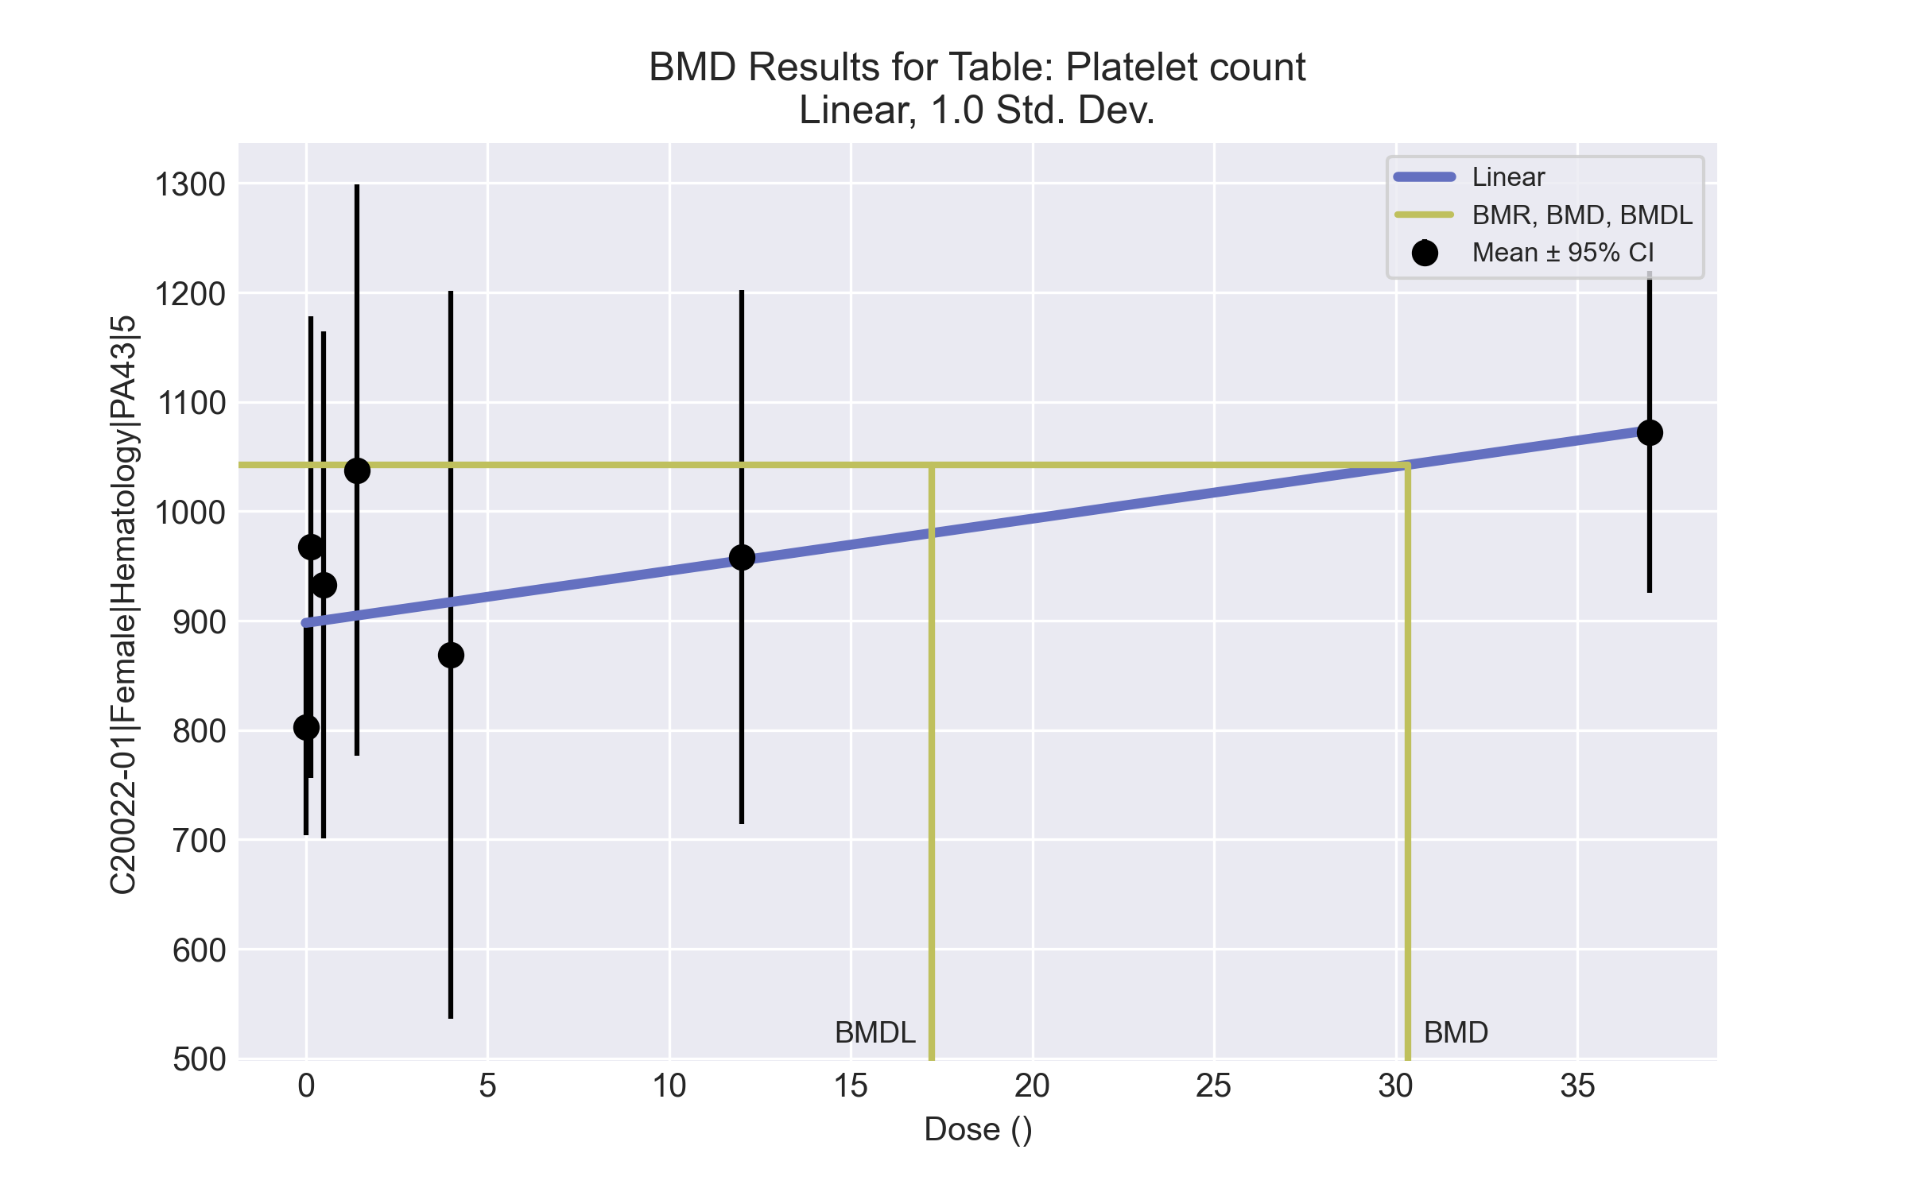

====================================================================   
 Polynomial Model. (Version: 2.21; Date: 03/14/2017)   
 Input Data File: C:\Windows\TEMP\bmds-95th462i.(d)   
 Gnuplot Plotting File: C:\Windows\TEMP\bmds-95th462i.plt  
 Tue Apr 13 16:29:16 2021  
 ====================================================================   
  
 BMDS_Model_Run   
~~~~~~~~~~~~~~~~~~~~~~~~~~~~~~~~~~~~~~~~~~~~~~~~~~~~~~~~~~~~~~~~~~~~~  
   
 The form of the response function is:   
  
 Y[dose] = beta_0 + beta_1*dose + beta_2*dose^2 + ...  
  
  
 Dependent variable = Response  
 Independent variable = Dose  
 rho is set to 0  
 The polynomial coefficients are restricted to be positive  
 A constant variance model is fit  
  
 Total number of dose groups = 7  
 Total number of records with missing values = 0  
 Maximum number of iterations = 500  
 Relative Function Convergence has been set to: 1e-008  
 Parameter Convergence has been set to: 1e-008  
  
  
  
 Default Initial Parameter Values   
 alpha = 1  
 rho = 0 Specified  
 beta_0 = 916.31  
 beta_1 = 0  
  
  
 Asymptotic Correlation Matrix of Parameter Estimates  
  
 ( *** The model parameter(s) -rho   
 have been estimated at a boundary point, or have been specified by the user,  
 and do not appear in the correlation matrix )  
  
 alpha beta_0 beta_1  
  
 alpha 1 -4.4e-005 1.4e-005  
  
 beta_0 -4.4e-005 1 -0.49  
  
 beta_1 1.4e-005 -0.49 1  
  
  
  
 Parameter Estimates  
  
 95.0% Wald Confidence Interval  
 Variable Estimate Std. Err. Lower Conf. Limit Upper Conf. Limit  
 alpha 20888.5 5222.63 10652.4 31124.7  
 beta_0 898.023 29.2593 840.676 955.37  
 beta_1 4.76266 2.11795 0.611549 8.91378  
  
  
  
 Table of Data and Estimated Values of Interest  
  
 Dose N Obs Mean Est Mean Obs Std Dev Est Std Dev Scaled Res.  
------ --- -------- -------- ----------- ----------- ----------  
  
 0 8 802 898 118 145 -1.87  
 0.15 5 967 899 170 145 1.06  
 0.5 5 933 900 187 145 0.504  
 1.4 3 1.04e+003 905 105 145 1.59  
 4 3 869 917 134 145 -0.58  
 12 4 958 955 153 145 0.0425  
 37 4 1.07e+003 1.07e+003 92.4 145 -0.0241  
  
  
  
 Model Descriptions for likelihoods calculated  
  
  
 Model A1: Yij = Mu(i) + e(ij)  
 Var{e(ij)} = Sigma^2  
  
 Model A2: Yij = Mu(i) + e(ij)  
 Var{e(ij)} = Sigma(i)^2  
  
 Model A3: Yij = Mu(i) + e(ij)  
 Var{e(ij)} = Sigma^2  
 Model A3 uses any fixed variance parameters that  
 were specified by the user  
  
 Model R: Yi = Mu + e(i)  
 Var{e(i)} = Sigma^2  
  
  
 Likelihoods of Interest  
  
 Model Log(likelihood) # Param's AIC  
 A1 -170.702213 8 357.404426  
 A2 -168.849402 14 365.698804  
 A3 -170.702213 8 357.404426  
 fitted -175.149759 3 356.299518  
 R -177.497268 2 358.994536  
  
  
 Explanation of Tests   
  
 Test 1: Do responses and/or variances differ among Dose levels?   
 (A2 vs. R)  
 Test 2: Are Variances Homogeneous? (A1 vs A2)  
 Test 3: Are variances adequately modeled? (A2 vs. A3)  
 Test 4: Does the Model for the Mean Fit? (A3 vs. fitted)  
 (Note: When rho=0 the results of Test 3 and Test 2 will be the same.)  
  
 Tests of Interest   
  
 Test -2*log(Likelihood Ratio) Test df p-value   
  
 Test 1 17.2957 12 0.1388  
 Test 2 3.70562 6 0.7164  
 Test 3 3.70562 6 0.7164  
 Test 4 8.89509 5 0.1133  
  
The p-value for Test 1 is greater than .05. There may not be a  
diffence between responses and/or variances among the dose levels  
Modelling the data with a dose/response curve may not be appropriate  
  
The p-value for Test 2 is greater than .1. A homogeneous variance   
model appears to be appropriate here  
  
  
The p-value for Test 3 is greater than .1. The modeled variance appears   
 to be appropriate here  
  
The p-value for Test 4 is greater than .1. The model chosen seems   
to adequately describe the data  
   
  
 Benchmark Dose Computation  
  
Specified effect = 1  
  
Risk Type = Estimated standard deviations from the control mean  
  
Confidence level = 0.95  
  
 BMD = 30.3462  
  
  
 BMDL = 17.2387  
  
  
 BMDU = 126.062

# Female BMD Results for Table: Thyroid Stimulating Hormone

BMDS version: BMDS v2.7.0

## Input dataset

|  |  |  |  |  |  |  |  |  |
| --- | --- | --- | --- | --- | --- | --- | --- | --- |
| Dose | 0 | 0.15 | 0.5 | 1.4a | 4a | 12a | 37a | 111a |
| N | 9 | 4 | 5 | 5 | 4 | 4 | 4 | 5 |
| Mean ± SD | 1.9 ± 0.492 | 1.675 ± 0.746 | 2.7 ± 1.022 | 1.7 ± 0.324 | 1.775 ± 0.892 | 1.65 ± 0.858 | 3.525 ± 1.619 | 5.98 ± 2.405 |

a Dose group removed in BMD modeling session

## Summary table

|  |  |  |  |  |  |
| --- | --- | --- | --- | --- | --- |
| Modela | Goodness of fit | | BMD | BMDL | Comments |
| *p*-value | AIC |
| Linear | 0.223 | 10.406 | 0.415 | 0.229 | Polynomial-7 recommended as best-fitting model on the basis of the lowest AIC. |
| Polynomial 2° | 0.445 | 9.502 | 0.438 | 0.332 |
| Polynomial 3° | 0.532 | 9.31 | 0.457 | 0.335 |
| Polynomial 4° | 0.559 | 9.26 | 0.467 | 0.257 |
| Polynomial 5° | 0.567 | 9.246 | 0.474 | 0.258 |
| Polynomial 6° | 0.57 | 9.242 | 0.478 | 0.258 |
| Polynomial 7°b | 0.571 | 9.24 | 0.481 | 0.258 |
| Power | -999 | 11.24 | 0.492 | 0.258 |
| Hill | -999 | 15.342 | -999 | -999 |
| Exponential M2 | 0.256 | 10.209 | 0.413 | 0.261 |
| Exponential M3 | -999 | 11.24 | 0.491 | -999 |
| Exponential M4 | -999 | 12.406 | 0.415 | 0.229 |
| Exponential M5 | -999 | 15.342 | -999 | 0 |

a Constant variance case presented (BMDS Test 2 p-value = 0.21, BMDS Test 3 p-value = 0.21).

b Recommended model

## Model recommendation details

|  |  |  |
| --- | --- | --- |
| Model | Bin | Notes |
| Linear | Valid | - |
| Polynomial 2° | Valid | - |
| Polynomial 3° | Valid | - |
| Polynomial 4° | Valid | - |
| Polynomial 5° | Valid | - |
| Polynomial 6° | Valid | - |
| Polynomial 7°a | Valid | - |
| Power | Warning | **Warnings**  • Zero degrees of freedom; saturated model |
| Hill | Failure | **Failures**  • BMD does not exist  • BMDL does not exist  **Warnings**  • Residual of Interest does not exist  • Zero degrees of freedom; saturated model  **Cautions**  • Warning(s): BMR value is not in the range of the mean function |
| Exponential M2 | Valid | - |
| Exponential M3 | Failure | **Failures**  • BMDL does not exist  **Warnings**  • Zero degrees of freedom; saturated model |
| Exponential M4 | Warning | **Warnings**  • Zero degrees of freedom; saturated model |
| Exponential M5 | Failure | **Failures**  • BMD does not exist  **Warnings**  • Residual of Interest does not exist  • Zero degrees of freedom; saturated model |

a Recommended model

## Recommended model

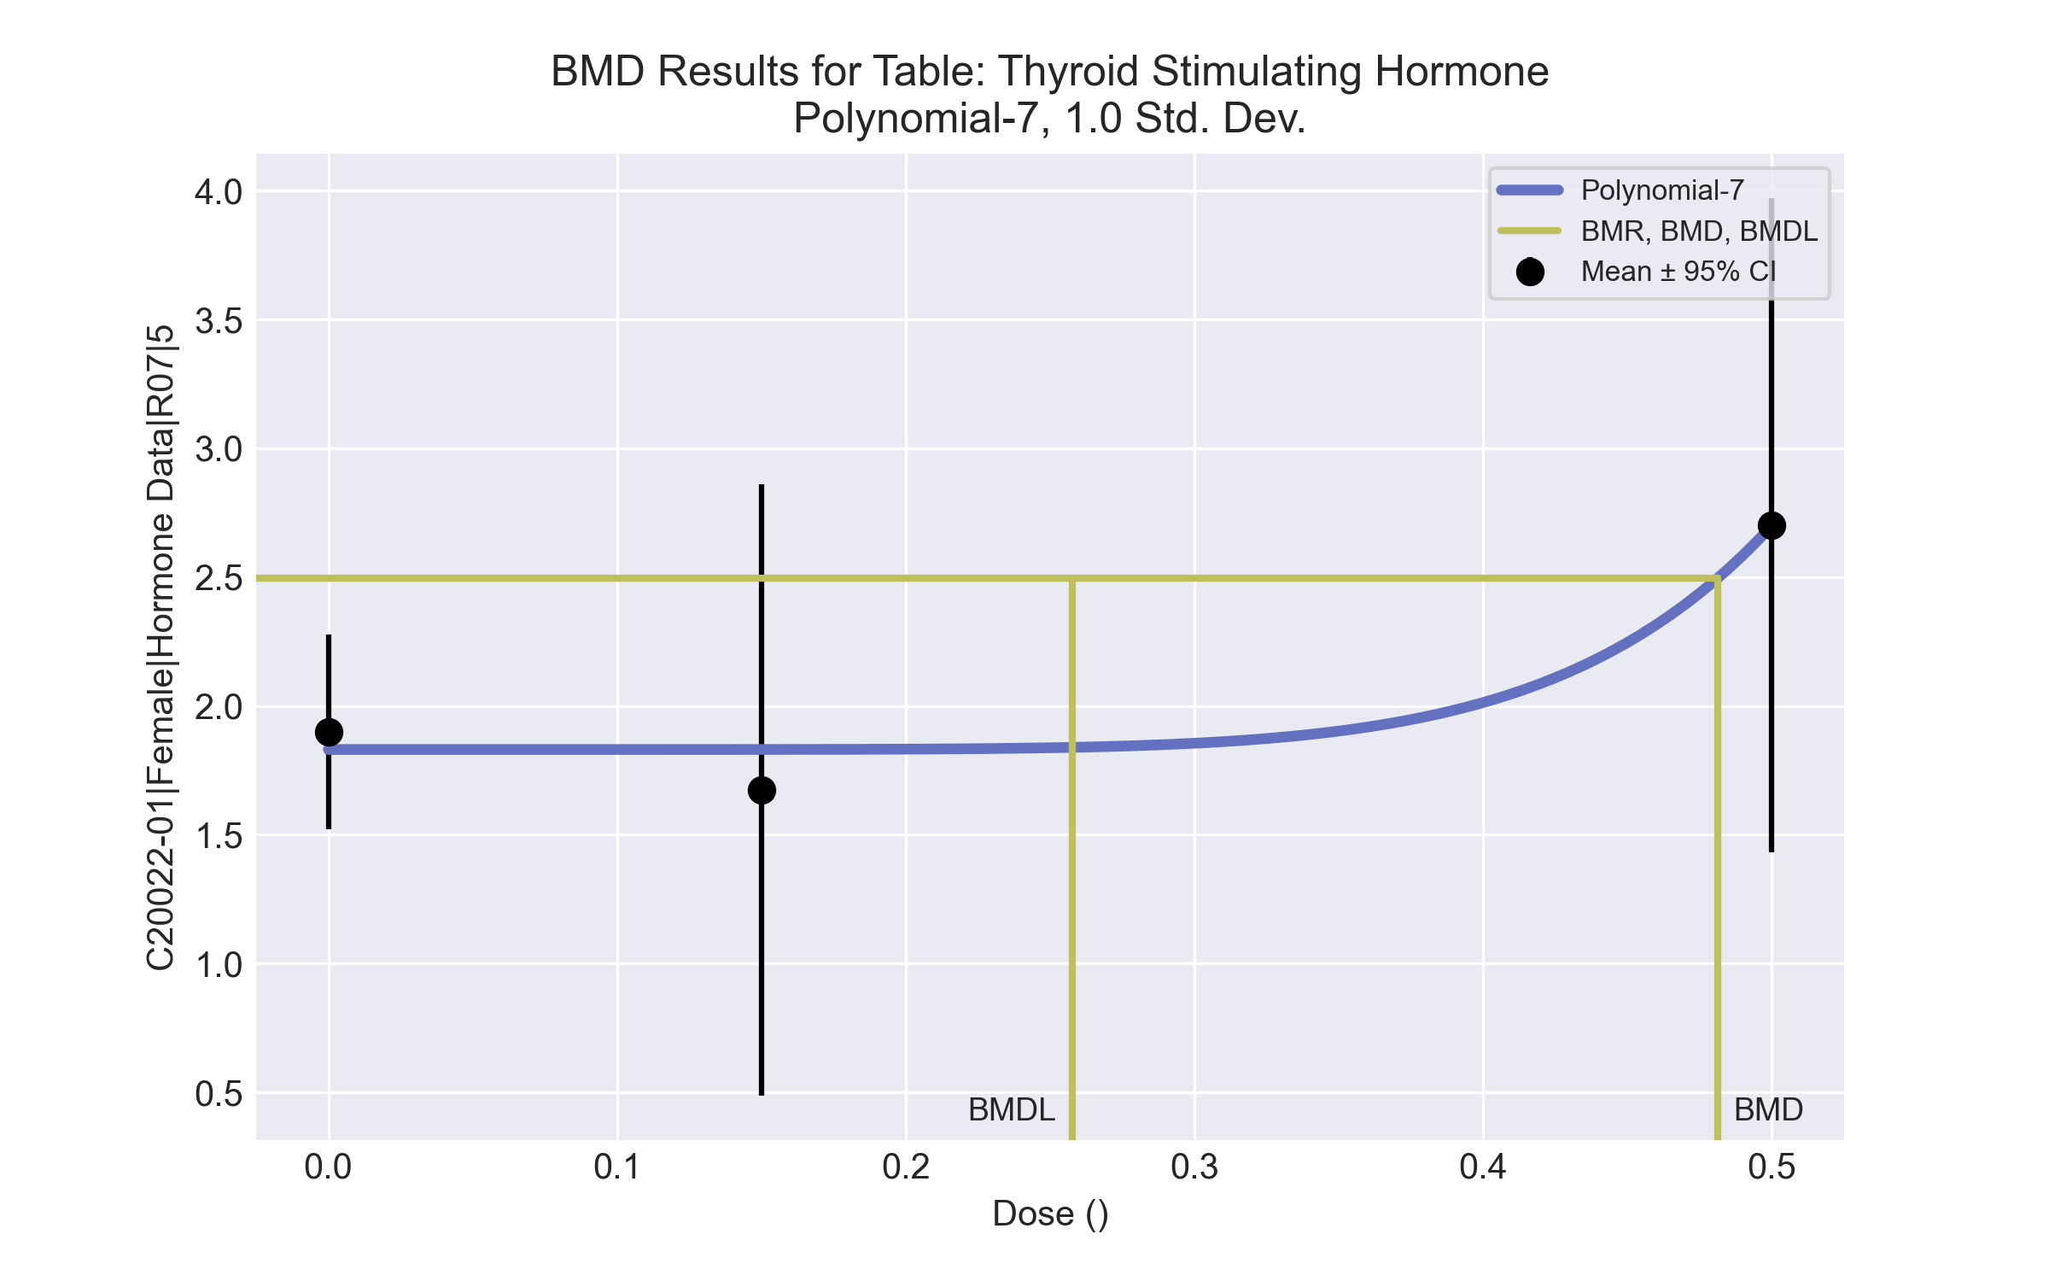

====================================================================   
 Polynomial Model. (Version: 2.21; Date: 03/14/2017)   
 Input Data File: C:\Windows\TEMP\bmds-wrku__4j.(d)   
 Gnuplot Plotting File: C:\Windows\TEMP\bmds-wrku__4j.plt  
 Tue Apr 13 17:21:50 2021  
 ====================================================================   
  
 BMDS_Model_Run   
~~~~~~~~~~~~~~~~~~~~~~~~~~~~~~~~~~~~~~~~~~~~~~~~~~~~~~~~~~~~~~~~~~~~~  
   
 The form of the response function is:   
  
 Y[dose] = beta_0 + beta_1*dose + beta_2*dose^2 + ...  
  
  
 Dependent variable = Response  
 Independent variable = Dose  
 rho is set to 0  
 The polynomial coefficients are restricted to be positive  
 A constant variance model is fit  
  
 Total number of dose groups = 3  
 Total number of records with missing values = 0  
 Maximum number of iterations = 500  
 Relative Function Convergence has been set to: 1e-008  
 Parameter Convergence has been set to: 1e-008  
  
  
  
 Default Initial Parameter Values   
 alpha = 0.519166  
 rho = 0 Specified  
 beta_0 = 76.5058  
 beta_1 = 0  
 beta_2 = 0  
 beta_3 = 0  
 beta_4 = 0  
 beta_5 = 0  
 beta_6 = 0  
 beta_7 = 0  
  
  
 Asymptotic Correlation Matrix of Parameter Estimates  
  
 ( *** The model parameter(s) -rho -beta_1 -beta_2 -beta_3 -beta_4 -beta_5 -beta_6   
 have been estimated at a boundary point, or have been specified by the user,  
 and do not appear in the correlation matrix )  
  
 alpha beta_0 beta_7  
  
 alpha 1 8.3e-008 3.1e-008  
  
 beta_0 8.3e-008 1 -0.53  
  
 beta_7 3.1e-008 -0.53 1  
  
  
  
 Parameter Estimates  
  
 95.0% Wald Confidence Interval  
 Variable Estimate Std. Err. Lower Conf. Limit Upper Conf. Limit  
 alpha 0.44044 0.146813 0.152691 0.728189  
 beta_0 1.83072 0.184078 1.46994 2.19151  
 beta_1 -0 NA  
 beta_2 -0 NA  
 beta_3 3.46127e-022 NA  
 beta_4 -0 NA  
 beta_5 1.13127e-020 NA  
 beta_6 -0 NA  
 beta_7 111.264 44.7056 23.6428 198.886  
  
NA - Indicates that this parameter has hit a bound  
 implied by some inequality constraint and thus  
 has no standard error.  
  
  
  
 Table of Data and Estimated Values of Interest  
  
 Dose N Obs Mean Est Mean Obs Std Dev Est Std Dev Scaled Res.  
------ --- -------- -------- ----------- ----------- ----------  
  
 0 9 1.9 1.83 0.492 0.664 0.313  
 0.15 4 1.68 1.83 0.746 0.664 -0.47  
 0.5 5 2.7 2.7 1.02 0.664 9.16e-005  
  
  
  
 Model Descriptions for likelihoods calculated  
  
  
 Model A1: Yij = Mu(i) + e(ij)  
 Var{e(ij)} = Sigma^2  
  
 Model A2: Yij = Mu(i) + e(ij)  
 Var{e(ij)} = Sigma(i)^2  
  
 Model A3: Yij = Mu(i) + e(ij)  
 Var{e(ij)} = Sigma^2  
 Model A3 uses any fixed variance parameters that  
 were specified by the user  
  
 Model R: Yi = Mu + e(i)  
 Var{e(i)} = Sigma^2  
  
  
 Likelihoods of Interest  
  
 Model Log(likelihood) # Param's AIC  
 A1 -1.459329 4 10.918657  
 A2 0.103171 6 11.793658  
 A3 -1.459329 4 10.918657  
 fitted -1.620177 3 9.240353  
 R -4.281853 2 12.563705  
  
  
 Explanation of Tests   
  
 Test 1: Do responses and/or variances differ among Dose levels?   
 (A2 vs. R)  
 Test 2: Are Variances Homogeneous? (A1 vs A2)  
 Test 3: Are variances adequately modeled? (A2 vs. A3)  
 Test 4: Does the Model for the Mean Fit? (A3 vs. fitted)  
 (Note: When rho=0 the results of Test 3 and Test 2 will be the same.)  
  
 Tests of Interest   
  
 Test -2*log(Likelihood Ratio) Test df p-value   
  
 Test 1 8.77005 4 0.06711  
 Test 2 3.125 2 0.2096  
 Test 3 3.125 2 0.2096  
 Test 4 0.321696 1 0.5706  
  
The p-value for Test 1 is greater than .05. There may not be a  
diffence between responses and/or variances among the dose levels  
Modelling the data with a dose/response curve may not be appropriate  
  
The p-value for Test 2 is greater than .1. A homogeneous variance   
model appears to be appropriate here  
  
  
The p-value for Test 3 is greater than .1. The modeled variance appears   
 to be appropriate here  
  
The p-value for Test 4 is greater than .1. The model chosen seems   
to adequately describe the data  
   
  
 Benchmark Dose Computation  
  
Specified effect = 1  
  
Risk Type = Estimated standard deviations from the control mean  
  
Confidence level = 0.95  
  
 BMD = 0.481091  
  
 BMDL = 0.257712  
  
 BMDU = 1.06217

# Female BMD Results for Table: Total Thyroxine

BMDS version: BMDS v2.7.0

## Input dataset

|  |  |  |  |  |  |  |  |  |
| --- | --- | --- | --- | --- | --- | --- | --- | --- |
| Dose | 0 | 0.15 | 0.5 | 1.4 | 4a | 12a | 37a | 111a |
| N | 9 | 4 | 5 | 5 | 4 | 4 | 4 | 5 |
| Mean ± SD | 2.763 ± 0.437 | 2.735 ± 0.612 | 3.414 ± 0.646 | 3.426 ± 0.54 | 2.615 ± 0.605 | 2.555 ± 0.412 | 1.835 ± 0.46 | 1.062 ± 0.259 |

a Dose group removed in BMD modeling session

## Summary table

|  |  |  |  |  |  |
| --- | --- | --- | --- | --- | --- |
| Modela | Goodness of fit | | BMD | BMDL | Comments |
| *p*-value | AIC |
| Linear (equivalent models include Power, Polynomial 2°, 3°, 4°, 5°, 6°, 7°) | 0.223 | -0.95 | 1.024 | 0.604 | Exponential-M4 recommended as best-fitting model on the basis of the lowest BMDL. |
| Hill | -999 | 0.054 | 0.423 | -999 |
| Exponential M2 (equivalent models include Exponential M3) | 0.202 | -0.761 | 1.088 | 0.68 |
| Exponential M4b | 0.244 | -0.599 | 0.417 | 0.117 |
| Exponential M5 | -999 | 0.054 | 0.463 | 0.151 |

a Constant variance case presented (BMDS Test 2 p-value = 0.839, BMDS Test 3 p-value = 0.839).

b Recommended model

## Model recommendation details

|  |  |  |
| --- | --- | --- |
| Model | Bin | Notes |
| Linear (equivalent models include Power, Polynomial 2°, 3°, 4°, 5°, 6°, 7°) | Valid | - |
| Hill | Failure | **Failures**  • BMDL does not exist  **Warnings**  • Zero degrees of freedom; saturated model  **Cautions**  • Warning(s): BMDL computation failed. |
| Exponential M2 (equivalent models include Exponential M3) | Valid | - |
| Exponential M4a | Valid | - |
| Exponential M5 | Warning | **Warnings**  • Zero degrees of freedom; saturated model |

a Recommended model

## Recommended model

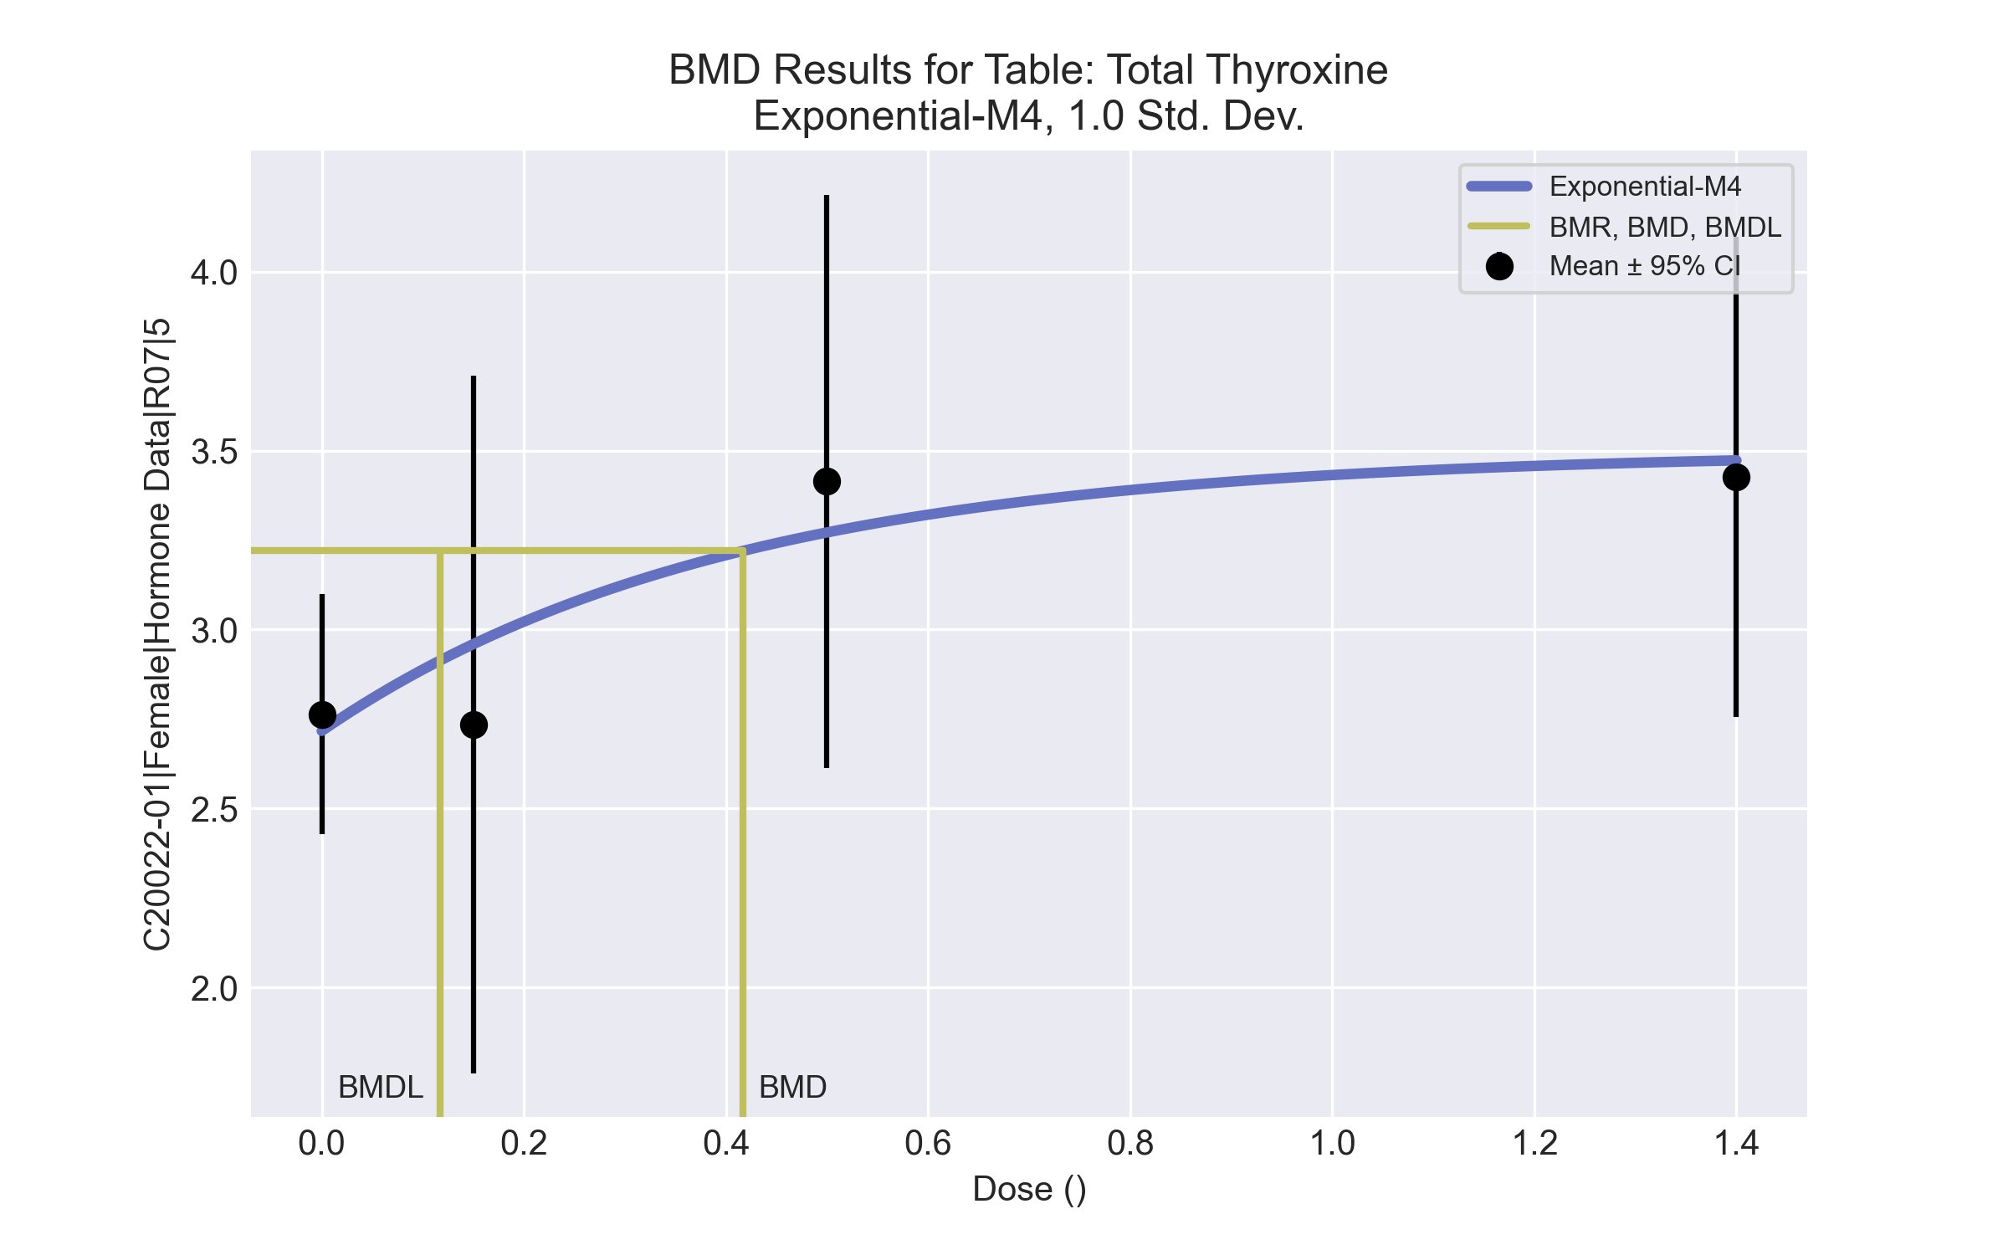

====================================================================   
 Exponential Model. (Version: 1.11; Date: 03/14/2017)   
 Input Data File: C:\Windows\TEMP\bmds-2zw7v73c.(d)   
 Gnuplot Plotting File:   
 Tue Apr 13 17:22:08 2021  
 ====================================================================   
  
 BMDS_Model_Run   
~~~~~~~~~~~~~~~~~~~~~~~~~~~~~~~~~~~~~~~~~~~~~~~~~~~~~~~~~~~~~~~~~~~~~  
   
 The form of the response function by Model:   
 Model 2: Y[dose] = a * exp{sign * b * dose}  
 Model 3: Y[dose] = a * exp{sign * (b * dose)^d}  
 Model 4: Y[dose] = a * [c-(c-1) * exp{-b * dose}]  
 Model 5: Y[dose] = a * [c-(c-1) * exp{-(b * dose)^d}]  
  
 Note: Y[dose] is the median response for exposure = dose;  
 sign = +1 for increasing trend in data;  
 sign = -1 for decreasing trend.  
  
 Model 2 is nested within Models 3 and 4.  
 Model 3 is nested within Model 5.  
 Model 4 is nested within Model 5.  
  
  
 Dependent variable = Response  
 Independent variable = Dose  
 Data are assumed to be distributed: normally  
 Variance Model: exp(lnalpha +rho *ln(Y[dose]))  
 rho is set to 0.  
 A constant variance model is fit.  
  
 Total number of dose groups = 4  
 Total number of records with missing values = 0  
 Maximum number of iterations = 500  
 Relative Function Convergence has been set to: 1e-008  
 Parameter Convergence has been set to: 1e-008  
  
 MLE solution provided: Exact  
  
  
 Initial Parameter Values  
  
 Variable Model 4  
 -------- --------  
 lnalpha -1.43283   
 rho 0 Specified  
 a 2.59825   
 b 1.49548   
 c 1.38451   
 d 1 Specified  
  
  
  
 Parameter Estimates  
  
 Variable Model 4 Std. Err.  
 -------- ------- ---------  
 lnalpha -1.37387 0.0746427  
 a 2.71669 0.15941  
 b 2.48275 2.22342  
 c 1.28725 0.119793  
  
 NC = No Convergence  
  
  
 Table of Stats From Input Data  
  
 Dose N Obs Mean Obs Std Dev  
 ----- --- ---------- -------------  
 0 9 2.763 0.4368  
 0.15 4 2.735 0.6125  
 0.5 5 3.414 0.6459  
 1.4 5 3.426 0.5404  
  
  
 Estimated Values of Interest  
  
 Dose Est Mean Est Std Scaled Residual  
 ------ ---------- --------- ----------------  
 0 2.717 0.5031 0.2781  
 0.15 2.959 0.5031 -0.8918  
 0.5 3.272 0.5031 0.6331  
 1.4 3.473 0.5031 -0.2086  
  
  
  
 Other models for which likelihoods are calculated:  
  
 Model A1: Yij = Mu(i) + e(ij)  
 Var{e(ij)} = Sigma^2  
  
 Model A2: Yij = Mu(i) + e(ij)  
 Var{e(ij)} = Sigma(i)^2  
  
 Model A3: Yij = Mu(i) + e(ij)  
 Var{e(ij)} = exp(lalpha + log(mean(i)) * rho)  
  
 Model R: Yij = Mu + e(i)  
 Var{e(ij)} = Sigma^2  
  
  
 Likelihoods of Interest  
  
 Model Log(likelihood) DF AIC  
 ------- ----------------- ---- ------------  
 A1 4.977572 5 0.0448556  
 A2 5.399748 8 5.200505  
 A3 4.977572 5 0.0448556  
 R 0.6538855 2 2.692229  
 4 4.299495 4 -0.598991  
  
  
 Additive constant for all log-likelihoods = -21.14. This constant added to the  
 above values gives the log-likelihood including the term that does not  
 depend on the model parameters.  
  
  
 Explanation of Tests  
  
 Test 1: Does response and/or variances differ among Dose levels? (A2 vs. R)  
 Test 2: Are Variances Homogeneous? (A2 vs. A1)  
 Test 3: Are variances adequately modeled? (A2 vs. A3)  
  
 Test 6a: Does Model 4 fit the data? (A3 vs 4)  
  
  
 Tests of Interest  
  
 Test -2*log(Likelihood Ratio) D. F. p-value  
 -------- ------------------------ ------ --------------  
 Test 1 9.492 6 0.1478  
 Test 2 0.8444 3 0.8388  
 Test 3 0.8444 3 0.8388  
 Test 6a 1.356 1 0.2442  
  
  
 The p-value for Test 1 is greater than .05. There may not be a  
 diffence between responses and/or variances among the dose levels  
 Modelling the data with a dose/response curve may not be appropriate.  
  
 The p-value for Test 2 is greater than .1. A homogeneous  
 variance model appears to be appropriate here.  
  
 The p-value for Test 3 is greater than .1. The modeled  
 variance appears to be appropriate here.  
  
 The p-value for Test 6a is greater than .1. Model 4 seems  
 to adequately describe the data.  
  
  
 Benchmark Dose Computations:  
  
 Specified Effect = 1.000000  
  
 Risk Type = Estimated standard deviations from control  
  
 Confidence Level = 0.950000  
  
 BMD = 0.4168  
  
 BMDL = 0.117178  
  
 BMDU = 14000

# Female BMD Results for Table: Triiodothyronine

BMDS version: BMDS v2.7.0

## Input dataset

|  |  |  |  |  |  |  |  |  |
| --- | --- | --- | --- | --- | --- | --- | --- | --- |
| Dose | 0 | 0.15 | 0.5 | 1.4 | 4 | 12 | 37 | 111 |
| N | 9 | 4 | 5 | 5 | 4 | 4 | 4 | 5 |
| Mean ± SD | 53.378 ± 4.313 | 56.95 ± 1.124 | 61.36 ± 5.149 | 66.58 ± 6.567 | 59.425 ± 14.795 | 57.05 ± 8.24 | 53.875 ± 4.164 | 38.58 ± 7.921 |

## Summary table

|  |  |  |  |  |  |
| --- | --- | --- | --- | --- | --- |
| Modela | Goodness of fit | | BMD | BMDL | Comments |
| *p*-value | AIC |
| Linear | <0.0001 | 229.623 | -9999 | 29.807 | No model was recommended as a best-fitting model. Doses were dropped until there were only 3 remaining dose-groups. |
| Polynomial 2° | <0.0001 | 229.623 | -9999 | -999 |
| Polynomial 3° | <0.0001 | 229.623 | -9999 | 33.444 |
| Polynomial 4° | <0.0001 | 229.623 | -9999 | 29.797 |
| Polynomial 5° | <0.0001 | 229.623 | -9999 | 161.425 |
| Polynomial 6° | <0.0001 | 229.623 | -9999 | -999 |
| Polynomial 7° | <0.0001 | 229.623 | -9999 | -999 |
| Power | 0.022 | 210.495 | 53.927 | 31.878 |
| Hill | 0.011 | 212.421 | 47.669 | 24.312 |
| Exponential M2 | 1.5E-04 | 222.227 | -22.977 | -999 |
| Exponential M3 | 1.5E-04 | 222.227 | -22.977 | -999 |
| Exponential M4 | <0.0001 | 233.623 | -999 | 0 |
| Exponential M5 | <0.0001 | 235.623 | -999 | 0 |

a Modeled variance case presented (BMDS Test 2 p-value = 0.001, BMDS Test 3 p-value = 6.7E-04).

## Model recommendation details

|  |  |  |
| --- | --- | --- |
| Model | Bin | Notes |
| Linear | Warning | **Warnings**  • Residual of Interest does not exist  • Variance model poorly fits dataset (p-value 3 = 0.0006711)  • Ratio of modeled to actual stdev. at control is greater than threshold (2.3 > 1.5)  **Cautions**  • Warning(s): BMD = 100*(maximum dose) |
| Polynomial 2° | Failure | **Failures**  • BMDL does not exist  **Warnings**  • Residual of Interest does not exist  • Variance model poorly fits dataset (p-value 3 = 0.0006711)  • Ratio of modeled to actual stdev. at control is greater than threshold (2.3 > 1.5)  **Cautions**  • Warning(s): BMD = 100*(maximum dose); BMDL computation failed. |
| Polynomial 3° | Warning | **Warnings**  • Residual of Interest does not exist  • Variance model poorly fits dataset (p-value 3 = 0.0006711)  • Ratio of modeled to actual stdev. at control is greater than threshold (2.3 > 1.5)  **Cautions**  • Warning(s): THIS USUALLY MEANS THE MODEL HAS NOT CONVERGED!; BMD = 100*(maximum dose) |
| Polynomial 4° | Warning | **Warnings**  • Residual of Interest does not exist  • Variance model poorly fits dataset (p-value 3 = 0.0006711)  • Ratio of modeled to actual stdev. at control is greater than threshold (2.3 > 1.5)  **Cautions**  • Warning(s): THIS USUALLY MEANS THE MODEL HAS NOT CONVERGED!; BMD = 100*(maximum dose) |
| Polynomial 5° | Warning | **Warnings**  • Residual of Interest does not exist  • Variance model poorly fits dataset (p-value 3 = 0.0006711)  • Ratio of modeled to actual stdev. at control is greater than threshold (2.3 > 1.5)  **Cautions**  • Warning(s): THIS USUALLY MEANS THE MODEL HAS NOT CONVERGED!; BMD = 100*(maximum dose)  • BMDL/high dose ratio is greater than threshold (1.45 > 1.0) |
| Polynomial 6° | Failure | **Failures**  • BMDL does not exist  **Warnings**  • Residual of Interest does not exist  • Variance model poorly fits dataset (p-value 3 = 0.0006711)  • Ratio of modeled to actual stdev. at control is greater than threshold (2.3 > 1.5)  **Cautions**  • Warning(s): THIS USUALLY MEANS THE MODEL HAS NOT CONVERGED!; BMD = 100*(maximum dose); BMDL computation failed. |
| Polynomial 7° | Failure | **Failures**  • BMDL does not exist  **Warnings**  • Residual of Interest does not exist  • Variance model poorly fits dataset (p-value 3 = 0.0006711)  • Ratio of modeled to actual stdev. at control is greater than threshold (2.3 > 1.5)  **Cautions**  • Warning(s): BMD = 100*(maximum dose); BMDL computation failed. |
| Power | Warning | **Warnings**  • Variance model poorly fits dataset (p-value 3 = 0.0006711)  • Goodness of fit p-value is less than threshold (0.0223 < 0.1)  • Residual at lowest dose is greater than threshold (2.09 > 2.0)  • Ratio of modeled to actual stdev. at control is greater than threshold (1.75 > 1.5) |
| Hill | Warning | **Warnings**  • Variance model poorly fits dataset (p-value 3 = 0.0006711)  • Goodness of fit p-value is less than threshold (0.0111 < 0.1)  • Residual at lowest dose is greater than threshold (2.09 > 2.0)  • Ratio of modeled to actual stdev. at control is greater than threshold (1.76 > 1.5) |
| Exponential M2 | Failure | **Failures**  • BMDL does not exist  **Warnings**  • Residual of Interest does not exist  • Variance model poorly fits dataset (p-value 3 = 0.0006711)  • Goodness of fit p-value is less than threshold (0.000155 < 0.1) |
| Exponential M3 | Failure | **Failures**  • BMDL does not exist  **Warnings**  • Residual of Interest does not exist  • Variance model poorly fits dataset (p-value 3 = 0.0006711)  • Goodness of fit p-value is less than threshold (0.000155 < 0.1) |
| Exponential M4 | Failure | **Failures**  • BMD does not exist  **Warnings**  • Residual of Interest does not exist  • Variance model poorly fits dataset (p-value 3 = 0.0006711) |
| Exponential M5 | Failure | **Failures**  • BMD does not exist  **Warnings**  • Residual of Interest does not exist  • Variance model poorly fits dataset (p-value 3 = 0.0006711) |

## Recommended model

*No model was recommended as a best-fitting model.*