# Male BMD Results for Table: Body Weight Gain

BMDS version: BMDS v2.7.0

## Input dataset

|  |  |  |  |  |  |  |  |  |
| --- | --- | --- | --- | --- | --- | --- | --- | --- |
| Dose | 0 | 0.15 | 0.5 | 1.4 | 4 | 12 | 37a | 111a |
| N | 10 | 5 | 5 | 5 | 5 | 5 | 5 | 5 |
| Mean ± SD | 14.46 ± 4.897 | 16.64 ± 2.554 | 19.6 ± 3.618 | 16.48 ± 4.106 | 15.58 ± 3.918 | 21.82 ± 5.148 | 15.34 ± 3.142 | 10.1 ± 6.405 |

a Dose group removed in BMD modeling session

## Summary table

|  |  |  |  |  |  |
| --- | --- | --- | --- | --- | --- |
| Modela | Goodness of fit | | BMD | BMDL | Comments |
| *p*-value | AIC |
| Linear | 0.168 | 142.508 | 9.382 | 5.612 | Power recommended as best-fitting model on the basis of the lowest AIC. |
| Polynomial 2° | 0.21 | 141.91 | 10.428 | 5.891 |
| Polynomial 3° | 0.226 | 141.712 | 10.904 | 5.998 |
| Polynomial 4° | 0.231 | 141.656 | 11.166 | 8.218 |
| Polynomial 5° | 0.233 | 141.639 | 11.328 | 6.04 |
| Polynomial 6° | 0.233 | 141.634 | 11.437 | 6.043 |
| Polynomial 7° | 0.233 | 141.632 | 11.516 | 8.226 |
| Powerb | 0.233 | 141.631 | 11.809 | 6.045 |
| Hill | 0.062 | 145.631 | 11.683 | 4.857 |
| Exponential M2 | 0.176 | 142.376 | 9.492 | 6.196 |
| Exponential M3 | 0.134 | 143.631 | 11.805 | -999 |
| Exponential M4 | 0.092 | 144.51 | 9.381 | 3.919 |
| Exponential M5 | 0.062 | 145.631 | 11.701 | 4.949 |

a Constant variance case presented (BMDS Test 2 p-value = 0.621, BMDS Test 3 p-value = 0.621).

b Recommended model

## Model recommendation details

|  |  |  |
| --- | --- | --- |
| Model | Bin | Notes |
| Linear | Valid | - |
| Polynomial 2° | Valid | - |
| Polynomial 3° | Valid | - |
| Polynomial 4° | Valid | - |
| Polynomial 5° | Valid | - |
| Polynomial 6° | Valid | - |
| Polynomial 7° | Valid | - |
| Powera | Valid | - |
| Hill | Warning | **Warnings**  • Goodness of fit p-value is less than threshold (0.0616 < 0.1)  **Cautions**  • Warning(s): THE MODEL HAS PROBABLY NOT CONVERGED!!!; THIS USUALLY MEANS THE MODEL HAS NOT CONVERGED! |
| Exponential M2 | Valid | - |
| Exponential M3 | Failure | **Failures**  • BMDL does not exist |
| Exponential M4 | Warning | **Warnings**  • Goodness of fit p-value is less than threshold (0.0915 < 0.1) |
| Exponential M5 | Warning | **Warnings**  • Goodness of fit p-value is less than threshold (0.0616 < 0.1) |

a Recommended model

## Recommended model

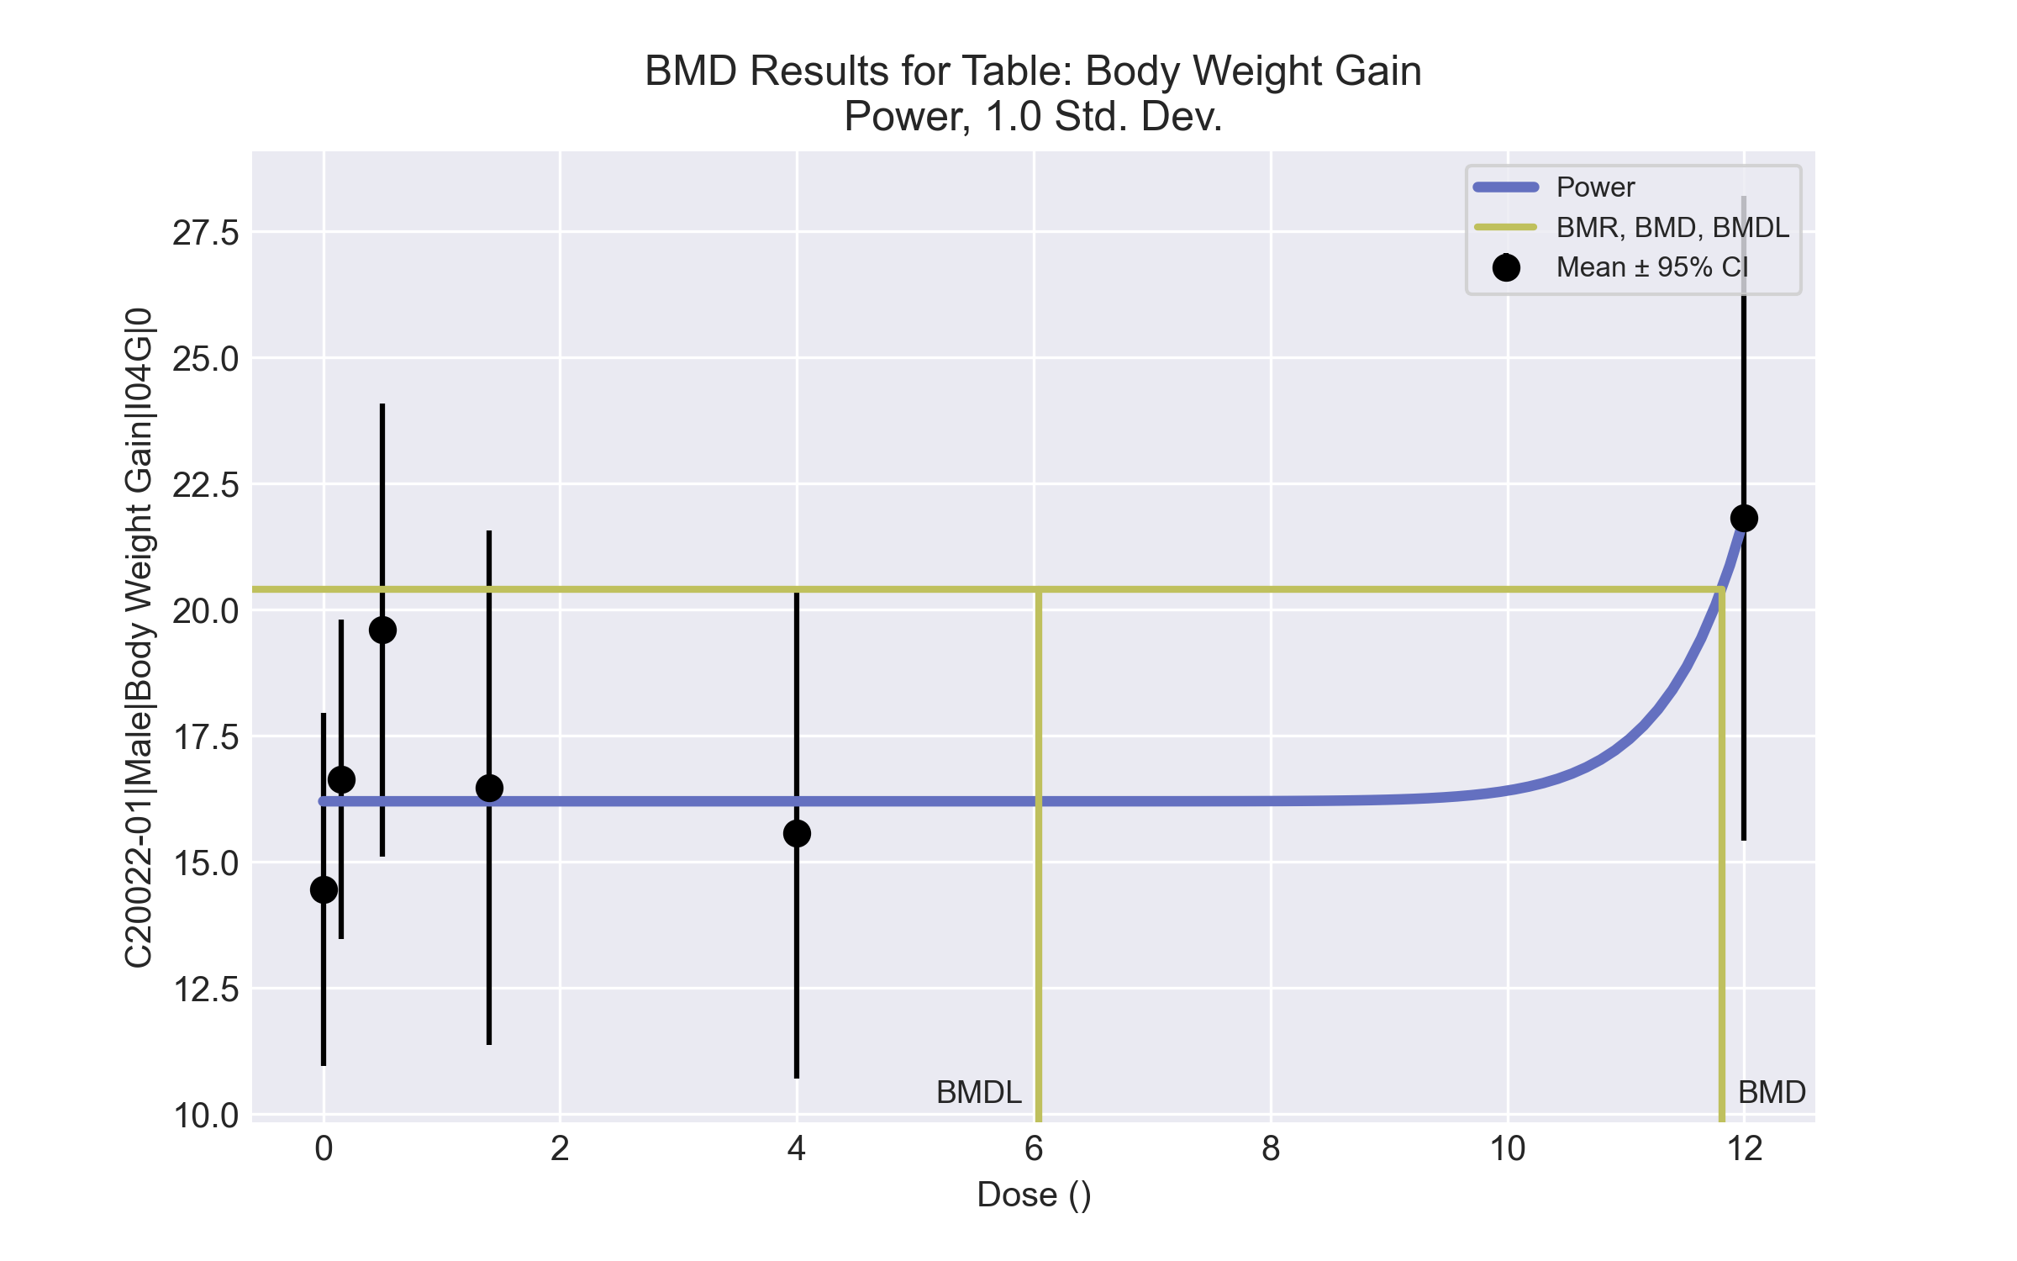

====================================================================   
 Power Model. (Version: 2.19; Date: 03/14/2017)   
 Input Data File: C:\Windows\TEMP\bmds-m8q7ewju.(d)   
 Gnuplot Plotting File: C:\Windows\TEMP\bmds-m8q7ewju.plt  
 Tue Apr 13 14:50:04 2021  
 ====================================================================   
  
 BMDS_Model_Run   
~~~~~~~~~~~~~~~~~~~~~~~~~~~~~~~~~~~~~~~~~~~~~~~~~~~~~~~~~~~~~~~~~~~~~  
   
 The form of the response function is:   
  
 Y[dose] = control + slope * dose^power  
  
  
 Dependent variable = Response  
 Independent variable = Dose  
 rho is set to 0  
 The power is restricted to be greater than or equal to 1  
 A constant variance model is fit  
  
 Total number of dose groups = 6  
 Total number of records with missing values = 0  
 Maximum number of iterations = 500  
 Relative Function Convergence has been set to: 1e-008  
 Parameter Convergence has been set to: 1e-008  
  
  
  
 Default Initial Parameter Values   
 alpha = 18.2462  
 rho = 0 Specified  
 control = 14.46  
 slope = 2.7647  
 power = -9999  
  
  
 Asymptotic Correlation Matrix of Parameter Estimates  
  
 ( *** The model parameter(s) -rho -power   
 have been estimated at a boundary point, or have been specified by the user,  
 and do not appear in the correlation matrix )  
  
 alpha control slope  
  
 alpha 1 7.3e-008 -2e-008  
  
 control -2e-009 1 -0.38  
  
 slope -1.2e-010 -0.38 1  
  
  
  
 Parameter Estimates  
  
 95.0% Wald Confidence Interval  
 Variable Estimate Std. Err. Lower Conf. Limit Upper Conf. Limit  
 alpha 17.7285 4.23792 9.42233 26.0347  
 control 16.2033 0.768733 14.6966 17.71  
 slope 2.10968e-019 7.63945e-020 6.12374e-020 3.60698e-019  
 power 18 NA  
  
NA - Indicates that this parameter has hit a bound  
 implied by some inequality constraint and thus  
 has no standard error.  
  
  
  
 Table of Data and Estimated Values of Interest  
  
 Dose N Obs Mean Est Mean Obs Std Dev Est Std Dev Scaled Res.  
------ --- -------- -------- ----------- ----------- ----------  
  
 0 10 14.5 16.2 4.9 4.21 -1.31  
 0.15 5 16.6 16.2 2.55 4.21 0.232  
 0.5 5 19.6 16.2 3.62 4.21 1.8  
 1.4 5 16.5 16.2 4.11 4.21 0.147  
 4 5 15.6 16.2 3.92 4.21 -0.331  
 12 5 21.8 21.8 5.15 4.21 4.8e-009  
  
  
  
 Model Descriptions for likelihoods calculated  
  
  
 Model A1: Yij = Mu(i) + e(ij)  
 Var{e(ij)} = Sigma^2  
  
 Model A2: Yij = Mu(i) + e(ij)  
 Var{e(ij)} = Sigma(i)^2  
  
 Model A3: Yij = Mu(i) + e(ij)  
 Var{e(ij)} = Sigma^2  
 Model A3 uses any fixed variance parameters that  
 were specified by the user  
  
 Model R: Yi = Mu + e(i)  
 Var{e(i)} = Sigma^2  
  
  
 Likelihoods of Interest  
  
 Model Log(likelihood) # Param's AIC  
 A1 -65.028337 7 144.056675  
 A2 -63.271883 12 150.543767  
 A3 -65.028337 7 144.056675  
 fitted -67.815541 3 141.631082  
 R -71.265161 2 146.530322  
  
  
 Explanation of Tests   
  
 Test 1: Do responses and/or variances differ among Dose levels?   
 (A2 vs. R)  
 Test 2: Are Variances Homogeneous? (A1 vs A2)  
 Test 3: Are variances adequately modeled? (A2 vs. A3)  
 Test 4: Does the Model for the Mean Fit? (A3 vs. fitted)  
 (Note: When rho=0 the results of Test 3 and Test 2 will be the same.)  
  
 Tests of Interest   
  
 Test -2*log(Likelihood Ratio) Test df p-value   
  
 Test 1 15.9866 10 0.1  
 Test 2 3.51291 5 0.6214  
 Test 3 3.51291 5 0.6214  
 Test 4 5.57441 4 0.2333  
  
The p-value for Test 1 is greater than .05. There may not be a  
diffence between responses and/or variances among the dose levels  
Modelling the data with a dose/response curve may not be appropriate  
  
The p-value for Test 2 is greater than .1. A homogeneous variance   
model appears to be appropriate here  
  
  
The p-value for Test 3 is greater than .1. The modeled variance appears   
 to be appropriate here  
  
The p-value for Test 4 is greater than .1. The model chosen seems   
to adequately describe the data  
   
  
 Benchmark Dose Computation  
  
Specified effect = 1  
  
Risk Type = Estimated standard deviations from the control mean   
  
Confidence level = 0.95  
  
 BMD = 11.8094   
  
  
 BMDL = 6.04458   
  
  
 BMDU = 20.9122

# Male BMD Results for Table: Kidney-Right Absolute

BMDS version: BMDS v2.7.0

## Input dataset

|  |  |  |  |  |  |  |  |  |
| --- | --- | --- | --- | --- | --- | --- | --- | --- |
| Dose | 0 | 0.15 | 0.5 | 1.4 | 4 | 12 | 37 | 111 |
| N | 10 | 5 | 5 | 5 | 5 | 5 | 5 | 5 |
| Mean ± SD | 0.947 ± 0.059 | 1.02 ± 0.056 | 0.98 ± 0.064 | 1.068 ± 0.059 | 0.974 ± 0.09 | 1.014 ± 0.081 | 0.938 ± 0.048 | 0.98 ± 0.042 |

## Summary table

|  |  |  |  |  |  |
| --- | --- | --- | --- | --- | --- |
| Modela | Goodness of fit | | BMD | BMDL | Comments |
| *p*-value | AIC |
| Linear | 0.014 | -190.534 | -9999 | 200.833 | No model was recommended as a best-fitting model. Doses were dropped until there were only 3 remaining dose-groups. |
| Polynomial 2° | 0.014 | -190.534 | -9999 | 139.029 |
| Polynomial 3° | 0.014 | -190.534 | -9999 | 126.385 |
| Polynomial 4° | 0.014 | -190.534 | -9999 | 121.71 |
| Polynomial 5° | 0.014 | -190.534 | -9999 | -999 |
| Polynomial 6° | 0.014 | -190.534 | -9999 | -999 |
| Polynomial 7° | 0.014 | -190.534 | -9999 | -999 |
| Power | 0.008 | -188.888 | 389.62 | 103.491 |
| Hill | 0.008 | -188.4 | -999 | -999 |
| Exponential M2 | 0.007 | -188.534 | 1 | -999 |
| Exponential M3 | 0.003 | -186.534 | 1.2E+07 | 8211.31 |
| Exponential M4 | 0.003 | -186.534 | -999 | 0 |
| Exponential M5 | 0.001 | -184.534 | -999 | 0 |

a Constant variance case presented (BMDS Test 2 p-value = 0.734, BMDS Test 3 p-value = 0.734).

## Model recommendation details

|  |  |  |
| --- | --- | --- |
| Model | Bin | Notes |
| Linear | Warning | **Warnings**  • Residual of Interest does not exist  • Goodness of fit p-value is less than threshold (0.0138 < 0.1)  **Cautions**  • Warning(s): BMD = 100*(maximum dose)  • BMDL/high dose ratio is greater than threshold (1.81 > 1.0) |
| Polynomial 2° | Warning | **Warnings**  • Residual of Interest does not exist  • Goodness of fit p-value is less than threshold (0.0138 < 0.1)  **Cautions**  • Warning(s): BMD = 100*(maximum dose)  • BMDL/high dose ratio is greater than threshold (1.25 > 1.0) |
| Polynomial 3° | Warning | **Warnings**  • Residual of Interest does not exist  • Goodness of fit p-value is less than threshold (0.0138 < 0.1)  **Cautions**  • Warning(s): BMD = 100*(maximum dose)  • BMDL/high dose ratio is greater than threshold (1.14 > 1.0) |
| Polynomial 4° | Warning | **Warnings**  • Residual of Interest does not exist  • Goodness of fit p-value is less than threshold (0.0138 < 0.1)  **Cautions**  • Warning(s): BMD = 100*(maximum dose)  • BMDL/high dose ratio is greater than threshold (1.1 > 1.0) |
| Polynomial 5° | Failure | **Failures**  • BMDL does not exist  **Warnings**  • Residual of Interest does not exist  • Goodness of fit p-value is less than threshold (0.0138 < 0.1)  **Cautions**  • Warning(s): BMD = 100*(maximum dose); BMDL computation failed. |
| Polynomial 6° | Failure | **Failures**  • BMDL does not exist  **Warnings**  • Residual of Interest does not exist  • Goodness of fit p-value is less than threshold (0.0138 < 0.1)  **Cautions**  • Warning(s): BMD = 100*(maximum dose); BMDL computation failed. |
| Polynomial 7° | Failure | **Failures**  • BMDL does not exist  **Warnings**  • Residual of Interest does not exist  • Goodness of fit p-value is less than threshold (0.0138 < 0.1)  **Cautions**  • Warning(s): BMD = 100*(maximum dose); BMDL computation failed. |
| Power | Warning | **Warnings**  • Goodness of fit p-value is less than threshold (0.00837 < 0.1)  • BMD/high dose ratio is greater than threshold (3.51 > 1.0) |
| Hill | Failure | **Failures**  • BMD does not exist  • BMDL does not exist  **Warnings**  • Residual of Interest does not exist  • Goodness of fit p-value is less than threshold (0.00759 < 0.1)  • Residual at lowest dose is greater than threshold (2.12 > 2.0)  **Cautions**  • Warning(s): BMR value is not in the range of the mean function |
| Exponential M2 | Failure | **Failures**  • BMDL does not exist  **Warnings**  • Goodness of fit p-value is less than threshold (0.00727 < 0.1)  • Residual of interest is greater than threshold (2.65 > 2.0) |
| Exponential M3 | Warning | **Warnings**  • Goodness of fit p-value is less than threshold (0.00347 < 0.1)  • BMD/BMDL ratio is greater than threshold (1.51e+03 > 20.0)  • BMD/high dose ratio is greater than threshold (1.12e+05 > 1.0)  **Cautions**  • BMD/BMDL ratio is greater than threshold (1.51e+03 > 5.0)  • BMDL/high dose ratio is greater than threshold (74.0 > 1.0) |
| Exponential M4 | Failure | **Failures**  • BMD does not exist  **Warnings**  • Residual of Interest does not exist  • Goodness of fit p-value is less than threshold (0.00347 < 0.1) |
| Exponential M5 | Failure | **Failures**  • BMD does not exist  **Warnings**  • Residual of Interest does not exist  • Goodness of fit p-value is less than threshold (0.00147 < 0.1) |

## Recommended model

*No model was recommended as a best-fitting model.*

**Male BMD Results for Table: Kidney-Right Relative**

BMDS version: BMDS v2.7.0

## Input dataset

|  |  |  |  |  |  |  |  |  |
| --- | --- | --- | --- | --- | --- | --- | --- | --- |
| Dose | 0 | 0.15 | 0.5 | 1.4 | 4a | 12a | 37a | 111a |
| N | 10 | 5 | 5 | 5 | 5 | 5 | 5 | 5 |
| Mean ± SD | 3.048 ± 0.163 | 3.248 ± 0.114 | 3.106 ± 0.19 | 3.34 ± 0.237 | 3.157 ± 0.219 | 3.109 ± 0.194 | 3.042 ± 0.172 | 3.178 ± 0.167 |

a Dose group removed in BMD modeling session

## Summary table

|  |  |  |  |  |  |
| --- | --- | --- | --- | --- | --- |
| Modela | Goodness of fit | | BMD | BMDL | Comments |
| *p*-value | AIC |
| Linear (equivalent models include Power) | 0.105 | -55.379 | 1.02 | 0.608 | Exponential-M2 recommended as best-fitting model on the basis of the lowest AIC. |
| Polynomial 2° | 0.034 | -53.405 | 1.084 | 0.609 |
| Polynomial 3° | 0.036 | -53.477 | 1.156 | 0.612 |
| Polynomial 4° | 0.037 | -53.512 | 1.196 | 0.614 |
| Polynomial 5° | 0.037 | -53.526 | 1.224 | 0.615 |
| Polynomial 6° | 0.037 | -53.531 | 1.244 | 0.615 |
| Polynomial 7° | 0.037 | -53.533 | 1.259 | 0.615 |
| Hill | 0.03 | -53.153 | 0.283 | 3.6E-07 |
| Exponential M2b (equivalent models include Exponential M3) | 0.105 | -55.386 | 1.029 | 0.628 |
| Exponential M4 | 0.034 | -53.379 | 1.019 | 0.004 |
| Exponential M5 | 0.034 | -53.379 | 1.019 | 0.003 |

a Constant variance case presented (BMDS Test 2 p-value = 0.462, BMDS Test 3 p-value = 0.462).

b Recommended model

## Model recommendation details

|  |  |  |
| --- | --- | --- |
| Model | Bin | Notes |
| Linear (equivalent models include Power) | Valid | - |
| Polynomial 2° | Warning | **Warnings**  • Goodness of fit p-value is less than threshold (0.0343 < 0.1) |
| Polynomial 3° | Warning | **Warnings**  • Goodness of fit p-value is less than threshold (0.0358 < 0.1) |
| Polynomial 4° | Warning | **Warnings**  • Goodness of fit p-value is less than threshold (0.0365 < 0.1) |
| Polynomial 5° | Warning | **Warnings**  • Goodness of fit p-value is less than threshold (0.0368 < 0.1) |
| Polynomial 6° | Warning | **Warnings**  • Goodness of fit p-value is less than threshold (0.0369 < 0.1) |
| Polynomial 7° | Warning | **Warnings**  • Goodness of fit p-value is less than threshold (0.0369 < 0.1) |
| Hill | Warning | **Warnings**  • Goodness of fit p-value is less than threshold (0.0296 < 0.1)  • BMD/BMDL ratio is greater than threshold (7.88e+05 > 20.0)  **Cautions**  • BMD/BMDL ratio is greater than threshold (7.88e+05 > 5.0) |
| Exponential M2a (equivalent models include Exponential M3) | Valid | - |
| Exponential M4 | Warning | **Warnings**  • Goodness of fit p-value is less than threshold (0.0338 < 0.1)  • BMD/BMDL ratio is greater than threshold (2.37e+02 > 20.0)  **Cautions**  • BMD/BMDL ratio is greater than threshold (2.37e+02 > 5.0) |
| Exponential M5 | Warning | **Warnings**  • Goodness of fit p-value is less than threshold (0.0338 < 0.1)  • BMD/BMDL ratio is greater than threshold (3.21e+02 > 20.0)  **Cautions**  • BMD/BMDL ratio is greater than threshold (3.21e+02 > 5.0) |

a Recommended model

## Recommended model

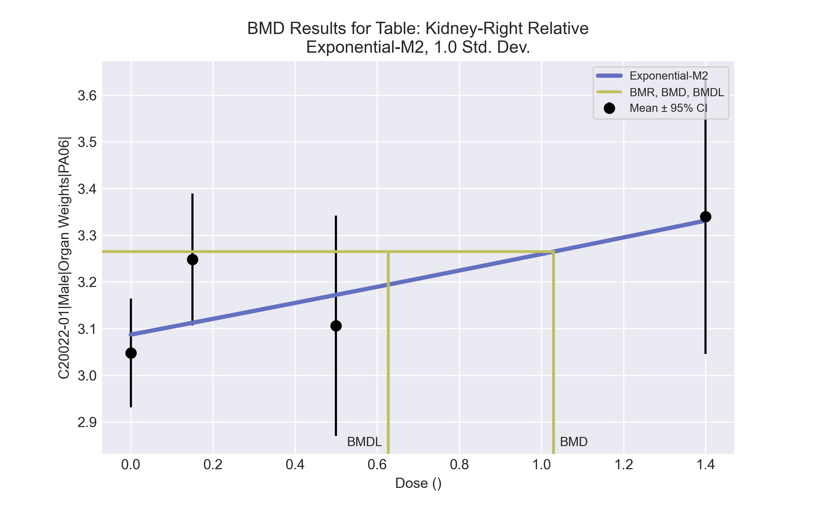

====================================================================   
 Exponential Model. (Version: 1.11; Date: 03/14/2017)   
 Input Data File: C:\Windows\TEMP\bmds-i0zxfjt6.(d)   
 Gnuplot Plotting File:   
 Tue Apr 13 14:57:27 2021  
 ====================================================================   
  
 BMDS_Model_Run   
~~~~~~~~~~~~~~~~~~~~~~~~~~~~~~~~~~~~~~~~~~~~~~~~~~~~~~~~~~~~~~~~~~~~~  
   
 The form of the response function by Model:   
 Model 2: Y[dose] = a * exp{sign * b * dose}  
 Model 3: Y[dose] = a * exp{sign * (b * dose)^d}  
 Model 4: Y[dose] = a * [c-(c-1) * exp{-b * dose}]  
 Model 5: Y[dose] = a * [c-(c-1) * exp{-(b * dose)^d}]  
  
 Note: Y[dose] is the median response for exposure = dose;  
 sign = +1 for increasing trend in data;  
 sign = -1 for decreasing trend.  
  
 Model 2 is nested within Models 3 and 4.  
 Model 3 is nested within Model 5.  
 Model 4 is nested within Model 5.  
  
  
 Dependent variable = Response  
 Independent variable = Dose  
 Data are assumed to be distributed: normally  
 Variance Model: exp(lnalpha +rho *ln(Y[dose]))  
 rho is set to 0.  
 A constant variance model is fit.  
  
 Total number of dose groups = 4  
 Total number of records with missing values = 0  
 Maximum number of iterations = 500  
 Relative Function Convergence has been set to: 1e-008  
 Parameter Convergence has been set to: 1e-008  
  
 MLE solution provided: Exact  
  
  
 Initial Parameter Values  
  
 Variable Model 2  
 -------- --------  
 lnalpha -3.63541   
 rho 0 Specified  
 a 3.086   
 b 0.054473   
 c 0 Specified  
 d 1 Specified  
  
  
  
 Parameter Estimates  
  
 Variable Model 2 Std. Err.  
 -------- ------- ---------  
 lnalpha -3.45545 0.00893021  
 a 3.08693 0.044721  
 b 0.0543724 0.0206898  
  
 NC = No Convergence  
  
  
 Table of Stats From Input Data  
  
 Dose N Obs Mean Obs Std Dev  
 ----- --- ---------- -------------  
 0 10 3.048 0.1628  
 0.15 5 3.248 0.1135  
 0.5 5 3.106 0.1901  
 1.4 5 3.34 0.237  
  
  
 Estimated Values of Interest  
  
 Dose Est Mean Est Std Scaled Residual  
 ------ ---------- --------- ----------------  
 0 3.087 0.1777 -0.699  
 0.15 3.112 0.1777 1.709  
 0.5 3.172 0.1777 -0.833  
 1.4 3.331 0.1777 0.1122  
  
  
  
 Other models for which likelihoods are calculated:  
  
 Model A1: Yij = Mu(i) + e(ij)  
 Var{e(ij)} = Sigma^2  
  
 Model A2: Yij = Mu(i) + e(ij)  
 Var{e(ij)} = Sigma(i)^2  
  
 Model A3: Yij = Mu(i) + e(ij)  
 Var{e(ij)} = exp(lalpha + log(mean(i)) * rho)  
  
 Model R: Yij = Mu + e(i)  
 Var{e(ij)} = Sigma^2  
  
  
 Likelihoods of Interest  
  
 Model Log(likelihood) DF AIC  
 ------- ----------------- ---- ------------  
 A1 32.94261 5 -55.88522  
 A2 34.22987 8 -52.45974  
 A3 32.94261 5 -55.88522  
 R 27.72496 2 -51.44993  
 2 30.69314 3 -55.38628  
  
  
 Additive constant for all log-likelihoods = -22.97. This constant added to the  
 above values gives the log-likelihood including the term that does not  
 depend on the model parameters.  
  
  
 Explanation of Tests  
  
 Test 1: Does response and/or variances differ among Dose levels? (A2 vs. R)  
 Test 2: Are Variances Homogeneous? (A2 vs. A1)  
 Test 3: Are variances adequately modeled? (A2 vs. A3)  
 Test 4: Does Model 2 fit the data? (A3 vs. 2)  
  
  
 Tests of Interest  
  
 Test -2*log(Likelihood Ratio) D. F. p-value  
 -------- ------------------------ ------ --------------  
 Test 1 13.01 6 0.04288  
 Test 2 2.575 3 0.462  
 Test 3 2.575 3 0.462  
 Test 4 4.499 2 0.1055  
  
  
 The p-value for Test 1 is less than .05. There appears to be a  
 difference between response and/or variances among the dose  
 levels, it seems appropriate to model the data.  
  
 The p-value for Test 2 is greater than .1. A homogeneous  
 variance model appears to be appropriate here.  
  
 The p-value for Test 3 is greater than .1. The modeled  
 variance appears to be appropriate here.  
  
 The p-value for Test 4 is greater than .1. Model 2 seems  
 to adequately describe the data.  
  
  
 Benchmark Dose Computations:  
  
 Specified Effect = 1.000000  
  
 Risk Type = Estimated standard deviations from control  
  
 Confidence Level = 0.950000  
  
 BMD = 1.0293  
  
 BMDL = 0.627541  
  
 BMDU = 3.08928

# Male BMD Results for Table: Liver Weight Absolute

BMDS version: BMDS v2.7.0

## Input dataset

|  |  |  |  |  |  |  |  |  |
| --- | --- | --- | --- | --- | --- | --- | --- | --- |
| Dose | 0 | 0.15 | 0.5 | 1.4 | 4 | 12 | 37a | 111a |
| N | 10 | 5 | 5 | 5 | 5 | 5 | 5 | 5 |
| Mean ± SD | 11.481 ± 0.983 | 12.004 ± 0.835 | 12.314 ± 0.662 | 12.48 ± 0.782 | 11.796 ± 0.785 | 13.138 ± 0.909 | 12.746 ± 0.671 | 14.312 ± 0.246 |

a Dose group removed in BMD modeling session

## Summary table

|  |  |  |  |  |  |
| --- | --- | --- | --- | --- | --- |
| Modela | Goodness of fit | | BMD | BMDL | Comments |
| *p*-value | AIC |
| Linear (equivalent models include Power) | 0.148 | 30.626 | 8.397 | 5.223 | Exponential-M2 recommended as best-fitting model on the basis of the lowest AIC. |
| Polynomial 2° | 0.085 | 32.488 | 9.473 | 5.274 |
| Polynomial 3° | 0.09 | 32.335 | 10.101 | 5.335 |
| Polynomial 4° | 0.093 | 32.275 | 10.467 | 5.359 |
| Polynomial 5° | 0.094 | 32.254 | 10.713 | 5.368 |
| Polynomial 6° | 0.094 | 32.247 | 10.89 | 5.371 |
| Polynomial 7° | 0.094 | 32.244 | 11.024 | 5.372 |
| Hill | 0.091 | 32.331 | 0.739 | 2.7E-08 |
| Exponential M2b (equivalent models include Exponential M3) | 0.15 | 30.603 | 8.492 | 5.426 |
| Exponential M4 | 0.079 | 32.627 | 8.393 | 0.036 |
| Exponential M5 | 0.079 | 32.627 | 8.394 | 1.2E-04 |

a Constant variance case presented (BMDS Test 2 p-value = 0.901, BMDS Test 3 p-value = 0.901).

b Recommended model

## Model recommendation details

|  |  |  |
| --- | --- | --- |
| Model | Bin | Notes |
| Linear (equivalent models include Power) | Valid | - |
| Polynomial 2° | Warning | **Warnings**  • Goodness of fit p-value is less than threshold (0.0845 < 0.1) |
| Polynomial 3° | Warning | **Warnings**  • Goodness of fit p-value is less than threshold (0.0904 < 0.1) |
| Polynomial 4° | Warning | **Warnings**  • Goodness of fit p-value is less than threshold (0.0928 < 0.1) |
| Polynomial 5° | Warning | **Warnings**  • Goodness of fit p-value is less than threshold (0.0937 < 0.1) |
| Polynomial 6° | Warning | **Warnings**  • Goodness of fit p-value is less than threshold (0.094 < 0.1) |
| Polynomial 7° | Warning | **Warnings**  • Goodness of fit p-value is less than threshold (0.0941 < 0.1) |
| Hill | Warning | **Warnings**  • Goodness of fit p-value is less than threshold (0.0906 < 0.1)  • BMD/BMDL ratio is greater than threshold (2.7e+07 > 20.0)  **Cautions**  • BMD/BMDL ratio is greater than threshold (2.7e+07 > 5.0) |
| Exponential M2a (equivalent models include Exponential M3) | Valid | - |
| Exponential M4 | Warning | **Warnings**  • Goodness of fit p-value is less than threshold (0.0795 < 0.1)  • BMD/BMDL ratio is greater than threshold (2.33e+02 > 20.0)  **Cautions**  • BMD/BMDL ratio is greater than threshold (2.33e+02 > 5.0) |
| Exponential M5 | Warning | **Warnings**  • Goodness of fit p-value is less than threshold (0.0795 < 0.1)  • BMD/BMDL ratio is greater than threshold (6.72e+04 > 20.0)  **Cautions**  • BMD/BMDL ratio is greater than threshold (6.72e+04 > 5.0) |

a Recommended model

## Recommended model

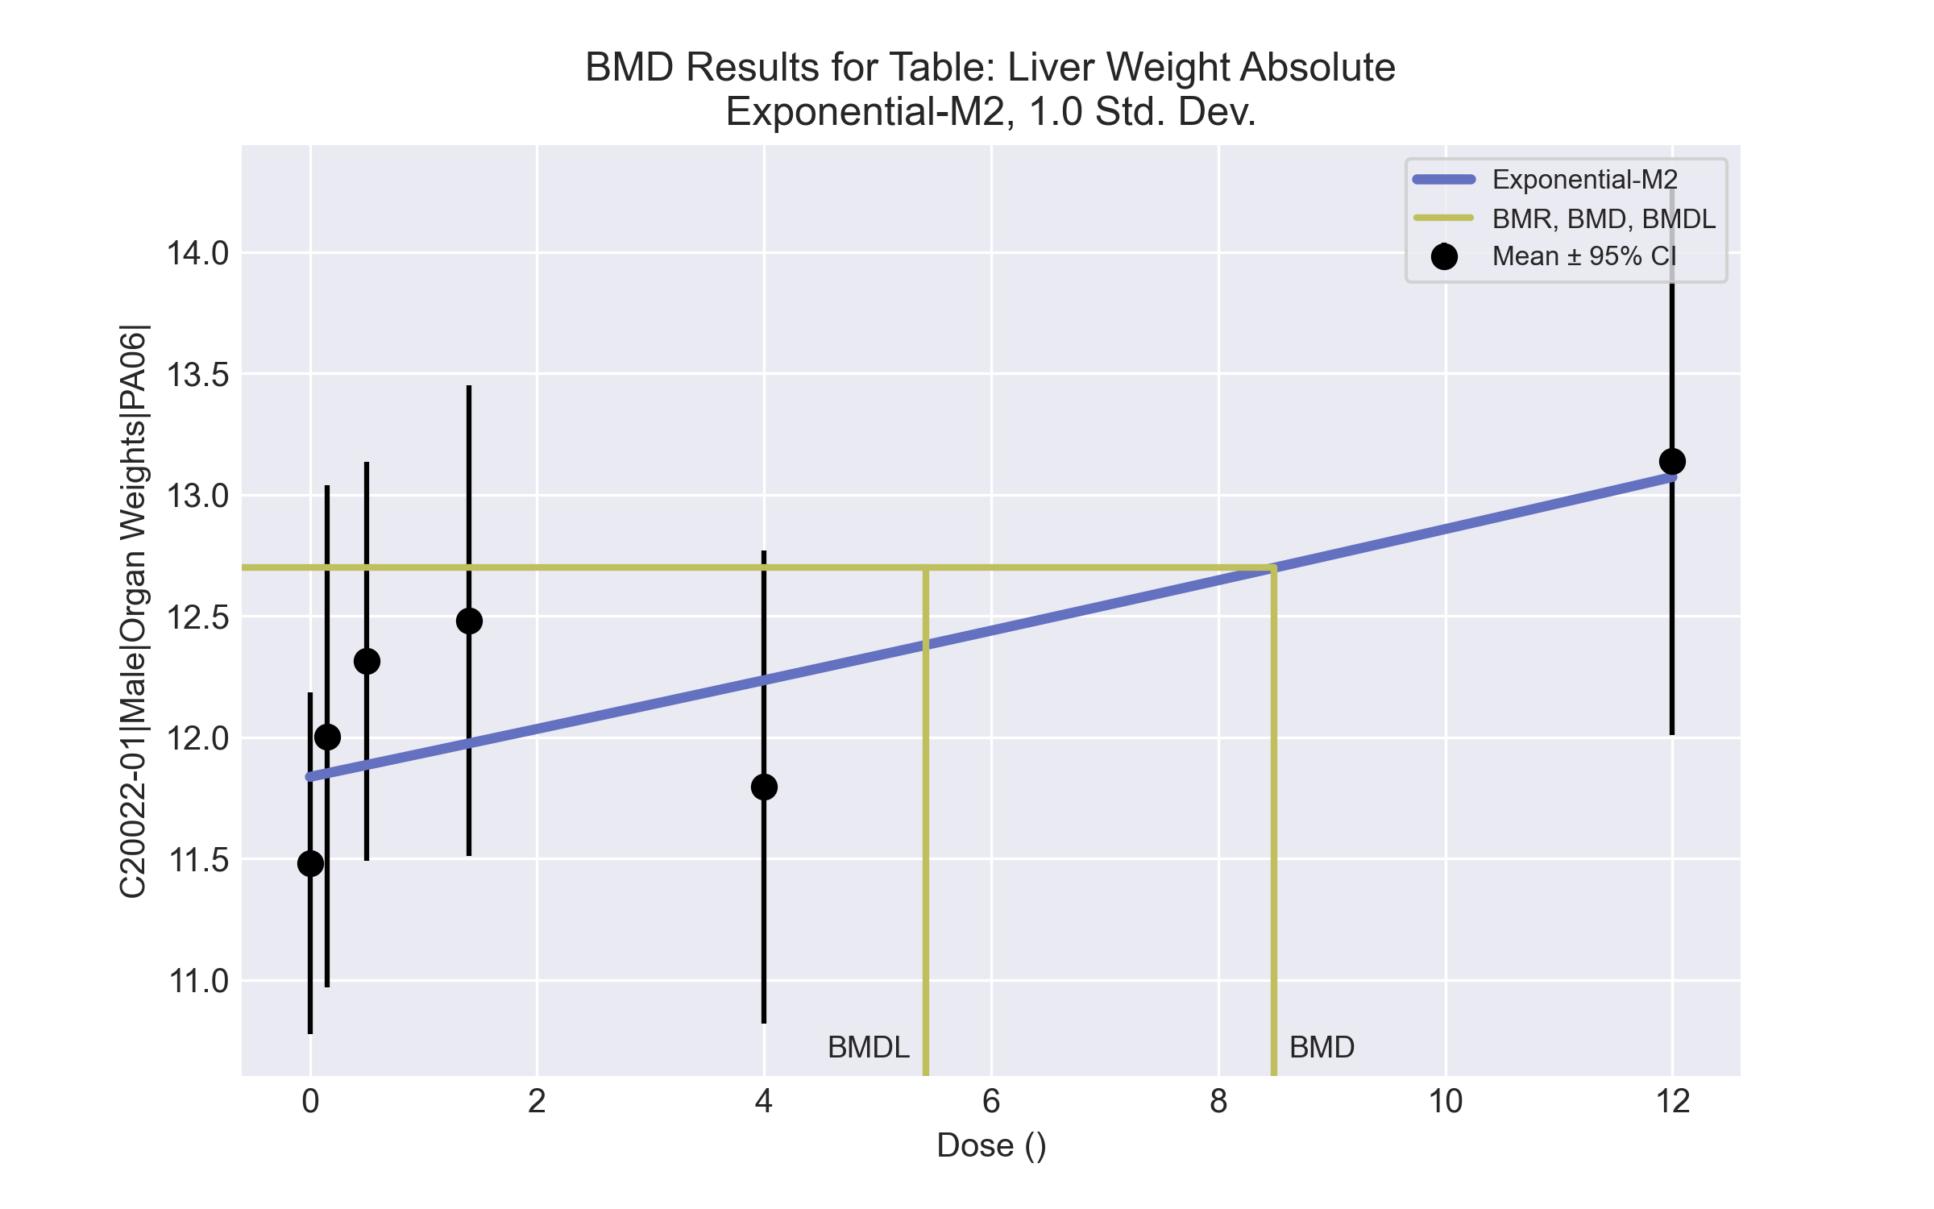

====================================================================   
 Exponential Model. (Version: 1.11; Date: 03/14/2017)   
 Input Data File: C:\Windows\TEMP\bmds-8g9ypi6f.(d)   
 Gnuplot Plotting File:   
 Tue Apr 13 14:57:40 2021  
 ====================================================================   
  
 BMDS_Model_Run   
~~~~~~~~~~~~~~~~~~~~~~~~~~~~~~~~~~~~~~~~~~~~~~~~~~~~~~~~~~~~~~~~~~~~~  
   
 The form of the response function by Model:   
 Model 2: Y[dose] = a * exp{sign * b * dose}  
 Model 3: Y[dose] = a * exp{sign * (b * dose)^d}  
 Model 4: Y[dose] = a * [c-(c-1) * exp{-b * dose}]  
 Model 5: Y[dose] = a * [c-(c-1) * exp{-(b * dose)^d}]  
  
 Note: Y[dose] is the median response for exposure = dose;  
 sign = +1 for increasing trend in data;  
 sign = -1 for decreasing trend.  
  
 Model 2 is nested within Models 3 and 4.  
 Model 3 is nested within Model 5.  
 Model 4 is nested within Model 5.  
  
  
 Dependent variable = Response  
 Independent variable = Dose  
 Data are assumed to be distributed: normally  
 Variance Model: exp(lnalpha +rho *ln(Y[dose]))  
 rho is set to 0.  
 A constant variance model is fit.  
  
 Total number of dose groups = 6  
 Total number of records with missing values = 0  
 Maximum number of iterations = 500  
 Relative Function Convergence has been set to: 1e-008  
 Parameter Convergence has been set to: 1e-008  
  
 MLE solution provided: Exact  
  
  
 Initial Parameter Values  
  
 Variable Model 2  
 -------- --------  
 lnalpha -0.489897   
 rho 0 Specified  
 a 11.8318   
 b 0.008268   
 c 0 Specified  
 d 1 Specified  
  
  
  
 Parameter Estimates  
  
 Variable Model 2 Std. Err.  
 -------- ------- ---------  
 lnalpha -0.297059 0.177611  
 a 11.8368 0.171414  
 b 0.00827744 0.00280862  
  
 NC = No Convergence  
  
  
 Table of Stats From Input Data  
  
 Dose N Obs Mean Obs Std Dev  
 ----- --- ---------- -------------  
 0 10 11.48 0.9825  
 0.15 5 12 0.8346  
 0.5 5 12.31 0.6622  
 1.4 5 12.48 0.7818  
 4 5 11.8 0.7852  
 12 5 13.14 0.909  
  
  
 Estimated Values of Interest  
  
 Dose Est Mean Est Std Scaled Residual  
 ------ ---------- --------- ----------------  
 0 11.84 0.862 -1.305  
 0.15 11.85 0.862 0.3956  
 0.5 11.89 0.862 1.111  
 1.4 11.97 0.862 1.311  
 4 12.24 0.862 -1.139  
 12 13.07 0.862 0.1689  
  
  
  
 Other models for which likelihoods are calculated:  
  
 Model A1: Yij = Mu(i) + e(ij)  
 Var{e(ij)} = Sigma^2  
  
 Model A2: Yij = Mu(i) + e(ij)  
 Var{e(ij)} = Sigma(i)^2  
  
 Model A3: Yij = Mu(i) + e(ij)  
 Var{e(ij)} = exp(lalpha + log(mean(i)) * rho)  
  
 Model R: Yij = Mu + e(i)  
 Var{e(ij)} = Sigma^2  
  
  
 Likelihoods of Interest  
  
 Model Log(likelihood) DF AIC  
 ------- ----------------- ---- ------------  
 A1 -8.926804 7 31.85361  
 A2 -8.125288 12 40.25058  
 A3 -8.926804 7 31.85361  
 R -15.99842 2 35.99684  
 2 -12.30147 3 30.60295  
  
  
 Additive constant for all log-likelihoods = -32.16. This constant added to the  
 above values gives the log-likelihood including the term that does not  
 depend on the model parameters.  
  
  
 Explanation of Tests  
  
 Test 1: Does response and/or variances differ among Dose levels? (A2 vs. R)  
 Test 2: Are Variances Homogeneous? (A2 vs. A1)  
 Test 3: Are variances adequately modeled? (A2 vs. A3)  
 Test 4: Does Model 2 fit the data? (A3 vs. 2)  
  
  
 Tests of Interest  
  
 Test -2*log(Likelihood Ratio) D. F. p-value  
 -------- ------------------------ ------ --------------  
 Test 1 15.75 10 0.1071  
 Test 2 1.603 5 0.9009  
 Test 3 1.603 5 0.9009  
 Test 4 6.749 4 0.1497  
  
  
 The p-value for Test 1 is greater than .05. There may not be a  
 diffence between responses and/or variances among the dose levels  
 Modelling the data with a dose/response curve may not be appropriate.  
  
 The p-value for Test 2 is greater than .1. A homogeneous  
 variance model appears to be appropriate here.  
  
 The p-value for Test 3 is greater than .1. The modeled  
 variance appears to be appropriate here.  
  
 The p-value for Test 4 is greater than .1. Model 2 seems  
 to adequately describe the data.  
  
  
 Benchmark Dose Computations:  
  
 Specified Effect = 1.000000  
  
 Risk Type = Estimated standard deviations from control  
  
 Confidence Level = 0.950000  
  
 BMD = 8.49203  
  
 BMDL = 5.4262  
  
 BMDU = 20.8734

# Male BMD Results for Table: Liver Weight Relative

BMDS version: BMDS v2.7.0

## Input dataset

|  |  |  |  |  |  |  |  |  |
| --- | --- | --- | --- | --- | --- | --- | --- | --- |
| Dose | 0 | 0.15 | 0.5 | 1.4 | 4 | 12 | 37 | 111 |
| N | 10 | 5 | 5 | 5 | 5 | 5 | 5 | 5 |
| Mean ± SD | 36.877 ± 1.656 | 38.209 ± 1.748 | 39.027 ± 1.909 | 39.013 ± 2.731 | 38.257 ± 1.713 | 40.278 ± 1.742 | 41.328 ± 2.247 | 46.417 ± 1.917 |

## Summary table

|  |  |  |  |  |  |
| --- | --- | --- | --- | --- | --- |
| Modela | Goodness of fit | | BMD | BMDL | Comments |
| *p*-value | AIC |
| Linear (equivalent models include Polynomial 2°, 3°, 6°, 7°) | 0.175 | 111.078 | 25.515 | 20.366 | Hill recommended as best-fitting model on the basis of the lowest AIC. |
| Power (equivalent models include Polynomial 4°, 5°) | 0.175 | 111.078 | 25.515 | 20.366 |
| Hillb | 0.173 | 111.798 | 16.251 | 8.358 |
| Exponential M2 (equivalent models include Exponential M3) | 0.15 | 111.535 | 27.768 | 22.444 |
| Exponential M4 (equivalent models include Exponential M5) | 0.169 | 111.872 | 16.924 | 9.765 |

a Constant variance case presented (BMDS Test 2 p-value = 0.945, BMDS Test 3 p-value = 0.945).

b Recommended model

## Model recommendation details

|  |  |  |
| --- | --- | --- |
| Model | Bin | Notes |
| Linear (equivalent models include Polynomial 2°, 3°, 6°, 7°) | Warning | **Warnings**  • Residual at lowest dose is greater than threshold (2.11 > 2.0) |
| Power (equivalent models include Polynomial 4°, 5°) | Warning | **Warnings**  • Residual at lowest dose is greater than threshold (2.11 > 2.0) |
| Hilla | Valid | - |
| Exponential M2 (equivalent models include Exponential M3) | Warning | **Warnings**  • Residual at lowest dose is greater than threshold (2.16 > 2.0) |
| Exponential M4 (equivalent models include Exponential M5) | Valid | - |

a Recommended model

## Recommended model

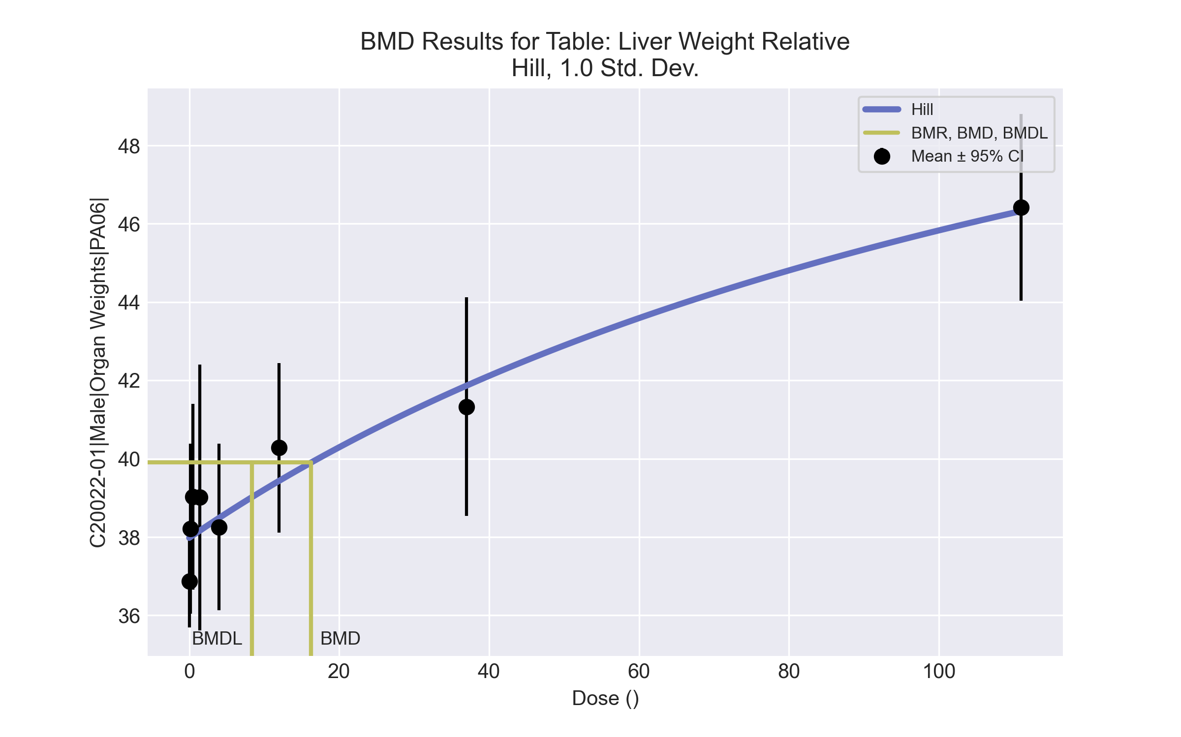

====================================================================   
 Hill Model. (Version: 2.18; Date: 03/14/2017)   
 Input Data File: C:\Windows\TEMP\bmds-nsb8m0ak.(d)   
 Gnuplot Plotting File: C:\Windows\TEMP\bmds-nsb8m0ak.plt  
 Tue Apr 13 14:57:43 2021  
 ====================================================================   
  
 BMDS_Model_Run   
~~~~~~~~~~~~~~~~~~~~~~~~~~~~~~~~~~~~~~~~~~~~~~~~~~~~~~~~~~~~~~~~~~~~~  
   
 The form of the response function is:   
  
 Y[dose] = intercept + v*dose^n/(k^n + dose^n)  
  
  
 Dependent variable = Response  
 Independent variable = Dose  
 rho is set to 0  
 Power parameter restricted to be greater than 1  
 A constant variance model is fit  
  
 Total number of dose groups = 8  
 Total number of records with missing values = 0  
 Maximum number of iterations = 500  
 Relative Function Convergence has been set to: 1e-008  
 Parameter Convergence has been set to: 1e-008  
  
  
  
 Default Initial Parameter Values   
 alpha = 3.78568  
 rho = 0 Specified  
 intercept = 36.8767  
 v = 9.54077  
 n = 0.248512  
 k = 180.36  
  
  
 Asymptotic Correlation Matrix of Parameter Estimates  
  
 ( *** The model parameter(s) -rho -n   
 have been estimated at a boundary point, or have been specified by the user,  
 and do not appear in the correlation matrix )  
  
 alpha intercept v k  
  
 alpha 1 3.4e-008 1.3e-007 1.3e-007  
  
 intercept 3.4e-008 1 0.37 0.45  
  
 v 1.3e-007 0.37 1 0.99  
  
 k 1.3e-007 0.45 0.99 1  
  
  
  
 Parameter Estimates  
  
 95.0% Wald Confidence Interval  
 Variable Estimate Std. Err. Lower Conf. Limit Upper Conf. Limit  
 alpha 3.69366 0.778691 2.16745 5.21986  
 intercept 37.9792 0.374131 37.246 38.7125  
 v 19.5627 13.0874 -6.08813 45.2135  
 n 1 NA  
 k 149.167 164.802 -173.838 472.172  
  
NA - Indicates that this parameter has hit a bound  
 implied by some inequality constraint and thus  
 has no standard error.  
  
  
  
 Table of Data and Estimated Values of Interest  
  
 Dose N Obs Mean Est Mean Obs Std Dev Est Std Dev Scaled Res.  
------ --- -------- -------- ----------- ----------- ----------  
  
 0 10 36.9 38 1.66 1.92 -1.81  
 0.15 5 38.2 38 1.75 1.92 0.244  
 0.5 5 39 38 1.91 1.92 1.14  
 1.4 5 39 38.2 2.73 1.92 0.991  
 4 5 38.3 38.5 1.71 1.92 -0.272  
 12 5 40.3 39.4 1.74 1.92 0.98  
 37 5 41.3 41.9 2.25 1.92 -0.627  
 111 5 46.4 46.3 1.92 1.92 0.107  
  
  
  
 Model Descriptions for likelihoods calculated  
  
  
 Model A1: Yij = Mu(i) + e(ij)  
 Var{e(ij)} = Sigma^2  
  
 Model A2: Yij = Mu(i) + e(ij)  
 Var{e(ij)} = Sigma(i)^2  
  
 Model A3: Yij = Mu(i) + e(ij)  
 Var{e(ij)} = Sigma^2  
 Model A3 uses any fixed variance parameters that  
 were specified by the user  
  
 Model R: Yi = Mu + e(i)  
 Var{e(i)} = Sigma^2  
  
  
 Likelihoods of Interest  
  
 Model Log(likelihood) # Param's AIC  
 A1 -48.048332 9 114.096663  
 A2 -46.925893 16 125.851786  
 A3 -48.048332 9 114.096663  
 fitted -51.898875 4 111.797750  
 R -76.035562 2 156.071124  
  
  
 Explanation of Tests   
  
 Test 1: Do responses and/or variances differ among Dose levels?   
 (A2 vs. R)  
 Test 2: Are Variances Homogeneous? (A1 vs A2)  
 Test 3: Are variances adequately modeled? (A2 vs. A3)  
 Test 4: Does the Model for the Mean Fit? (A3 vs. fitted)  
 (Note: When rho=0 the results of Test 3 and Test 2 will be the same.)  
  
 Tests of Interest   
  
 Test -2*log(Likelihood Ratio) Test df p-value   
  
 Test 1 58.2193 14 <.0001  
 Test 2 2.24488 7 0.9451  
 Test 3 2.24488 7 0.9451  
 Test 4 7.70109 5 0.1735  
  
The p-value for Test 1 is less than .05. There appears to be a  
difference between response and/or variances among the dose levels  
It seems appropriate to model the data  
  
The p-value for Test 2 is greater than .1. A homogeneous variance   
model appears to be appropriate here  
  
  
The p-value for Test 3 is greater than .1. The modeled variance appears   
 to be appropriate here  
  
The p-value for Test 4 is greater than .1. The model chosen seems   
to adequately describe the data  
   
  
 Benchmark Dose Computation  
  
Specified effect = 1  
  
Risk Type = Estimated standard deviations from the control mean   
  
Confidence level = 0.95  
  
 BMD = 16.2511  
  
 BMDL = 8.35765  
  
 BMDU = 32.6117

# Male BMD Results for Table: Cholesterol

BMDS version: BMDS v2.7.0

## Input dataset

|  |  |  |  |  |  |  |  |  |
| --- | --- | --- | --- | --- | --- | --- | --- | --- |
| Dose | 0 | 0.15 | 0.5 | 1.4a | 4a | 12a | 37a | 111a |
| N | 9 | 5 | 5 | 5 | 5 | 5 | 5 | 5 |
| Mean ± SD | 103.333 ± 13.266 | 102.2 ± 9.011 | 123 ± 28.24 | 115 ± 27.028 | 109.2 ± 10.01 | 108.4 ± 14.029 | 90.2 ± 10.686 | 79.8 ± 8.843 |

a Dose group removed in BMD modeling session

## Summary table

|  |  |  |  |  |  |
| --- | --- | --- | --- | --- | --- |
| Modela | Goodness of fit | | BMD | BMDL | Comments |
| *p*-value | AIC |
| Linear | 0.093 | 129.043 | 0.343 | 0.157 | Power recommended as best-fitting model on the basis of the lowest AIC. |
| Polynomial 2° | 0.287 | 127.359 | 0.377 | 0.202 |
| Polynomial 3° | 0.398 | 126.938 | 0.411 | 0.261 |
| Polynomial 4° | 0.437 | 126.828 | 0.431 | 0.227 |
| Polynomial 5° | 0.449 | 126.796 | 0.444 | 0.264 |
| Polynomial 6° | 0.453 | 126.787 | 0.453 | 0.232 |
| Polynomial 7° | 0.454 | 126.784 | 0.46 | 0.264 |
| Powerb | 0.455 | 126.783 | 0.484 | 0.225 |
| Hill | 0.38 | 165.904 | 0.297 | -999 |
| Exponential M2 | 0.101 | 128.91 | 0.337 | 0.166 |
| Exponential M3 | -999 | 128.783 | 0.481 | 0.227 |
| Exponential M4 | -999 | 131.042 | 0.343 | 0.157 |
| Exponential M5 | -999 | 167.904 | 0.426 | 0.156 |

a Modeled variance case presented (BMDS Test 2 p-value = 0.031, BMDS Test 3 p-value = 0.443).

b Recommended model

## Model recommendation details

|  |  |  |
| --- | --- | --- |
| Model | Bin | Notes |
| Linear | Warning | **Warnings**  • Goodness of fit p-value is less than threshold (0.0932 < 0.1) |
| Polynomial 2° | Valid | - |
| Polynomial 3° | Valid | - |
| Polynomial 4° | Valid | - |
| Polynomial 5° | Valid | - |
| Polynomial 6° | Valid | - |
| Polynomial 7° | Valid | - |
| Powera | Valid | - |
| Hill | Failure | **Failures**  • BMDL does not exist  **Cautions**  • Warning(s): BMDL computation failed. |
| Exponential M2 | Valid | - |
| Exponential M3 | Warning | **Warnings**  • Zero degrees of freedom; saturated model |
| Exponential M4 | Warning | **Warnings**  • Zero degrees of freedom; saturated model |
| Exponential M5 | Warning | **Warnings**  • Zero degrees of freedom; saturated model |

a Recommended model

## Recommended model

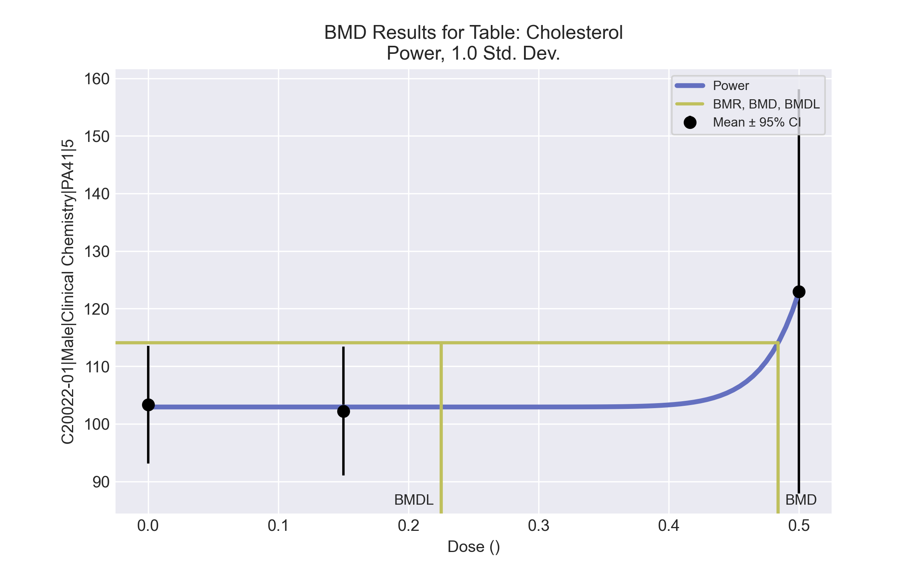

====================================================================   
 Power Model. (Version: 2.19; Date: 03/14/2017)   
 Input Data File: C:\Windows\TEMP\bmds-78puv0do.(d)   
 Gnuplot Plotting File: C:\Windows\TEMP\bmds-78puv0do.plt  
 Tue Apr 13 15:46:22 2021  
 ====================================================================   
  
 BMDS_Model_Run   
~~~~~~~~~~~~~~~~~~~~~~~~~~~~~~~~~~~~~~~~~~~~~~~~~~~~~~~~~~~~~~~~~~~~~  
   
 The form of the response function is:   
  
 Y[dose] = control + slope * dose^power  
  
  
 Dependent variable = Response  
 Independent variable = Dose  
 The power is restricted to be greater than or equal to 1  
 The variance is to be modeled as Var(i) = exp(lalpha + log(mean(i)) * rho)  
  
 Total number of dose groups = 3  
 Total number of records with missing values = 0  
 Maximum number of iterations = 500  
 Relative Function Convergence has been set to: 1e-008  
 Parameter Convergence has been set to: 1e-008  
  
  
  
 Default Initial Parameter Values   
 lalpha = 5.72904  
 rho = 0  
 control = 102.2  
 slope = 41.6  
 power = -9999  
  
  
 Asymptotic Correlation Matrix of Parameter Estimates  
  
 ( *** The model parameter(s) -power   
 have been estimated at a boundary point, or have been specified by the user,  
 and do not appear in the correlation matrix )  
  
 lalpha rho control slope  
  
 lalpha 1 -1 -0.24 0.77  
  
 rho -1 1 0.23 -0.77  
  
 control -0.24 0.23 1 -0.25  
  
 slope 0.77 -0.77 -0.25 1  
  
  
  
 Parameter Estimates  
  
 95.0% Wald Confidence Interval  
 Variable Estimate Std. Err. Lower Conf. Limit Upper Conf. Limit  
 lalpha -37.7746 30.1434 -96.8546 21.3054  
 rho 9.19186 6.46413 -3.4776 21.8613  
 control 102.929 2.97689 97.094 108.763  
 slope 5.2616e+006 3.06229e+006 -740364 1.12636e+007  
 power 18 NA  
  
NA - Indicates that this parameter has hit a bound  
 implied by some inequality constraint and thus  
 has no standard error.  
  
  
  
 Table of Data and Estimated Values of Interest  
  
 Dose N Obs Mean Est Mean Obs Std Dev Est Std Dev Scaled Res.  
------ --- -------- -------- ----------- ----------- ----------  
  
 0 9 103 103 13.3 11.1 0.109  
 0.15 5 102 103 9.01 11.1 -0.146  
 0.5 5 123 123 28.2 25.3 6.15e-008  
  
  
  
 Model Descriptions for likelihoods calculated  
  
  
 Model A1: Yij = Mu(i) + e(ij)  
 Var{e(ij)} = Sigma^2  
  
 Model A2: Yij = Mu(i) + e(ij)  
 Var{e(ij)} = Sigma(i)^2  
  
 Model A3: Yij = Mu(i) + e(ij)  
 Var{e(ij)} = exp(lalpha + rho*ln(Mu(i)))  
 Model A3 uses any fixed variance parameters that  
 were specified by the user  
  
 Model R: Yi = Mu + e(i)  
 Var{e(i)} = Sigma^2  
  
  
 Likelihoods of Interest  
  
 Model Log(likelihood) # Param's AIC  
 A1 -62.293341 4 132.586681  
 A2 -58.817429 6 129.634858  
 A3 -59.111911 5 128.223822  
 fitted -59.391560 4 126.783119  
 R -64.802884 2 133.605767  
  
  
 Explanation of Tests   
  
 Test 1: Do responses and/or variances differ among Dose levels?   
 (A2 vs. R)  
 Test 2: Are Variances Homogeneous? (A1 vs A2)  
 Test 3: Are variances adequately modeled? (A2 vs. A3)  
 Test 4: Does the Model for the Mean Fit? (A3 vs. fitted)  
 (Note: When rho=0 the results of Test 3 and Test 2 will be the same.)  
  
 Tests of Interest   
  
 Test -2*log(Likelihood Ratio) Test df p-value   
  
 Test 1 11.9709 4 0.01757  
 Test 2 6.95182 2 0.03093  
 Test 3 0.588964 1 0.4428  
 Test 4 0.559298 1 0.4545  
  
The p-value for Test 1 is less than .05. There appears to be a  
difference between response and/or variances among the dose levels  
It seems appropriate to model the data  
  
The p-value for Test 2 is less than .1. A non-homogeneous variance   
model appears to be appropriate  
  
The p-value for Test 3 is greater than .1. The modeled variance appears   
 to be appropriate here  
  
The p-value for Test 4 is greater than .1. The model chosen seems   
to adequately describe the data  
   
  
 Benchmark Dose Computation  
  
Specified effect = 1  
  
Risk Type = Estimated standard deviations from the control mean   
  
Confidence level = 0.95  
  
 BMD = 0.483907   
  
  
 BMDL = 0.225061   
  
  
 BMDU = 0.736299

# Male BMD Results for Table: Erythrocyte Count

BMDS version: BMDS v2.7.0

## Input dataset

|  |  |  |  |  |  |  |  |  |
| --- | --- | --- | --- | --- | --- | --- | --- | --- |
| Dose | 0 | 0.15 | 0.5 | 1.4 | 4 | 12 | 37 | 111 |
| N | 6 | 2 | 4 | 4 | 5 | 3 | 2 | 4 |
| Mean ± SD | 8.53 ± 0.69 | 8.4 ± 0.41 | 8.785 ± 0.667 | 8.607 ± 0.417 | 8.228 ± 0.217 | 8.44 ± 0.447 | 7.99 ± 0 | 8.03 ± 0.284 |

## Summary table

|  |  |  |  |  |  |
| --- | --- | --- | --- | --- | --- |
| Modela | Goodness of fit | | BMD | BMDL | Comments |
| *p*-value | AIC |
| Linear (equivalent models include Power, Polynomial 2°, 3°, 4°, 5°) | <0.0001 | -13.915 | 103.189 | 65.732 | No model was recommended as a best-fitting model. Doses were dropped until there were only 3 remaining dose-groups. |
| Polynomial 6° | <0.0001 | 281.233 | 3.722 | -999 |
| Polynomial 7° | <0.0001 | 276.466 | 3.721 | -999 |
| Hill | <0.0001 | -16.394 | 18.966 | -999 |
| Exponential M2 | -999 | 165.781 | -999 | 0 |
| Exponential M3 | -999 | 11.236 | 53950 | -999 |
| Exponential M4 | -999 | -13.037 | 14.095 | 1.784 |
| Exponential M5 | -999 | 169.57 | -999 | 0 |

a Modeled variance case presented (BMDS Test 2 p-value = <0.0001, BMDS Test 3 p-value = <0.0001).

## Model recommendation details

|  |  |  |
| --- | --- | --- |
| Model | Bin | Notes |
| Linear (equivalent models include Power, Polynomial 2°, 3°, 4°, 5°) | Warning | **Warnings**  • Variance model poorly fits dataset (p-value 3 = 0.0001)  **Cautions**  • Warning(s): Warning: Likelihood for fitted model larger than the Likelihood for model A3. |
| Polynomial 6° | Failure | **Failures**  • BMDL does not exist  **Warnings**  • Variance model poorly fits dataset (p-value 3 = 0.0001)  • Residual of interest is greater than threshold (2.66 > 2.0)  • Ratio of modeled to actual stdev. at control is greater than threshold (3.71 > 1.5)  **Cautions**  • Warning(s): THIS USUALLY MEANS THE MODEL HAS NOT CONVERGED!; BMDL computation failed.; Warning: Likelihood for fitted model larger than the Likelihood for model A3. |
| Polynomial 7° | Failure | **Failures**  • BMDL does not exist  **Warnings**  • Variance model poorly fits dataset (p-value 3 = 0.0001)  • Residual of interest is greater than threshold (2.66 > 2.0)  • Ratio of modeled to actual stdev. at control is greater than threshold (3.83 > 1.5)  **Cautions**  • Warning(s): THE MODEL HAS PROBABLY NOT CONVERGED!!!; THIS USUALLY MEANS THE MODEL HAS NOT CONVERGED!; BMDL computation failed.; Warning: Likelihood for fitted model larger than the Likelihood for model A3. |
| Hill | Failure | **Failures**  • BMDL does not exist  **Warnings**  • Variance model poorly fits dataset (p-value 3 = 0.0001)  **Cautions**  • Warning(s): BMDL computation failed. |
| Exponential M2 | Failure | **Failures**  • BMD does not exist  **Warnings**  • Residual of Interest does not exist  • Variance model poorly fits dataset (p-value 3 = 0.0001)  • Residual at lowest dose is greater than threshold (2.46 > 2.0) |
| Exponential M3 | Failure | **Failures**  • BMDL does not exist  **Warnings**  • Variance model poorly fits dataset (p-value 3 = 0.0001)  • BMD/high dose ratio is greater than threshold (4.86e+02 > 1.0) |
| Exponential M4 | Warning | **Warnings**  • Variance model poorly fits dataset (p-value 3 = 0.0001)  **Cautions**  • BMD/BMDL ratio is greater than threshold (7.9 > 5.0) |
| Exponential M5 | Failure | **Failures**  • BMD does not exist  **Warnings**  • Residual of Interest does not exist  • Variance model poorly fits dataset (p-value 3 = 0.0001)  • Residual at lowest dose is greater than threshold (2.46 > 2.0) |

## Recommended model

*No model was recommended as a best-fitting model.*

# Male BMD Results for Table: Mean Cell HGB Concentration

BMDS version: BMDS v2.7.0

## Input dataset

|  |  |  |  |  |  |  |  |  |
| --- | --- | --- | --- | --- | --- | --- | --- | --- |
| Dose | 0 | 0.15 | 0.5 | 1.4 | 4 | 12 | 37 | 111 |
| N | 6 | 2 | 4 | 4 | 5 | 3 | 2 | 4 |
| Mean ± SD | 29.267 ± 0.635 | 29.75 ± 0.071 | 29.4 ± 0.698 | 31.4 ± 0.829 | 31.82 ± 1.228 | 30.433 ± 1.531 | 29.25 ± 0.778 | 29.45 ± 0.379 |

## Summary table

|  |  |  |  |  |  |
| --- | --- | --- | --- | --- | --- |
| Modela | Goodness of fit | | BMD | BMDL | Comments |
| *p*-value | AIC |
| Linear | 2.5E-04 | 50.44 | -9999 | 254.722 | No model was recommended as a best-fitting model. Doses were dropped until there were only 3 remaining dose-groups. |
| Polynomial 2° | 2.5E-04 | 50.44 | -9999 | 168.565 |
| Polynomial 3° | 2.5E-04 | 50.44 | -9999 | 145.574 |
| Polynomial 4° | 2.5E-04 | 50.44 | -9999 | 135.764 |
| Polynomial 5° | 2.5E-04 | 50.44 | -9999 | -999 |
| Polynomial 6° | 2.5E-04 | 50.44 | -9999 | -999 |
| Polynomial 7° | 2.5E-04 | 50.44 | -9999 | -999 |
| Power | 9.0E-04 | 48.298 | 118.173 | 75.937 |
| Hill | 0.002 | 46.148 | -999 | -999 |
| Exponential M2 | 4.4E-04 | 49.997 | 12517.2 | 573.102 |
| Exponential M3 | 1.8E-04 | 52.007 | 1471.59 | -999 |
| Exponential M4 | 1.8E-04 | 51.996 | 13043.7 | 584.204 |
| Exponential M5 | 1.1E-04 | 52.886 | -999 | 0 |

a Modeled variance case presented (BMDS Test 2 p-value = 0.013, BMDS Test 3 p-value = 0.002).

## Model recommendation details

|  |  |  |
| --- | --- | --- |
| Model | Bin | Notes |
| Linear | Warning | **Warnings**  • Residual of Interest does not exist  • Variance model poorly fits dataset (p-value 3 = 0.001831)  • Goodness of fit p-value is less than threshold (0.00025 < 0.1)  • Ratio of modeled to actual stdev. at control is greater than threshold (2.0 > 1.5)  **Cautions**  • Warning(s): THIS USUALLY MEANS THE MODEL HAS NOT CONVERGED!; BMD = 100*(maximum dose)  • BMDL/high dose ratio is greater than threshold (2.29 > 1.0) |
| Polynomial 2° | Warning | **Warnings**  • Residual of Interest does not exist  • Variance model poorly fits dataset (p-value 3 = 0.001831)  • Goodness of fit p-value is less than threshold (0.00025 < 0.1)  • Ratio of modeled to actual stdev. at control is greater than threshold (2.0 > 1.5)  **Cautions**  • Warning(s): BMD = 100*(maximum dose)  • BMDL/high dose ratio is greater than threshold (1.52 > 1.0) |
| Polynomial 3° | Warning | **Warnings**  • Residual of Interest does not exist  • Variance model poorly fits dataset (p-value 3 = 0.001831)  • Goodness of fit p-value is less than threshold (0.00025 < 0.1)  • Ratio of modeled to actual stdev. at control is greater than threshold (2.0 > 1.5)  **Cautions**  • Warning(s): BMD = 100*(maximum dose)  • BMDL/high dose ratio is greater than threshold (1.31 > 1.0) |
| Polynomial 4° | Warning | **Warnings**  • Residual of Interest does not exist  • Variance model poorly fits dataset (p-value 3 = 0.001831)  • Goodness of fit p-value is less than threshold (0.00025 < 0.1)  • Ratio of modeled to actual stdev. at control is greater than threshold (2.0 > 1.5)  **Cautions**  • Warning(s): THIS USUALLY MEANS THE MODEL HAS NOT CONVERGED!; BMD = 100*(maximum dose)  • BMDL/high dose ratio is greater than threshold (1.22 > 1.0) |
| Polynomial 5° | Failure | **Failures**  • BMDL does not exist  **Warnings**  • Residual of Interest does not exist  • Variance model poorly fits dataset (p-value 3 = 0.001831)  • Goodness of fit p-value is less than threshold (0.00025 < 0.1)  • Ratio of modeled to actual stdev. at control is greater than threshold (2.0 > 1.5)  **Cautions**  • Warning(s): THIS USUALLY MEANS THE MODEL HAS NOT CONVERGED!; BMD = 100*(maximum dose); BMDL computation failed. |
| Polynomial 6° | Failure | **Failures**  • BMDL does not exist  **Warnings**  • Residual of Interest does not exist  • Variance model poorly fits dataset (p-value 3 = 0.001831)  • Goodness of fit p-value is less than threshold (0.00025 < 0.1)  • Ratio of modeled to actual stdev. at control is greater than threshold (2.0 > 1.5)  **Cautions**  • Warning(s): THIS USUALLY MEANS THE MODEL HAS NOT CONVERGED!; BMD = 100*(maximum dose); BMDL computation failed. |
| Polynomial 7° | Failure | **Failures**  • BMDL does not exist  **Warnings**  • Residual of Interest does not exist  • Variance model poorly fits dataset (p-value 3 = 0.001831)  • Goodness of fit p-value is less than threshold (0.00025 < 0.1)  • Ratio of modeled to actual stdev. at control is greater than threshold (2.0 > 1.5)  **Cautions**  • Warning(s): BMD = 100*(maximum dose); BMDL computation failed. |
| Power | Warning | **Warnings**  • Variance model poorly fits dataset (p-value 3 = 0.001292)  • Goodness of fit p-value is less than threshold (0.000898 < 0.1)  • BMD/high dose ratio is greater than threshold (1.06 > 1.0)  • Residual at lowest dose is greater than threshold (2.16 > 2.0)  • Ratio of modeled to actual stdev. at control is greater than threshold (1.98 > 1.5) |
| Hill | Failure | **Failures**  • BMD does not exist  • BMDL does not exist  **Warnings**  • Residual of Interest does not exist  • Variance model poorly fits dataset (p-value 3 = 0.001831)  • Goodness of fit p-value is less than threshold (0.00155 < 0.1)  • Residual at lowest dose is greater than threshold (2.34 > 2.0)  • Ratio of modeled to actual stdev. at control is greater than threshold (1.94 > 1.5)  **Cautions**  • Warning(s): BMR value is not in the range of the mean function |
| Exponential M2 | Warning | **Warnings**  • Variance model poorly fits dataset (p-value 3 = 0.001292)  • Goodness of fit p-value is less than threshold (0.000438 < 0.1)  • BMD/BMDL ratio is greater than threshold (21.8 > 20.0)  • BMD/high dose ratio is greater than threshold (1.13e+02 > 1.0)  **Cautions**  • BMD/BMDL ratio is greater than threshold (21.8 > 5.0)  • BMDL/high dose ratio is greater than threshold (5.16 > 1.0) |
| Exponential M3 | Failure | **Failures**  • BMDL does not exist  **Warnings**  • Variance model poorly fits dataset (p-value 3 = 0.001292)  • Goodness of fit p-value is less than threshold (0.00018 < 0.1)  • BMD/high dose ratio is greater than threshold (13.3 > 1.0) |
| Exponential M4 | Warning | **Warnings**  • Variance model poorly fits dataset (p-value 3 = 0.001292)  • Goodness of fit p-value is less than threshold (0.000181 < 0.1)  • BMD/BMDL ratio is greater than threshold (22.3 > 20.0)  • BMD/high dose ratio is greater than threshold (1.18e+02 > 1.0)  **Cautions**  • BMD/BMDL ratio is greater than threshold (22.3 > 5.0)  • BMDL/high dose ratio is greater than threshold (5.26 > 1.0) |
| Exponential M5 | Failure | **Failures**  • BMD does not exist  **Warnings**  • Residual of Interest does not exist  • Variance model poorly fits dataset (p-value 3 = 0.001292)  • Goodness of fit p-value is less than threshold (0.00011 < 0.1) |

## Recommended model

*No model was recommended as a best-fitting model.*

# Male BMD Results for Table: Mean Cell Hemoglobin

BMDS version: BMDS v2.7.0

## Input dataset

|  |  |  |  |  |  |  |  |  |
| --- | --- | --- | --- | --- | --- | --- | --- | --- |
| Dose | 0 | 0.15 | 0.5 | 1.4 | 4a | 12a | 37a | 111a |
| N | 6 | 2 | 4 | 4 | 5 | 3 | 2 | 4 |
| Mean ± SD | 18 ± 0.374 | 18.1 ± 0.566 | 17.925 ± 0.714 | 19.325 ± 0.171 | 19.54 ± 0.799 | 18.6 ± 0.8 | 18.25 ± 0.071 | 18.5 ± 0.497 |

a Dose group removed in BMD modeling session

## Summary table

|  |  |  |  |  |  |
| --- | --- | --- | --- | --- | --- |
| Modela | Goodness of fit | | BMD | BMDL | Comments |
| *p*-value | AIC |
| Linear | 0.01 | -1.562 | 0.586 | 0.369 | Power recommended as best-fitting model on the basis of the lowest AIC. |
| Polynomial 2° | 0.232 | -7.765 | 0.851 | 0.708 |
| Polynomial 3° | 0.46 | -9.131 | 0.991 | 0.882 |
| Polynomial 4° | 0.555 | -9.508 | 1.077 | 0.759 |
| Polynomial 5° | 0.59 | -9.629 | 1.134 | 0.764 |
| Polynomial 6° | 0.602 | -9.67 | 1.175 | 0.766 |
| Polynomial 7° | 0.606 | -9.684 | 1.204 | 0.892 |
| Powerb | 0.609 | -9.692 | 1.32 | 0.761 |
| Hill | 0.319 | -7.692 | 1.207 | -999 |
| Exponential M2 | 0.012 | -1.89 | 0.597 | 0.382 |
| Exponential M3 | 0.319 | -7.692 | 1.306 | 0.763 |
| Exponential M4 | 0.003 | 0.446 | 0.585 | 0.365 |
| Exponential M5 | -999 | -5.692 | 1.298 | 0.526 |

a Modeled variance case presented (BMDS Test 2 p-value = 0.077, BMDS Test 3 p-value = 0.603).

b Recommended model

## Model recommendation details

|  |  |  |
| --- | --- | --- |
| Model | Bin | Notes |
| Linear | Warning | **Warnings**  • Goodness of fit p-value is less than threshold (0.0104 < 0.1)  • Ratio of modeled to actual stdev. at control is greater than threshold (1.74 > 1.5) |
| Polynomial 2° | Valid | - |
| Polynomial 3° | Valid | - |
| Polynomial 4° | Valid | - |
| Polynomial 5° | Valid | - |
| Polynomial 6° | Valid | - |
| Polynomial 7° | Valid | - |
| Powera | Valid | - |
| Hill | Failure | **Failures**  • BMDL does not exist  **Cautions**  • Warning(s): BMDL computation failed. |
| Exponential M2 | Warning | **Warnings**  • Goodness of fit p-value is less than threshold (0.0123 < 0.1) |
| Exponential M3 | Valid | - |
| Exponential M4 | Warning | **Warnings**  • Goodness of fit p-value is less than threshold (0.00251 < 0.1) |
| Exponential M5 | Warning | **Warnings**  • Zero degrees of freedom; saturated model |

a Recommended model

## Recommended model

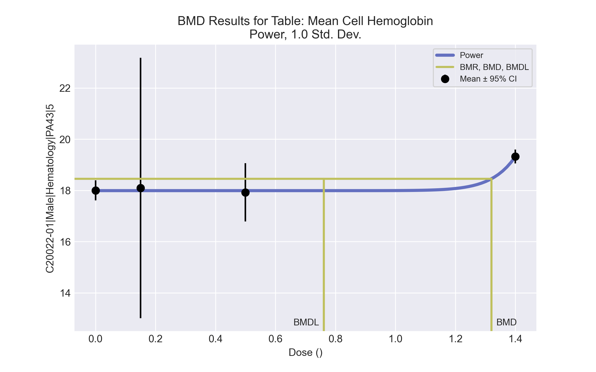

====================================================================   
 Power Model. (Version: 2.19; Date: 03/14/2017)   
 Input Data File: C:\Windows\TEMP\bmds-ttf823_h.(d)   
 Gnuplot Plotting File: C:\Windows\TEMP\bmds-ttf823_h.plt  
 Tue Apr 13 16:15:34 2021  
 ====================================================================   
  
 BMDS_Model_Run   
~~~~~~~~~~~~~~~~~~~~~~~~~~~~~~~~~~~~~~~~~~~~~~~~~~~~~~~~~~~~~~~~~~~~~  
   
 The form of the response function is:   
  
 Y[dose] = control + slope * dose^power  
  
  
 Dependent variable = Response  
 Independent variable = Dose  
 The power is restricted to be greater than or equal to 1  
 The variance is to be modeled as Var(i) = exp(lalpha + log(mean(i)) * rho)  
  
 Total number of dose groups = 4  
 Total number of records with missing values = 0  
 Maximum number of iterations = 500  
 Relative Function Convergence has been set to: 1e-008  
 Parameter Convergence has been set to: 1e-008  
  
  
  
 Default Initial Parameter Values   
 lalpha = -1.51602  
 rho = 0  
 control = 17.925  
 slope = 1.02349  
 power = -9999  
  
  
 Asymptotic Correlation Matrix of Parameter Estimates  
  
 ( *** The model parameter(s) -power   
 have been estimated at a boundary point, or have been specified by the user,  
 and do not appear in the correlation matrix )  
  
 lalpha rho control slope  
  
 lalpha 1 -1 0.28 -0.32  
  
 rho -1 1 -0.28 0.31  
  
 control 0.28 -0.28 1 -0.88  
  
 slope -0.32 0.31 -0.88 1  
  
  
  
 Parameter Estimates  
  
 95.0% Wald Confidence Interval  
 Variable Estimate Std. Err. Lower Conf. Limit Upper Conf. Limit  
 lalpha 90.9889 35.0033 22.3836 159.594  
 rho -32.0157 12.0215 -55.5773 -8.45406  
 control 17.9917 0.134091 17.7289 18.2545  
 slope 0.00312345 0.000358722 0.00242036 0.00382653  
 power 18 NA  
  
NA - Indicates that this parameter has hit a bound  
 implied by some inequality constraint and thus  
 has no standard error.  
  
  
  
 Table of Data and Estimated Values of Interest  
  
 Dose N Obs Mean Est Mean Obs Std Dev Est Std Dev Scaled Res.  
------ --- -------- -------- ----------- ----------- ----------  
  
 0 6 18 18 0.374 0.465 0.0439  
 0.15 2 18.1 18 0.566 0.465 0.33  
 0.5 4 17.9 18 0.714 0.465 -0.287  
 1.4 4 19.3 19.3 0.171 0.148 -5.2e-007  
  
  
  
 Model Descriptions for likelihoods calculated  
  
  
 Model A1: Yij = Mu(i) + e(ij)  
 Var{e(ij)} = Sigma^2  
  
 Model A2: Yij = Mu(i) + e(ij)  
 Var{e(ij)} = Sigma(i)^2  
  
 Model A3: Yij = Mu(i) + e(ij)  
 Var{e(ij)} = exp(lalpha + rho*ln(Mu(i)))  
 Model A3 uses any fixed variance parameters that  
 were specified by the user  
  
 Model R: Yi = Mu + e(i)  
 Var{e(i)} = Sigma^2  
  
  
 Likelihoods of Interest  
  
 Model Log(likelihood) # Param's AIC  
 A1 6.429643 5 -2.859287  
 A2 9.848017 8 -3.696034  
 A3 9.342679 6 -6.685358  
 fitted 8.846234 4 -9.692468  
 R -2.464817 2 8.929633  
  
  
 Explanation of Tests   
  
 Test 1: Do responses and/or variances differ among Dose levels?   
 (A2 vs. R)  
 Test 2: Are Variances Homogeneous? (A1 vs A2)  
 Test 3: Are variances adequately modeled? (A2 vs. A3)  
 Test 4: Does the Model for the Mean Fit? (A3 vs. fitted)  
 (Note: When rho=0 the results of Test 3 and Test 2 will be the same.)  
  
 Tests of Interest   
  
 Test -2*log(Likelihood Ratio) Test df p-value   
  
 Test 1 24.6257 6 0.0004005  
 Test 2 6.83675 3 0.07729  
 Test 3 1.01068 2 0.6033  
 Test 4 0.99289 2 0.6087  
  
The p-value for Test 1 is less than .05. There appears to be a  
difference between response and/or variances among the dose levels  
It seems appropriate to model the data  
  
The p-value for Test 2 is less than .1. A non-homogeneous variance   
model appears to be appropriate  
  
The p-value for Test 3 is greater than .1. The modeled variance appears   
 to be appropriate here  
  
The p-value for Test 4 is greater than .1. The model chosen seems   
to adequately describe the data  
   
  
 Benchmark Dose Computation  
  
Specified effect = 1  
  
Risk Type = Estimated standard deviations from the control mean   
  
Confidence level = 0.95  
  
 BMD = 1.32034   
  
  
 BMDL = 0.760887   
  
  
 BMDU = 1.35402

# Male BMD Results for Table: Neutrophil Count

BMDS version: BMDS v2.7.0

## Input dataset

|  |  |  |  |  |  |  |  |  |
| --- | --- | --- | --- | --- | --- | --- | --- | --- |
| Dose | 0 | 0.15 | 0.5 | 1.4 | 4 | 12 | 37a | 111a |
| N | 6 | 2 | 4 | 4 | 5 | 3 | 2 | 4 |
| Mean ± SD | 0.835 ± 0.283 | 1.075 ± 0.304 | 0.845 ± 0.116 | 1.337 ± 0.316 | 1.544 ± 0.468 | 1.247 ± 0.335 | 1.23 ± 0.014 | 1.24 ± 0.314 |

a Dose group removed in BMD modeling session

## Summary table

|  |  |  |  |  |  |
| --- | --- | --- | --- | --- | --- |
| Modela | Goodness of fit | | BMD | BMDL | Comments |
| *p*-value | AIC |
| Linear (equivalent models include Power, Polynomial 2°, 3°, 4°, 5°, 6°, 7°) | 0.009 | -16.811 | 10.63 | 5.413 | Exponential-M4 recommended as best-fitting model on the basis of the lowest AIC. |
| Hill | 0.222 | -23.433 | 1.296 | 0.542 |
| Exponential M2 (equivalent models include Exponential M3) | 0.007 | -16.403 | 12.226 | 6.787 |
| Exponential M4b | 0.186 | -23.633 | 0.811 | 0.305 |
| Exponential M5 | 0.222 | -23.433 | 1.339 | 0.508 |

a Constant variance case presented (BMDS Test 2 p-value = 0.207, BMDS Test 3 p-value = 0.207).

b Recommended model

## Model recommendation details

|  |  |  |
| --- | --- | --- |
| Model | Bin | Notes |
| Linear (equivalent models include Power, Polynomial 2°, 3°, 4°, 5°, 6°, 7°) | Warning | **Warnings**  • Goodness of fit p-value is less than threshold (0.00855 < 0.1) |
| Hill | Valid | - |
| Exponential M2 (equivalent models include Exponential M3) | Warning | **Warnings**  • Goodness of fit p-value is less than threshold (0.00715 < 0.1)  • BMD/high dose ratio is greater than threshold (1.02 > 1.0) |
| Exponential M4a | Valid | - |
| Exponential M5 | Valid | - |

a Recommended model

## Recommended model

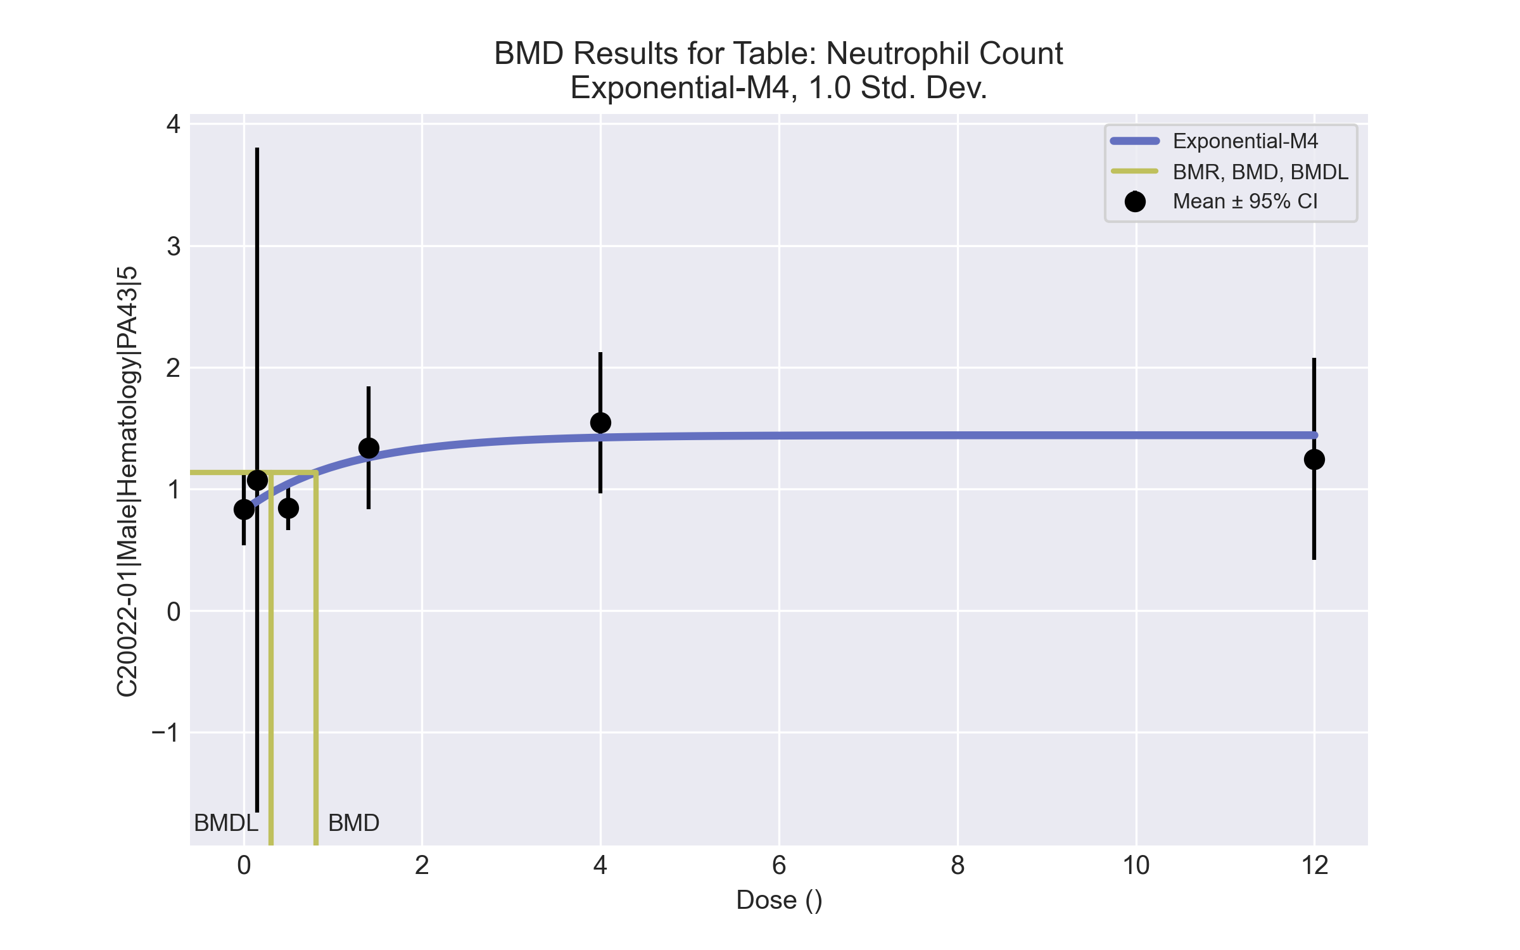

====================================================================   
 Exponential Model. (Version: 1.11; Date: 03/14/2017)   
 Input Data File: C:\Windows\TEMP\bmds-2pmamge9.(d)   
 Gnuplot Plotting File:   
 Tue Apr 13 16:15:53 2021  
 ====================================================================   
  
 BMDS_Model_Run   
~~~~~~~~~~~~~~~~~~~~~~~~~~~~~~~~~~~~~~~~~~~~~~~~~~~~~~~~~~~~~~~~~~~~~  
   
 The form of the response function by Model:   
 Model 2: Y[dose] = a * exp{sign * b * dose}  
 Model 3: Y[dose] = a * exp{sign * (b * dose)^d}  
 Model 4: Y[dose] = a * [c-(c-1) * exp{-b * dose}]  
 Model 5: Y[dose] = a * [c-(c-1) * exp{-(b * dose)^d}]  
  
 Note: Y[dose] is the median response for exposure = dose;  
 sign = +1 for increasing trend in data;  
 sign = -1 for decreasing trend.  
  
 Model 2 is nested within Models 3 and 4.  
 Model 3 is nested within Model 5.  
 Model 4 is nested within Model 5.  
  
  
 Dependent variable = Response  
 Independent variable = Dose  
 Data are assumed to be distributed: normally  
 Variance Model: exp(lnalpha +rho *ln(Y[dose]))  
 rho is set to 0.  
 A constant variance model is fit.  
  
 Total number of dose groups = 6  
 Total number of records with missing values = 0  
 Maximum number of iterations = 500  
 Relative Function Convergence has been set to: 1e-008  
 Parameter Convergence has been set to: 1e-008  
  
 MLE solution provided: Exact  
  
  
 Initial Parameter Values  
  
 Variable Model 4  
 -------- --------  
 lnalpha -2.51869   
 rho 0 Specified  
 a 0.79325   
 b 0.127   
 c 2.04374   
 d 1 Specified  
  
  
  
 Parameter Estimates  
  
 Variable Model 4 Std. Err.  
 -------- ------- ---------  
 lnalpha -2.31804 0.0284248  
 a 0.821486 0.109698  
 b 0.871397 0.469464  
 c 1.75411 0.275238  
  
 NC = No Convergence  
  
  
 Table of Stats From Input Data  
  
 Dose N Obs Mean Obs Std Dev  
 ----- --- ---------- -------------  
 0 6 0.835 0.2831  
 0.15 2 1.075 0.3041  
 0.5 4 0.845 0.1156  
 1.4 4 1.337 0.3165  
 4 5 1.544 0.4678  
 12 3 1.247 0.335  
  
  
 Estimated Values of Interest  
  
 Dose Est Mean Est Std Scaled Residual  
 ------ ---------- --------- ----------------  
 0 0.8215 0.3138 0.1055  
 0.15 0.8974 0.3138 0.8005  
 0.5 1.04 0.3138 -1.245  
 1.4 1.258 0.3138 0.5062  
 4 1.422 0.3138 0.8694  
 12 1.441 0.3138 -1.072  
  
  
  
 Other models for which likelihoods are calculated:  
  
 Model A1: Yij = Mu(i) + e(ij)  
 Var{e(ij)} = Sigma^2  
  
 Model A2: Yij = Mu(i) + e(ij)  
 Var{e(ij)} = Sigma(i)^2  
  
 Model A3: Yij = Mu(i) + e(ij)  
 Var{e(ij)} = exp(lalpha + log(mean(i)) * rho)  
  
 Model R: Yij = Mu + e(i)  
 Var{e(ij)} = Sigma^2  
  
  
 Likelihoods of Interest  
  
 Model Log(likelihood) DF AIC  
 ------- ----------------- ---- ------------  
 A1 18.22427 7 -22.44855  
 A2 21.82096 12 -19.64191  
 A3 18.22427 7 -22.44855  
 R 9.945759 2 -15.89152  
 4 15.81649 4 -23.63297  
  
  
 Additive constant for all log-likelihoods = -22.05. This constant added to the  
 above values gives the log-likelihood including the term that does not  
 depend on the model parameters.  
  
  
 Explanation of Tests  
  
 Test 1: Does response and/or variances differ among Dose levels? (A2 vs. R)  
 Test 2: Are Variances Homogeneous? (A2 vs. A1)  
 Test 3: Are variances adequately modeled? (A2 vs. A3)  
  
 Test 6a: Does Model 4 fit the data? (A3 vs 4)  
  
  
 Tests of Interest  
  
 Test -2*log(Likelihood Ratio) D. F. p-value  
 -------- ------------------------ ------ --------------  
 Test 1 23.75 10 0.008291  
 Test 2 7.193 5 0.2067  
 Test 3 7.193 5 0.2067  
 Test 6a 4.816 3 0.1858  
  
  
 The p-value for Test 1 is less than .05. There appears to be a  
 difference between response and/or variances among the dose  
 levels, it seems appropriate to model the data.  
  
 The p-value for Test 2 is greater than .1. A homogeneous  
 variance model appears to be appropriate here.  
  
 The p-value for Test 3 is greater than .1. The modeled  
 variance appears to be appropriate here.  
  
 The p-value for Test 6a is greater than .1. Model 4 seems  
 to adequately describe the data.  
  
  
 Benchmark Dose Computations:  
  
 Specified Effect = 1.000000  
  
 Risk Type = Estimated standard deviations from control  
  
 Confidence Level = 0.950000  
  
 BMD = 0.810542  
  
 BMDL = 0.305367  
  
 BMDU = 4.44504

# Male BMD Results for Table: Total Thyroxine

BMDS version: BMDS v2.7.0

## Input dataset

|  |  |  |  |  |  |  |  |  |
| --- | --- | --- | --- | --- | --- | --- | --- | --- |
| Dose | 0 | 0.15 | 0.5 | 1.4 | 4 | 12 | 37 | 111 |
| N | 6 | 3 | 5 | 5 | 4 | 4 | 3 | 5 |
| Mean ± SD | 3.032 ± 0.718 | 3.093 ± 1.006 | 2.728 ± 0.614 | 2.686 ± 0.729 | 2.945 ± 0.556 | 2.022 ± 0.684 | 0.79 ± 0.288 | 0.45 ± 0.087 |

## Summary table

|  |  |  |  |  |  |
| --- | --- | --- | --- | --- | --- |
| Modela | Goodness of fit | | BMD | BMDL | Comments |
| *p*-value | AIC |
| Linear (equivalent models include Power, Polynomial 2°, 3°, 4°, 5°) | 0.002 | 5.741 | 42.938 | 33.253 | Exponential-M4 recommended as best-fitting model on the basis of the lowest AIC. |
| Polynomial 6° | 0.002 | 5.741 | 42.938 | 33.253 |
| Polynomial 7° | <0.0001 | 381.742 | 3.872 | -999 |
| Hill | 0.81 | -9.672 | 10.911 | 6.704 |
| Exponential M2 (equivalent models include Exponential M3) | 0.03 | -1.314 | 18.448 | 10.816 |
| Exponential M4b | 0.655 | -9.968 | 7.264 | 5.024 |
| Exponential M5 | 0.8 | -9.616 | 10.656 | 5.726 |

a Modeled variance case presented (BMDS Test 2 p-value = 0.007, BMDS Test 3 p-value = 0.862).

b Recommended model

## Model recommendation details

|  |  |  |
| --- | --- | --- |
| Model | Bin | Notes |
| Linear (equivalent models include Power, Polynomial 2°, 3°, 4°, 5°) | Warning | **Warnings**  • Goodness of fit p-value is less than threshold (0.00183 < 0.1) |
| Polynomial 6° | Warning | **Warnings**  • Goodness of fit p-value is less than threshold (0.00183 < 0.1) |
| Polynomial 7° | Failure | **Failures**  • BMDL does not exist  **Warnings**  • Residual at lowest dose is greater than threshold (2.3 > 2.0)  • Ratio of modeled to actual stdev. at control is greater than threshold (10.3 > 1.5)  **Cautions**  • Warning(s): THIS USUALLY MEANS THE MODEL HAS NOT CONVERGED!; BMDL computation failed. |
| Hill | Valid | - |
| Exponential M2 (equivalent models include Exponential M3) | Warning | **Warnings**  • Goodness of fit p-value is less than threshold (0.0302 < 0.1) |
| Exponential M4a | Valid | - |
| Exponential M5 | Valid | - |

a Recommended model

## Recommended model

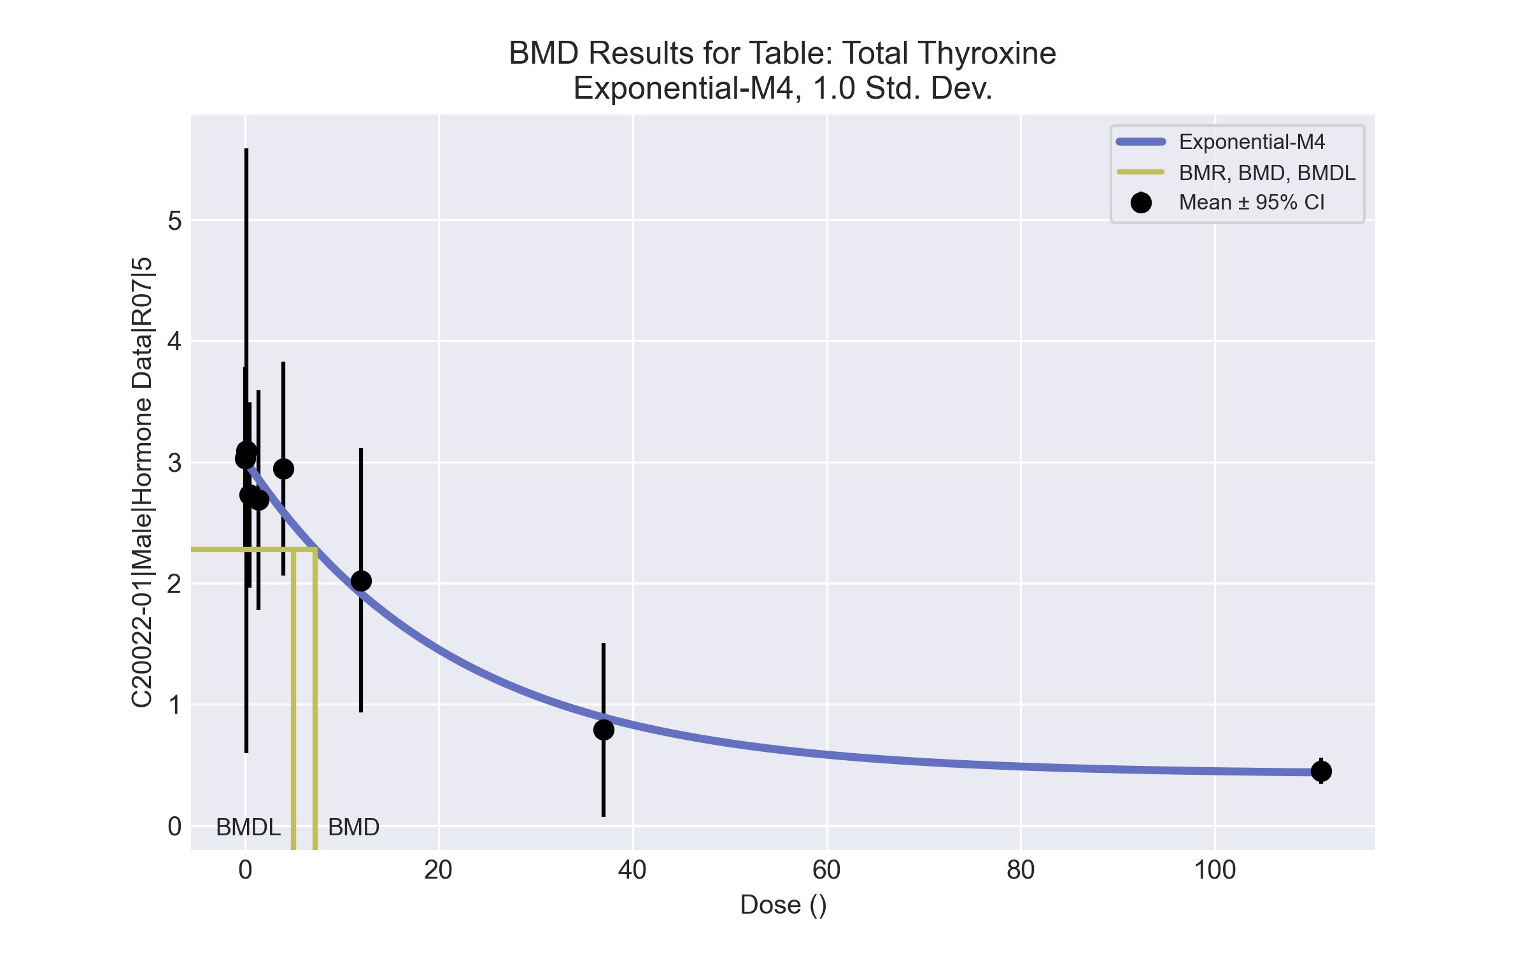

====================================================================   
 Exponential Model. (Version: 1.11; Date: 03/14/2017)   
 Input Data File: C:\Windows\TEMP\bmds-gb6j92ae.(d)   
 Gnuplot Plotting File:   
 Tue Apr 13 16:16:20 2021  
 ====================================================================   
  
 BMDS_Model_Run   
~~~~~~~~~~~~~~~~~~~~~~~~~~~~~~~~~~~~~~~~~~~~~~~~~~~~~~~~~~~~~~~~~~~~~  
   
 The form of the response function by Model:   
 Model 2: Y[dose] = a * exp{sign * b * dose}  
 Model 3: Y[dose] = a * exp{sign * (b * dose)^d}  
 Model 4: Y[dose] = a * [c-(c-1) * exp{-b * dose}]  
 Model 5: Y[dose] = a * [c-(c-1) * exp{-(b * dose)^d}]  
  
 Note: Y[dose] is the median response for exposure = dose;  
 sign = +1 for increasing trend in data;  
 sign = -1 for decreasing trend.  
  
 Model 2 is nested within Models 3 and 4.  
 Model 3 is nested within Model 5.  
 Model 4 is nested within Model 5.  
  
  
 Dependent variable = Response  
 Independent variable = Dose  
 Data are assumed to be distributed: normally  
 Variance Model: exp(lnalpha +rho *ln(Y[dose]))  
 The variance is to be modeled as Var(i) = exp(lalpha + log(mean(i)) * rho)  
  
 Total number of dose groups = 8  
 Total number of records with missing values = 0  
 Maximum number of iterations = 500  
 Relative Function Convergence has been set to: 1e-008  
 Parameter Convergence has been set to: 1e-008  
  
 MLE solution provided: Exact  
  
  
 Initial Parameter Values  
  
 Variable Model 4  
 -------- --------  
 lnalpha -2.70511   
 rho 2.02126   
 a 3.248   
 b 0.045145   
 c 0.131949   
 d 1 Specified  
  
  
  
 Parameter Estimates  
  
 Variable Model 4 Std. Err.  
 -------- ------- ---------  
 lnalpha -2.92988 0.364832  
 rho 2.11142 0.409262  
 a 3.02198 0.160563  
 b 0.0463274 0.00740492  
 c 0.139905 0.0161993  
  
 NC = No Convergence  
  
  
 Table of Stats From Input Data  
  
 Dose N Obs Mean Obs Std Dev  
 ----- --- ---------- -------------  
 0 6 3.032 0.718  
 0.15 3 3.093 1.006  
 0.5 5 2.728 0.6142  
 1.4 5 2.686 0.7286  
 4 4 2.945 0.5556  
 12 4 2.023 0.6842  
 37 3 0.79 0.2883  
 111 5 0.45 0.0866  
  
  
 Estimated Values of Interest  
  
 Dose Est Mean Est Std Scaled Residual  
 ------ ---------- --------- ----------------  
 0 3.022 0.7427 0.03195  
 0.15 3.004 0.7381 0.2097  
 0.5 2.962 0.7273 -0.7209  
 1.4 2.859 0.7004 -0.5515  
 4 2.582 0.6291 1.153  
 12 1.914 0.4585 0.4754  
 37 0.891 0.2046 -0.8548  
 111 0.438 0.09666 0.2781  
  
  
  
 Other models for which likelihoods are calculated:  
  
 Model A1: Yij = Mu(i) + e(ij)  
 Var{e(ij)} = Sigma^2  
  
 Model A2: Yij = Mu(i) + e(ij)  
 Var{e(ij)} = Sigma(i)^2  
  
 Model A3: Yij = Mu(i) + e(ij)  
 Var{e(ij)} = exp(lalpha + log(mean(i)) * rho)  
  
 Model R: Yij = Mu + e(i)  
 Var{e(ij)} = Sigma^2  
  
  
 Likelihoods of Interest  
  
 Model Log(likelihood) DF AIC  
 ------- ----------------- ---- ------------  
 A1 3.143209 9 11.71358  
 A2 12.9115 16 6.177005  
 A3 11.63132 10 -3.262634  
 R -21.25766 2 46.51532  
 4 9.983987 5 -9.967974  
  
  
 Additive constant for all log-likelihoods = -32.16. This constant added to the  
 above values gives the log-likelihood including the term that does not  
 depend on the model parameters.  
  
  
 Explanation of Tests  
  
 Test 1: Does response and/or variances differ among Dose levels? (A2 vs. R)  
 Test 2: Are Variances Homogeneous? (A2 vs. A1)  
 Test 3: Are variances adequately modeled? (A2 vs. A3)  
  
 Test 6a: Does Model 4 fit the data? (A3 vs 4)  
  
  
 Tests of Interest  
  
 Test -2*log(Likelihood Ratio) D. F. p-value  
 -------- ------------------------ ------ --------------  
 Test 1 68.34 14 < 0.0001  
 Test 2 19.54 7 0.006663  
 Test 3 2.56 6 0.8617  
 Test 6a 3.295 5 0.6547  
  
  
 The p-value for Test 1 is less than .05. There appears to be a  
 difference between response and/or variances among the dose  
 levels, it seems appropriate to model the data.  
  
 The p-value for Test 2 is less than .1. A non-homogeneous  
 variance model appears to be appropriate.  
  
 The p-value for Test 3 is greater than .1. The modeled  
 variance appears to be appropriate here.  
  
 The p-value for Test 6a is greater than .1. Model 4 seems  
 to adequately describe the data.  
  
  
 Benchmark Dose Computations:  
  
 Specified Effect = 1.000000  
  
 Risk Type = Estimated standard deviations from control  
  
 Confidence Level = 0.950000  
  
 BMD = 7.26419  
  
 BMDL = 5.02408  
  
 BMDU = 11.5697

# Male BMD Results for Table: Triiodothyronine

BMDS version: BMDS v2.7.0

## Input dataset

|  |  |  |  |  |  |  |  |  |
| --- | --- | --- | --- | --- | --- | --- | --- | --- |
| Dose | 0 | 0.15 | 0.5 | 1.4 | 4 | 12 | 37 | 111 |
| N | 6 | 3 | 5 | 5 | 4 | 4 | 3 | 5 |
| Mean ± SD | 52.55 ± 7.707 | 55.767 ± 14.146 | 58.34 ± 12.448 | 51.04 ± 12.707 | 53.75 ± 10.891 | 49.425 ± 10.387 | 36.467 ± 8.838 | 24.16 ± 2.688 |

## Summary table

|  |  |  |  |  |  |
| --- | --- | --- | --- | --- | --- |
| Modela | Goodness of fit | | BMD | BMDL | Comments |
| *p*-value | AIC |
| Linear (equivalent models include Power, Polynomial 2°, 4°, 6°, 7°) | 0.705 | 198.506 | 34.036 | 25.797 | Hill recommended as best-fitting model on the basis of the lowest BMDL. |
| Polynomial 3° | 0.705 | 198.506 | 34.036 | 25.797 |
| Polynomial 5° | 0.705 | 198.506 | 34.036 | 25.797 |
| Hillb | 0.758 | 200.594 | 19.107 | 7.426 |
| Exponential M2 (equivalent models include Exponential M3) | 0.857 | 197.319 | 24.008 | 16.388 |
| Exponential M4 | 0.844 | 198.755 | 16.929 | 8.215 |
| Exponential M5 | 0.76 | 200.584 | 19.497 | 8.394 |

a Constant variance case presented (BMDS Test 2 p-value = 0.136, BMDS Test 3 p-value = 0.136).

b Recommended model

## Model recommendation details

|  |  |  |
| --- | --- | --- |
| Model | Bin | Notes |
| Linear (equivalent models include Power, Polynomial 2°, 4°, 6°, 7°) | Valid | - |
| Polynomial 3° | Valid | - |
| Polynomial 5° | Valid | - |
| Hilla | Valid | - |
| Exponential M2 (equivalent models include Exponential M3) | Valid | - |
| Exponential M4 | Valid | - |
| Exponential M5 | Valid | - |

a Recommended model

## Recommended model

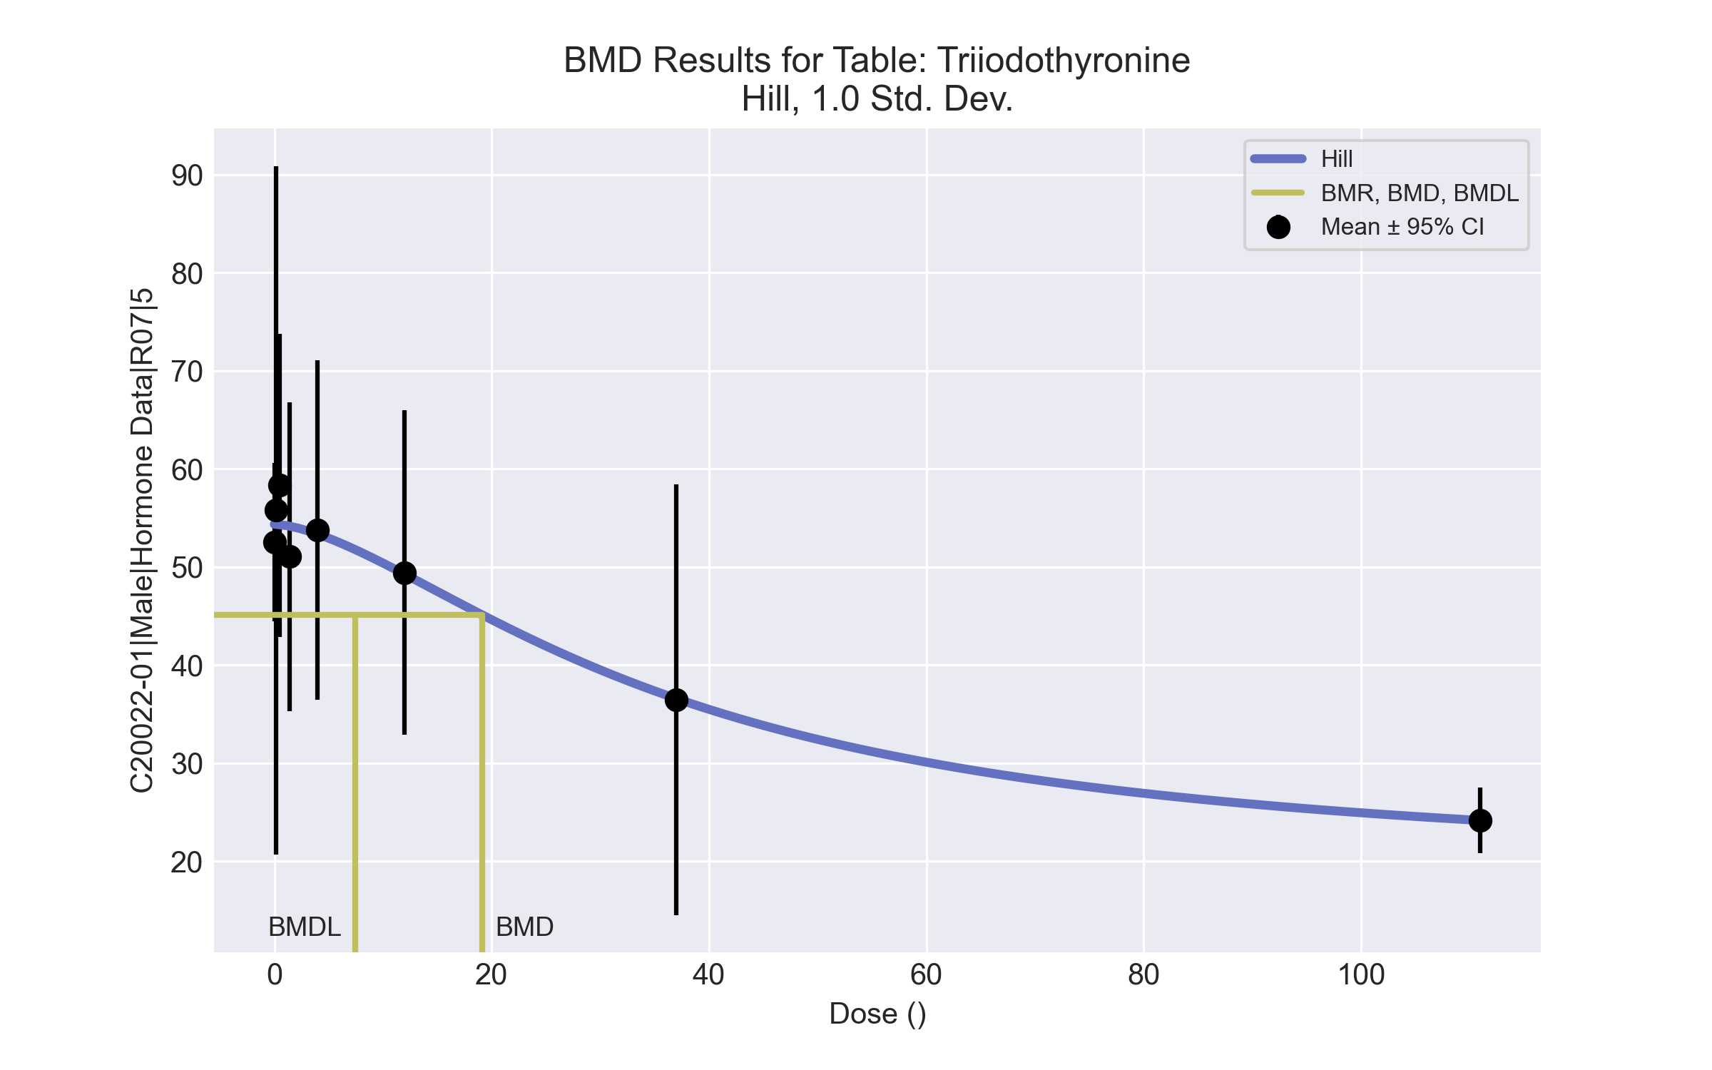

====================================================================   
 Hill Model. (Version: 2.18; Date: 03/14/2017)   
 Input Data File: C:\Windows\TEMP\bmds-v9dr3prm.(d)   
 Gnuplot Plotting File: C:\Windows\TEMP\bmds-v9dr3prm.plt  
 Tue Apr 13 16:16:22 2021  
 ====================================================================   
  
 BMDS_Model_Run   
~~~~~~~~~~~~~~~~~~~~~~~~~~~~~~~~~~~~~~~~~~~~~~~~~~~~~~~~~~~~~~~~~~~~~  
   
 The form of the response function is:   
  
 Y[dose] = intercept + v*dose^n/(k^n + dose^n)  
  
  
 Dependent variable = Response  
 Independent variable = Dose  
 rho is set to 0  
 Power parameter restricted to be greater than 1  
 A constant variance model is fit  
  
 Total number of dose groups = 8  
 Total number of records with missing values = 0  
 Maximum number of iterations = 500  
 Relative Function Convergence has been set to: 1e-008  
 Parameter Convergence has been set to: 1e-008  
  
  
  
 Default Initial Parameter Values   
 alpha = 104.726  
 rho = 0 Specified  
 intercept = 52.55  
 v = -28.39  
 n = 1.84481  
 k = 33.3569  
  
  
 Asymptotic Correlation Matrix of Parameter Estimates  
  
 ( *** The model parameter(s) -rho   
 have been estimated at a boundary point, or have been specified by the user,  
 and do not appear in the correlation matrix )  
  
 alpha intercept v n k  
  
 alpha 1 -2.2e-006 5.8e-007 1.3e-007 3.7e-007  
  
 intercept -2.2e-006 1 -0.45 -0.46 0.19  
  
 v 5.8e-007 -0.45 1 0.91 -0.91  
  
 n 1.3e-007 -0.46 0.91 1 -0.8  
  
 k 3.7e-007 0.19 -0.91 -0.8 1  
  
  
  
 Parameter Estimates  
  
 95.0% Wald Confidence Interval  
 Variable Estimate Std. Err. Lower Conf. Limit Upper Conf. Limit  
 alpha 85.2454 20.3776 45.3061 125.185  
 intercept 54.3557 2.19031 50.0628 58.6487  
 v -35.4418 17.6124 -69.9615 -0.922127  
 n 1.58988 1.45081 -1.25366 4.43342  
 k 36.8282 31.973 -25.8378 99.4941  
  
  
  
 Table of Data and Estimated Values of Interest  
  
 Dose N Obs Mean Est Mean Obs Std Dev Est Std Dev Scaled Res.  
------ --- -------- -------- ----------- ----------- ----------  
  
 0 6 52.5 54.4 7.71 9.23 -0.479  
 0.15 3 55.8 54.4 14.1 9.23 0.266  
 0.5 5 58.3 54.3 12.4 9.23 0.974  
 1.4 5 51 54.2 12.7 9.23 -0.756  
 4 4 53.8 53.3 10.9 9.23 0.0875  
 12 4 49.4 49.3 10.4 9.23 0.0371  
 37 3 36.5 36.6 8.84 9.23 -0.0192  
 111 5 24.2 24.1 2.69 9.23 0.00416  
  
  
  
 Model Descriptions for likelihoods calculated  
  
  
 Model A1: Yij = Mu(i) + e(ij)  
 Var{e(ij)} = Sigma^2  
  
 Model A2: Yij = Mu(i) + e(ij)  
 Var{e(ij)} = Sigma(i)^2  
  
 Model A3: Yij = Mu(i) + e(ij)  
 Var{e(ij)} = Sigma^2  
 Model A3 uses any fixed variance parameters that  
 were specified by the user  
  
 Model R: Yi = Mu + e(i)  
 Var{e(i)} = Sigma^2  
  
  
 Likelihoods of Interest  
  
 Model Log(likelihood) # Param's AIC  
 A1 -94.357133 9 206.714266  
 A2 -88.826760 16 209.653520  
 A3 -94.357133 9 206.714266  
 fitted -95.296838 5 200.593677  
 R -110.451695 2 224.903390  
  
  
 Explanation of Tests   
  
 Test 1: Do responses and/or variances differ among Dose levels?   
 (A2 vs. R)  
 Test 2: Are Variances Homogeneous? (A1 vs A2)  
 Test 3: Are variances adequately modeled? (A2 vs. A3)  
 Test 4: Does the Model for the Mean Fit? (A3 vs. fitted)  
 (Note: When rho=0 the results of Test 3 and Test 2 will be the same.)  
  
 Tests of Interest   
  
 Test -2*log(Likelihood Ratio) Test df p-value   
  
 Test 1 43.2499 14 <.0001  
 Test 2 11.0607 7 0.136  
 Test 3 11.0607 7 0.136  
 Test 4 1.87941 4 0.7579  
  
The p-value for Test 1 is less than .05. There appears to be a  
difference between response and/or variances among the dose levels  
It seems appropriate to model the data  
  
The p-value for Test 2 is greater than .1. A homogeneous variance   
model appears to be appropriate here  
  
  
The p-value for Test 3 is greater than .1. The modeled variance appears   
 to be appropriate here  
  
The p-value for Test 4 is greater than .1. The model chosen seems   
to adequately describe the data  
   
  
 Benchmark Dose Computation  
  
Specified effect = 1  
  
Risk Type = Estimated standard deviations from the control mean   
  
Confidence level = 0.95  
  
 BMD = 19.1065  
  
 BMDL = 7.42637  
  
 BMDU = 42.0681